Parish Dates January 2022 onwards
Monday 24th January 7.30pm House Group at the Rectory
Tuesday 25th January 10.15am Prayer time in church
with Holy Communion.
Thursday 27th January from 11.30am Locals’ Lunch in Village Hall.
4.30pm Chat and Chocolate

Sunday 30th January 09.00am Holy Communion
10.30am Parish Communion with Sunday School
12.00pm Baptism of Harry, George & Henrietta Bracewell
Tuesday 1st February 10.15am Prayer time in church

Sunday 6th February 09.00am Holy Communion
10.30am Parish Communion with Sunday School
12.00pm Baptism of Charlotte Hickey
4.00pm Holy Communion at Old Mill Court
Monday 7th February 7.30pm House Group at the Rectory
Tuesday 8th February 10.15am Prayer time in church.
2.45pm School Service in church
Thursday 10th February from 11.30am Locals’ Lunch in Village Hall.
4.30pm Chat and Chocolate

Sunday 13th February 09.00am Holy Communion
10.30am Morning Worship with Sunday School
Tuesday 15th February 10.15am Prayer time in church.
7.30pm House Group at the Rectory

KEY DATE FOR YOUR DIARY
Friday 11th March 7.00-10.30pm – Parish Quiz and Social at the Village Hall with meal and entertainment

Website : www.hooleparishchurch.com
Facebook page: St Michael and All Angels Church, Hoole,
Rector – Revd Ann Templeman anntempleman@live.co.uk 01772 448515The Rectory, 69 Liverpool Old Road Much Hoole PR4 4RB
Please take this sheet home with you
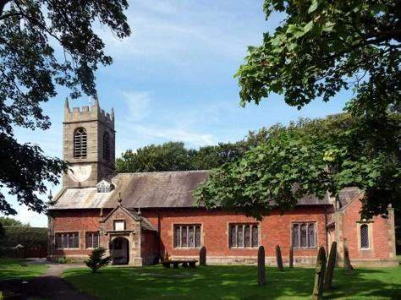
St. Michael and All Angels – Hoole

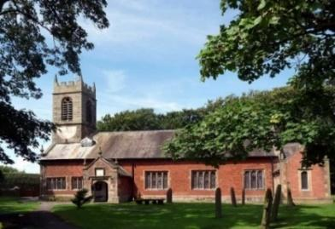

Welcome to our church again this morning. Please stay for a chat and a cup of tea or coffee after the 10.30 service, a great way to meet people

Sunday 23rd January 2022 Epiphany 3

GOOD NEWS OF GREAT JOY

‘The Spirit of the Lord is upon me’ Luke 4: v 18.

PRAYER OF THE DAY: God of all mercy, your Son proclaimed
good news to the poor, release to the captives, and freedom to the
oppressed: anoint us with your Holy Spirit and set all your people free
to praise you in Christ our Lord. Amen.

No Sunday School today during the service
Noisy Church at 3.45pm.
There are toys and colouring sheets
for younger children at the back of church.

9.00am. Holy Communion (Book of Common Prayer) begins p237

10.30am. Morning Worship.
Reading: Luke 4: v 14-21.

Hymns: 265 – Hark the glad sound.
Canticle 1 – God we praise you (Ode to joy).
45 – As the deer pants for the water.
259 – Hail to the Lord’s anointed.
409 – Lord for the years.

3.45pm. Noisy Church in Church.
BIBLE READING: Luke 4: v 14-21.
Jesus returned to Galilee in the power of the Spirit, and news about him spread through the whole countryside. He was teaching in their synagogues, and everyone praised him. He went to Nazareth, where he had been brought up, and on the Sabbath day he went into the synagogue, as was his custom. He stood up to read, and the scroll of the prophet Isaiah was handed to him. Unrolling it, he found the place where it is written:

“The Spirit of the Lord is on me, because he has anointed me
to proclaim good news to the poor.
He has sent me to proclaim freedom for the prisoners
and recovery of sight for the blind,
to set the oppressed free, to proclaim the year of the Lord’s favour.”

Then he rolled up the scroll, gave it back to the attendant and sat down. The eyes of everyone in the synagogue were fastened on him. He began by saying to them, “Today this scripture is fulfilled in your hearing.”

Prayer: We pray for those who are sick, especially Baby Erica Ivy, Patricia Mortimer, Rose Wood, Tom Parkinson, Karen Kenyon, Rose Brown, Peter Parker, Steve Coughlan and James Turbefield. We give thanks for the lives of Eva Coxhead, Michael Taylor & Mavis McCormick & pray for their family & friends.

Suggested Bible readings this week.
Monday 24th Jan. Mark 3: v 22-30. Tuesday 25th Jan. Matthew 19: v 27-end.
Wednesday 26th Jan. Mark 4: v 1-20. Thursday 27th Jan. Mark 4: v 21-25.
Friday 28th Jan. Mark 4: v 26-34. Saturday 29th Jan. Mark 4: v 35-end.

A LOVE LETTER FROM GOD – HOUSEGROUPS
In our Bible Study/Housegroups we will be looking at the
1st letter of John (page 1225 in the church Bibles) between now and Lent. The great theme of this inspiring letter is God’s love. In the first session, Tuesday 18th and Monday 24th January, we will be looking at 1 John 1.
TUESDAY 10.15am IN CHURCH
This will be a short service of either Morning Prayer or Holy Communion – a lovely time midweek to meet and pray together over God’s Word.

Churches together Penwortham Foodbank
We extend our thanks to the members of the congregation for their continuing generosity of foodstuffs. Sadly as inflation and the cost of all bills increase, the numbers of people needing support continues to grow. Please remember them in your prayers and if possible in your continued giving.

Confirmation
2 Confirmation groups will be starting this month. One for adults, one for
young people aged 11-18. Please let Rev Ann know if you are interested in
joining these groups.

“YOU ARE THE BODY OF CHRIST AND EACH ONE OF YOU IS A PART OF IT” (1 Corinthians 12 v27)
Last Sunday we were thinking about the implications of this famous bible verse. Thank you very much to those who identified the gifts they have been given by God. Today if you regard St Michael’s as your church please fill in the enclosed sheet. and hand to Ann or Churchwardens.

