Parish Dates February 2022 onwards
Tuesday 1st February 10.15am Prayer time in church
7.30pm House Group at the Rectory
Wednesday 2nd Feb. 1.15pm School visit to Church.

Sunday 6th February 09.00am Holy Communion
10.30am Parish Communion with Sunday School
12.00pm Baptism of Charlotte Hickey
4.00pm Holy Communion at Old Mill Court
Monday 7th February 7.30pm House Group at the Rectory
Tuesday 8th February 10.15am Prayer time in church.
2.45pm School Service in church
Thursday 10th February from 11.30am Locals’ Lunch in Village Hall.
4.30pm Chat and Chocolate

Sunday 13th February 09.00am Holy Communion
10.30am Morning Worship with Sunday School
Tuesday 15th February 10.15am Prayer time in church.
7.30pm House Group at the Rectory

Sunday 20th February 09.00am Holy Communion
10.30am Parish Communion with Sunday School
Monday 21st February 7.30pm House Group at the Rectory
Tuesday 22nd February 10.15am Prayer time in church.
Thursday 24th February from 11.30am Locals’ Lunch in Village Hall.
4.30pm Chat and Chocolate
Sunday 27th February 09.00am Holy Communion
10.30am Morning Worship
3.45pm Pancake Church in the Village Hall.
KEY DATE FOR YOUR DIARY
Friday 11th March 7.00-10.30pm – Parish Quiz and Social at
the Village Hall with meal and entertainment. Please get your tickets today

Website : www.hooleparishchurch.com
Facebook page: St Michael and All Angels Church, Hoole,
Rector – Revd Ann Templeman anntempleman@live.co.uk 01772 448515The Rectory, 69 Liverpool Old Road Much Hoole PR4 4RB
Please take this sheet home with you
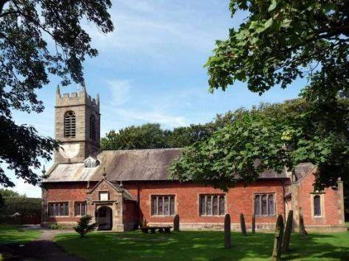
St. Michael and All Angels – Hoole

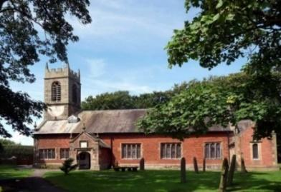

Welcome to our church again this morning. Please stay for a chat and a cup of tea or coffee after the 10.30 service, a great way to meet people

Sunday 30th January 2022 Epiphany 4

THE BEATITUDES – THE SERMON ON THE MOUNT

“Blessed are the poor in spirit, for theirs is the Kingdom of Heaven”
Matthew 5: v 3.
PRAYER OF THE DAY: God of heaven, you send the gospel to the
ends of the earth and your messengers to every nation: send your
Holy Spirit to transform us by the good news of everlasting life
in Jesus Christ our Lord. Amen.

Sunday School today during the service
There are toys and colouring sheets
for younger children at the back of church.

9.00am. Holy Communion (Book of Common Prayer) begins p237

10.30am. Parish Communion with Sunday School.
Readings: Numbers 12: v 1-3, 5, 10 & 13.
Matthew 5: v 1-10.

Hymns: 67 – Be still for the presence of the Lord.
Screen – My Lighthouse.
584 Rock of Ages
448 – Meekness and Majesty.
195 – From Heaven you came – The Servant King.

H/C Hymns: Supp. 5: Bless the Lord O my soul; 620 – Such Love.

12.00 noon: Baptism of Harry, George & Henrietta Bracewell.
READINGS: Numbers 12: v 1-3, 5, 10 & 13.
Miriam and Aaron began to talk against Moses because of his Cushite wife, for he had married a Cushite. “Has the Lord spoken only through Moses?” they asked. “Hasn’t he also spoken through us?” And the Lord heard this.
(Now Moses was a very meek man, more meek than anyone else
on the face of the earth.)
Then the Lord came down in a pillar of cloud; he stood at the entrance to the tent and summoned Aaron and Miriam. When the two of them stepped forward. When the cloud lifted from above the tent, Miriam’s skin was leprous—it became as white as snow. Aaron turned toward her and saw that she had a defiling skin disease. So Moses cried out to the Lord, “Please, God, heal her!”

Matthew 5: v 1-10. Now when Jesus saw the crowds, he went up on a mountainside and sat down. His disciples came to him, and he began to teach them. He said:
‘Blessed are the poor in spirit, for theirs is the kingdom of heaven.
Blessed are those who mourn, for they will be comforted.
Blessed are the meek, for they will inherit the earth.
Blessed are those who hunger and thirst for righteousness,
for they will be filled.
Blessed are the merciful, for they will be shown mercy.
Blessed are the pure in heart, for they will see God.
Blessed are the peacemakers, for they will be called children of God.
Blessed are those who are persecuted because of righteousness,
for theirs is the kingdom of heaven.

Prayer: We pray today for Harry George and Henrietta Bracewell to be baptised following this service, and for Charlotte Hickey to be baptised next week, we pray for their families at this special time. We pray for those who are sick, especially Baby Erica Ivy, Patricia Mortimer, Rose Wood, Tom Parkinson, Karen Kenyon, Rose Brown, Peter Parker, Steve Coughlan and James Turbefield. We give thanks for the life of Mavis McCormick & pray for Gerry and her family & friends.

Suggested Bible readings this week.
Monday 31st Jan. Mark 5: v 1-20. Tuesday 1st Feb. Mark 5: v 21-end.
Wednesday 2nd Feb. Luke 2: v 22-40. Thursday 3rd Feb. Mark 6: v 7-13.
Friday 4th Feb. Mark 6: v 14-29. Saturday 5th Feb. Mark 6: v 30-34.
A LOVE LETTER FROM GOD – HOUSEGROUPS
In our Bible Study/Housegroups we will be looking at the
1st letter of John (page 1225 in the church Bibles) between now and Lent. The great theme of this inspiring letter is God’s love. In the next session, Mon 31st Jan and Tues 8th Feb we will be looking at 1 John 2 v 1 -14.
TUESDAY 10.15am IN CHURCH
This will be a short service of either Morning Prayer or Holy Communion – a lovely time midweek to meet and pray together over God’s Word.

Churches together Penwortham Foodbank
A warm thankyou to everyone for your continuing generous gifts of foodstuffs. Sadly as inflation and the cost of all bills increase, the numbers of people needing support continues to grow. Please remember them in your prayers and if possible in your continued giving.

Confirmation
2 Confirmation groups will be starting this month. One for adults, one for
young people aged 11-18. Please let Rev Ann know if you are interested in
joining these groups.

“YOU ARE THE BODY OF CHRIST AND EACH ONE OF YOU IS A PART OF IT” (1 Corinthians 12 v27)
Over the last 2 Sundays we have been thinking about the implications of this famous bible verse. Thank you very much to those who identified the gifts they have been given by God. Please hand in a sheet about the gifts God has given you and how you could exercise these gifts at St Michael’s

Christian Aid Re-cycling and Coffee Morning:
Saturday February 5th 10am - 12 noon, St Andrew’s Church Hall, Longton
Please donate: stamps, currency, mobile phones, ink cartridges, ball-point pens, tools, jewellery, watches, spectacles, sandals and shoes etc.at St Andrew’s Church Hall Fri Feb. 4th from 4pm to 5pm or on Sat 5th from 9am to 10am. Cath Greenlees: 01772-613500

