Parish Dates From January 2023

Tuesday 10th Jan. 10.15am Morning Prayer in the Lodge.
7.30pm Men’s Fellowship meet in the Village Hall.
Thursday 12th Jan. 4.30pm Bible and Biscuits in the Lodge.

Sunday 15th Jan. 9.00am Holy Communion
10.30am Parish Communion with Sunday School
followed by 12.00noon There came Three Soldiers (St Michael’s Players)
Tuesday 17th Jan. 10.15am Holy Communion in the Lodge.
1.00pm Funeral of Jeffrey Oates
7.30pm Ladies Group AGM & Social Evening
in the Village Hall
Wednesday 18th Jan. 7.15pm ALPHA 2 begins in the Lodge.
HOW DOES GOD GUIDE US?
Thursday 19th Jan. 4.30pm Chat and Chocolate in the Lodge

Sunday 22nd Jan. 9.00am Holy Communion
10.30am Morning Worship with Sunday School and Baptism of Dexter Holding.
3.45pm PARTY CHURCH (in St Michael’s School)
Monday 23rd Jan. 7.30pm PCC Meeting in the Lodge.
Tuesday 24th Jan. 10.15am Holy Communion in the Lodge.
Wednesday 25th Jan. 7.15pm ALPHA 2 continues in the Lodge.
WHO IS THE HOLY SPIRIT?
Thursday 26th Jan. 4.30pm Bible and Biscuits in the Lodge.

Sunday 29th Jan. 9.00am Holy Communion
10.30am Parish Communion with Sunday School and
Baptism of Harry Tomlinson-Farrell.

Suggested Bible Readings This Week.
Monday 9th Jan. Matthew 3 v 13-end. Tuesday 10th Jan. Mark 1: v 21-28.
Wed. 11th Jan. Mark 1: v 29-39. Thursday 12th Jan. Mark 1: v 40-end.
Friday 13th Jan. Mark 2: v 1-12. Saturday 14th Jan. Mark 2: v 13-17.

www.hooleparishchurch.com
Facebook page: St Michael and All Angels Church, Hoole,
Rector – Revd Ann Templeman anntempleman@live.co.uk
01772 448515 or 07877659156

Please take this sheet home with you.
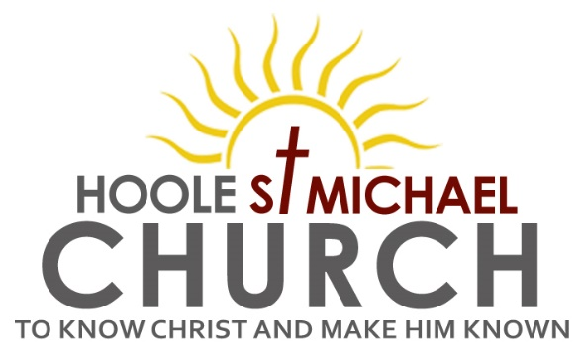
Welcome to our Church with a special welcome
to Revd. Richard Plant who is leading our worship at 9.00am.
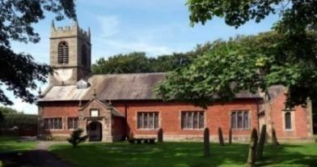
Please stay for refreshments in the Lodge after the service.
Sunday 8th January 2023

THE WISE MEN VISIT THE INFANT JESUS

“We saw his star in the East and have come to worship him”. Matt. 2: v 2b.

PRAYER OF THE DAY: “Creator of the Heavens, who led the Magi by a star to worship the Christ-Child: guide and sustain us, that we may find our journeys end in Jesus Christ our Lord.” Amen.
Sunday School today during the service. There are toys and
colouring sheets for younger children at the back of church

9.00am. Holy Communion (Book of Common Prayer) begins p237

10.30am. Morning Worship with Sunday School.
Reading: Matthew 2: v 1-12.
Hymns: 724 – We three Kings of orient are.
Screen – I reach up high.
427 – Love came down at Christmas.
729 – What Child is this.
49 – As with gladness men of old.
419 – Lord the light of your love (Shine, Jesus shine).

4.00pm. Holy Communion (Old Mill Court)
Reading: Matthew 2: v 1-12. After Jesus was born in Bethlehem in Judea, during the time of King Herod, Magi from the east came to Jerusalem and asked, ‘Where is the one who has been born king of the Jews? We saw his star when it rose and have come to worship him.’
When King Herod heard this he was disturbed, and all Jerusalem with him. When he had called together all the people’s chief priests and teachers of the law, he asked them where the Messiah was to be born. ‘In Bethlehem in Judea,’ they replied, ‘for this is what the prophet has written:
“But you, Bethlehem, in the land of Judah, are by no means least
among the rulers of Judah; for out of you will come a ruler
who will shepherd my people Israel.”
Then Herod called the Magi secretly and found out from them the exact time the star had appeared. He sent them to Bethlehem and said, ‘Go and search carefully for the child. As soon as you find him, report to me, so that I too may go and worship him.’
After they had heard the king, they went on their way, and the star they had seen when it rose went ahead of them until it stopped over the place where the child was. When they saw the star, they were overjoyed. On coming to the house, they saw the child with his mother Mary, and they bowed down and worshipped him. Then they opened their treasures and presented him with gifts of gold, frankincense and myrrh. And having been warned in a dream not to go back to Herod, they returned to their country by another route.

Prayer: We continue to pray that 2023 may be a year filled with love, joy and peace. We pray for Ann and Peter as they enjoy a well-earned break. We pray for the sick especially Erika Ivy, Sam Burns, Mona Lewis, Christine Barker, Antonietta Broadhurst, Isaac Rostron, Andy Shaw, Beryl and Bill Carr. We give thanks for the lives of Jeanette Taylor & Jeffrey Oates & pray for their families & friends.

ALPHA SESSIONS JANUARY – MARCH 2023
ALL SESSIONS 7.15- 8.45PM IN THE LODGE
1. Wednesday 18th January HOW DOES GOD GUIDE US?
2. Wednesday 26th January WHO IS THE HOLY SPIRIT?
3.Wednesday 1st February WHAT DOES THE HOLY SPIRIT DO?
4. Wednesday 8th February WHY AND HOW SHOULD WE TELL OTHERS?
Wednesday 15th February NO ALPHA THIS WEEK
Beginning of Lent:
Wednesday 22nd February 7.30pm ASH WEDNESDAY Holy Communion
5. Wednesday 1st March HOW CAN I RESIST EVIL?
6. Wednesday 8th March DOES GOD HEAL TODAY?
7. Wednesday 15th March HOW CAN I MAKE THE MOST OF THE REST OF MY LIFE? WITH JACOB’S JOIN MEAL
8. Wednesday 22nd March PREPARING FOR EASTER 1
9. Wednesday 29th March PREPARING FOR EASTER 2
10. SUNDAY 2ND APRIL PALM SUNDAY HOLY WEEK BEGINS
10.30AM Palm Sunday service with donkey procession from St Michael’s school to church
11. THURSDAY 5TH APRIL 7.00PM Maundy Thursday
PASSOVER MEAL

