Parish Dates January 2022 onwards
Tuesday 11th January 10.15am Prayer time in church.
7.30pm Men’s Fellowship in the Village Hall
Wednesday 12th January 11.00am Funeral of Eva Coxhead
Thursday 13th January from 11.30am Locals’ Lunch in Village Hall.

Sunday 16th January 09.00am Holy Communion
10.30am Parish Communion & Sunday School
Monday January 17th 7.30pm PCC at the Village Hall
Tuesday 18th January 10.15am Holy Communion in church.
2.45pm School Service in church
7.30pm House Group at the Rectory
7.30pm Ladies Group in the Village Hall
POSTPONED!!! Friday 21st January 7.00pm -10.30pm New Year Parish Social: Music from 60s to 90s in the Village Hall.

Sunday 23rd January 09.00am Holy Communion
10.30am Morning Worship
3.45pm NOISY CHURCH in Church
Monday 24th January 7.30pm House Group at the Rectory
Tuesday 25th January 10.15am Prayer time in church.
Thursday 27th January from 11.30am Locals’ Lunch in Village Hall.

Confirmation
2 Confirmation groups will be starting in the New Year to prepare for Confirmation in the summer:
1. For adults – there are already a number of people who have expressed an interest in this group. There will be 8-10 x1hr sessions discussing the basics of Christian commitment. Everyone is welcome whatever your age or Christian background.
2. For young people age 11-18 – we already have 7 interested
Please let Rev Ann know if you would like to join either group

Website : www.hooleparishchurch.com
Facebook page: St Michael and All Angels Church, Hoole,
Rector – Revd Ann Templeman anntempleman@live.co.uk 01772 448515The Rectory, 69 Liverpool Old Road Much Hoole PR4 4RB
Please take this sheet home with you
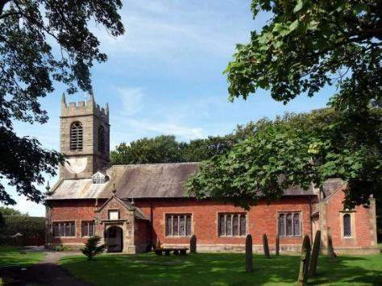
St. Michael and All Angels – Hoole

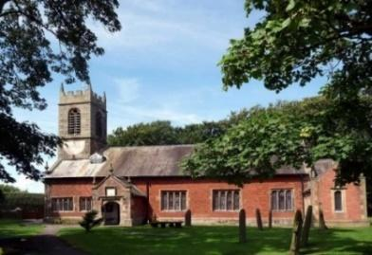

Welcome to our church again this morning, with a special welcome to Revd. Pat Belshaw who is leading our worship this week, while Ann and Peter are away on holiday. Please stay for a chat and a cup of tea or coffee after the 10.30 service, a great way to meet people

Sunday 9th January 2022 Epiphany 1

THE BAPTISM OF JESUS
‘And a voice came from Heaven “You are my beloved;
with you I am well pleased”’. Luke 3: v 22.

PRAYER OF THE DAY: Heavenly Father, at the Jordan you revealed
Jesus as your Son: may we recognize him as our Lord and know ourselves to
be your beloved children; through Jesus Christ our Saviour. Amen.

Sunday School today during the service
There are toys and colouring sheets
for younger children at the back of church.

9.00am. Holy Communion (Book of Common Prayer) begins p237

10.30am. Morning Worship with Sunday School
Reading: Luke 3: v 15-17 & 21-22.
Hymns: 411 – Lord Jesus Christ – Living Lord.
Screen – Nothing too big, big, big.
Canticle 2 – O bless the God of Israel.
615 – Spirit of the living God.
527 – On Jordan’s bank the Baptist’s cry.
419 – Lord the light of your love - Shine Jesus Shine.

4.00pm. Holy Communion (Old Mill Court).
BIBLE READING: Luke 3: v 15-17 & 21-22.
The people were waiting expectantly and were all wondering in their hearts if John might possibly be the Messiah. John answered them all, ‘I baptise you with water. But one who is more powerful than I will come, the straps of whose sandals I am not worthy to untie. He will baptise you with the Holy Spirit and fire. His winnowing fork is in his hand to clear his threshing-floor and to gather the wheat into his barn, but he will burn up the chaff with unquenchable fire.’
When all the people were being baptised, Jesus was baptised too. And as he was praying, heaven was opened and the Holy Spirit descended on him in bodily form like a dove. And a voice came from heaven: ‘You are my Son, whom I love; with you I am well pleased.’

Prayer: We pray for our children beginning a new term at school. We pray for those who are sick, especially Baby Erica Ivy, Patricia Mortimer, Rose Wood, Tom Parkinson, Karen Kenyon, Rose Brown, Peter Parker, Steve Coughlan and James Turbefield. We give thanks for the life of Eva Coxhead and pray for her family and friends at this difficult time.

WEEKLY GIVING ENVELOPES 2022: Don’t forget to pick up your box of envelopes. Please consider changing your giving to a Standing Order, as we now have to pay bank charges.
New Year’s Resolution?
Please consider coming along to our fortnightly Bible Studies and/or the weekly prayer time on Tuesday mornings?
Prayer of commitment
I am no longer my own, but yours,
send me where you will, rank me with whom you will;
let me be employed for you, or laid aside for you;
exalted for you, or bought low for you;
let me be full, let me be empty;
Freely and wholeheartedly I yield my life and all I possess to your pleasure and disposal. Amen.
HELP: Has anyone seen Ann’s green 2022 church diary – last seen Sunday 19th December in Church?

Suggested Bible readings this week.
Monday 10th Jan. Mark 1: v 14-20. Tuesday 11th Jan. Mark 1: v 21-28.
Wednesday 12th Jan. Mark 1: v 29-39. Thursday 13th Jan. Mark 1: v 40-end.
Friday 14th Jan. Mark 2: v 1-12. Saturday 15th Jan. Mark 2: v 13-17.

A LOVE LETTER FROM GOD – HOUSEGROUPS
In our Bible Study/Housegroups we will be looking at the
1st letter of John (page 1225 in the church Bibles) between now and Lent. The great theme of this inspiring letter is God’s love. In the first session, Tuesday 18th and Monday 24th January, we will be looking at 1 John 1.

TUESDAY 10.15am IN CHURCH
This will be a short service of either Morning Prayer or Holy Communion – a lovely time midweek to meet and pray together over God’s Word.

