Parish Dates June 2021 onwards
Monday July 12th 7.00pm PCC Meeting in church.
Tuesday July 13th 10.15am – 10.45am Prayer time live in Church
Sunday 18th July OUTREACH WEEKEND
09.00am Holy Communion in Church
10.30am Parish Communion in Church
2.30PM – 4.30PM FAMILY CHURCH COMMUNITY EVENT WITH
ALL AGE SERVICE WITH BISHOP PHILIP.
RACES, FOOTBALL, CREAM TEAS
Monday July 12th 7.30pm Bible Study by Zoom.
Tuesday 20th July 2.00pm Year 6 Leavers’ Service in Church.
7.30pm Bible Study in Church with Compline.
Saturday July 24th 1.30pm – Marriage of John Wilson and Rachel Johnson.
Sunday July 25th 09.00am Holy Communion in Church
10.30am Morning Worship in Church
12 noon Baptism of Elodie Hesketh
Saturday July 31st from 10.00am Grand Opening of New Village Hall
Sunday August 1st 09.00am Holy Communion in Church
10.30am Parish Communion in Church
Sunday August 8th 09.00am Holy Communion in Church
10.30am Morning Worship in Church
Sunday August 15th 09.00am Holy Communion in Church
10.30am Parish Communion in Church

Key Future Dates SAVE THE DATE Harvest Festival and Social
Friday Oct 1st 7.00pm Harvest Supper & Parish Social with Quiz
and Entertainment in the New Village Hall.
Sunday Oct 3rd 10.30am HARVEST FESTIVAL

All the above services are ‘Live’ in church
We will aim to have audio recordings of all 10.30 services on the website www.hooleparishchurch.com by Sunday lunch time.
The Zoom link for all church Zoom activities is on the front of website.
Our Facebook page: St Michael and All Angels Church, Hoole,
Rector – Revd Ann Templeman anntempleman@live.co.uk 01772 448515
The Rectory, 69 Liverpool Old Road Much Hoole PR4 4RB
Please take this sheet home with you
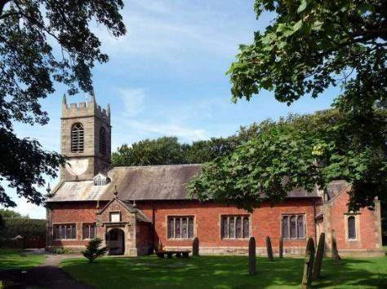
St. Michael and All Angels – Hoole

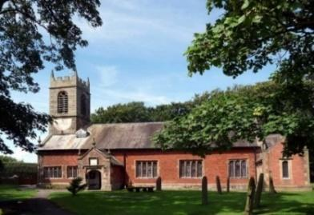

Welcome to our church again this morning. We continue to welcome new friends and welcome back others.

Sunday 11th July 2021 Trinity 6

GOD’S COMFORT, STRENGTH AND REST.

“Comfort, comfort my people - - - - those who hope in the Lord will renew their strength - - - - they will run and not grow weary, they will walk and will not be faint.” Isaiah 40: v 1 & 31.

PRAYER OF THE DAY: Creator God, you made us all in your
image: may we discern you in all that we see, and serve you in all that
we do; through Jesus Christ our Lord. Amen.

Sunday School today during the service
There are toys for younger children
at the back of church.

9.00am. Holy Communion (Book of Common Prayer) begins p237

10.30am. Morning Worship.

Readings: Isaiah 40: v 1,2,11 and v 25 to end.
Matthew 11: v 28-30.

Hymns : 489 – O God beyond all praising.
Children’s song (screen) – Why don’t you put your trust in Jesus
(tune – Match of the day) also Chariots of Fire theme tune video.
219 – God is our strength and refuge.
Supp. 2 – How deep the Father’s love for us.
70 – Be thou my vision.

12.00 noon. Baptism of Bella Smith

BIBLE READINGS: Isaiah 40: v 1,2,11 and v 25 to end.

Comfort, comfort my people, says your God. Speak tenderly to Jerusalem, and proclaim to her that her hard service has been completed, that her sin has been paid for, that she has received from the Lord’s hand double for all her sins.

He tends his flock like a shepherd: he gathers the lambs in his arms and carries them close to his heart; he gently leads those that have young.

‘To whom will you compare me? Or who is my equal?’ says the Holy One.
Lift up your eyes and look to the heavens: who created all these? He who brings out the starry host one by one and calls forth each of them by name. Because of his great power and mighty strength, not one of them is missing. Why do you complain Jacob? Why do you say, Israel. My way is hidden from the Lord; my cause is disregarded by my God’? Do you not know? Have you not heard? The Lord is the everlasting God, the Creator of the ends of the earth. He will not grow tired or weary, and his understanding no one can fathom. He gives strength to the weary
and increases the power of the weak. Even youths grow tired and weary, and young men stumble and fall; but those who hope in the Lord will renew their strength.
They will soar on wings like eagles; they will run and not grow weary, they will walk and not be faint.

Matthew 11: v 28-30.

‘Come to me, all you who are weary and burdened, and I will give you rest.
Take my yoke upon you and learn from me, for I am gentle and humble in heart, and you will find rest for your souls. For my yoke is easy and my burden is light.’

Prayer. We pray for RUNING THE RACE - our special community event for the whole church Family with Bishop Philip on 18th July at 2.30pm and pray that many will be encouraged to come along.
We give thanks for the planning permission for our much needed Lodge in the churchyard and pray for the PCC as they discuss how to find the money for this exciting new venture which is essential for the growth of our church.
We pray for the parents of Bella Smith and Elodie Hesketh. preparing for Baptism today and on 25th July. We pray for Rachel Johnson and John Wilson preparing for marriage on 24th July
We pray for those who are sick, especially Baby Erica Ivy, Patricia Mortimer, Bill and Beryl Carr, Nick Slinger, Alan Fleetwood, Nicola Middleton, Anthony Brogden and Josephine Hodge. We give thanks for the life of Peter Blakeley and Michael Watkins and pray for their families and friends.
REFRESHMENTS AFTER 10.30 SERVICE
Volunteers needed for rota. Please let Barbara Wood know if you can help. bw12252@hotmail.com
FORTNIGHTLY AND BIBLE STUDIES AND PRAYER TIMES CONTINUE
Prayer time continues from 10.15 am to 10.45am in church
on Tuesday July 13th.
Join us for Bible Study on Monday 19th July 7.30pm by Zoom
and Tuesday 20th July 7.30pm in Church with Compline
We continue looking at Paul’s 1st letter to the Thessalonians chapter 4-5
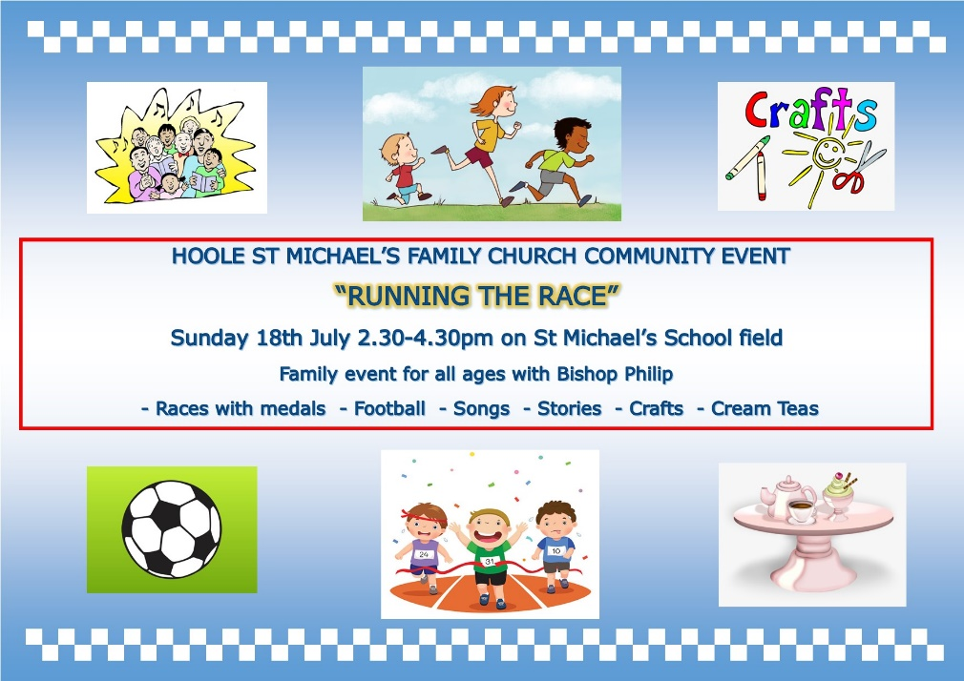

Village Hall. Grand Opening 31st July 10.am onwards by the Mayor of South Ribble, Cllr Jane Bell.All welcome. Fair ground, stalls, food etc. The Ladies Group will be having a Tombola Stall. Please put donations of prizes in the plastic box near font
After the official opening many of the regular events will then be able to resume, amongst these will be the very popular twice monthly “Local’s Lunch”, the first of which will be held on August 12th.

