PARISH DATES
Monday 17th July 7.30pm Bible for Beginners 3 in the Lodge
Tuesday 18th July 10.15am Holy Communion in the Lodge.
Wednesday 19th July 9.30am-11.30am ST MICHAEL’S LITTLE ANGELS
Thursday 20th July 2.00pm St Michael’s School Leavers Service
SCHOOL RE-STARTS MONDAY 4th SEPTEMBER
Sunday 23rd July 9.00am Holy Communion
10.30am Morning Worship with Sunday School
SUNDAY SCHOOL BEFORE THE SUMMER BREAK
Tuesday 25th July 10.15am Holy Communion in the Lodge.
3.30pm Funeral Service of Brenda Collins
Sunday 30th July 9.00am Holy Communion
10.30am Parish Communion
Monday 31st July 7.30pm PCC Meeting in the Lodge.
Tuesday 1st August 10.15am Holy Communion in the Lodge.
Sunday 6th August 9.00am Holy Communion
10.30am Parish Communion*
Tuesday 8th August 10.15am Morning Worship in the Lodge.
Sunday 13th August 9.00am Holy Communion
10.30am Morning Worship*
* No official Sunday School during August, but there will be informal children’s
activities in the lodge during Sermon and Prayers.

FUTURE DATES FOR YOUR DIARY:
SEPTEMBER 10th 3.45pm - Hogwarts Church
SEPTEMBER 17TH 3.30pm – Celebration of Marriage Service Bishop Jill Duff
SEPTEMBER 29th 7.00pm - Harvest Social and Quiz – Village Hall
OCTOBER 1st 10.30am- Harvest Thanksgiving Service
NOVEMBER 5th 6.00pm - Service of Thanksgiving for Loved Ones
NOVEMBER 11th 10.00 - 2.00 – Parish Quiet Day at Whalley Abbey with Archdeacon Mark

Suggested Bible Readings for this week:
Monday 17th July Matt. 10: v 34 to 11: v1. Tuesday 18th July Matt. 11: v 20-24.
Wed. 19th July Matt. 11: v 25-27. Thursday 20th July Matt. 11: v 28-end.
Friday 21st July Matt. 12: v 1-8. Saturday 22nd July John 20: v 1-2 & 11-18.

www.hooleparishchurch.com Facebook : St Michael and All Angels Church, Hoole,
Rector Ann Templeman anntempleman@live.co.uk 01772 448515 or 07877659156
PLEASE TAKE THIS SHEET HOME WITH YOU.
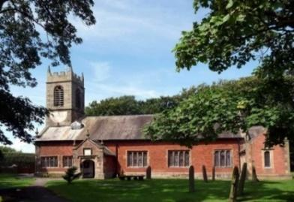
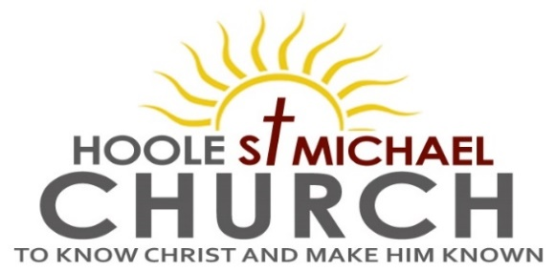

Welcome to our Church today.
Please stay for refreshments in the Lodge which follow the 10.30am service

Sunday 16th July 2023

NOTHING CAN SEPARATE US FROM THE LOVE OF CHRIST.

“Rejoice with me; I have found my lost sheep”. (Luke 15 v 6).

PRAYER OF THE DAY Merciful God, you have prepared for
those who love you such good things as pass our understanding: pour
into our hearts such love toward you that we, loving you in all things
and above all things, may obtain your promises, which exceed all that
we can desire; through Jesus Christ your Son our Lord, who is alive
and reigns with you, in the unity of the Holy Spirit, one God, now and
for ever. Amen.

Sunday School today during the service.
There are toys and colouring sheets for younger children
at the back of church.

9.00am. Holy Communion (Book of Common Prayer) begins p237

10.30am. Parish Communion with Sunday School and the Baptism of Francesca and Harry Sutton.
Readings: Isaiah 53 v 6 Romans 8: v 37-39 Luke 15: v 3-7
Hymns: Suppl. 5 – Bless the Lord O my soul.
Screen – God loves me.
25 – All things bright and beautiful (first and last verses only)
Yet not I but through Christ in me.
Screen – Bring to the Lord. (Tune – Jerusalem)
H/C Hymns: 620 – Such Love. Suppl. 2 – How deep the Father’s love.
Reading 1: Isaiah 53 v 6 We all, like sheep, have gone astray, each of us has turned to his own way; And the Lord has laid on Him the iniquity of us all.
Reading 2: Romans 8: v 37-39. No, in all these things we are more than conquerors through him who loved us. For I am convinced that neither death nor life, neither angels nor demons, neither the present nor the future, nor any powers, neither height nor depth, nor anything else in all creation, will be able to separate us from the love of God that is in Christ Jesus our Lord.

Reading 3 Luke 15: v 3-7. Jesus told them this parable: ‘Suppose one of you has a hundred sheep and loses one of them. Doesn’t he leave the ninety-nine in the open country and go after the lost sheep until he finds it? And when he finds it, he joyfully puts it on his shoulders and goes home. Then he calls his friends and neighbours together and says, “Rejoice with me; I have found my lost sheep.”
I tell you that in the same way there will be more rejoicing in heaven over one sinner who repents than over ninety-nine righteous people who do not need to repent.

Prayer: We pray for Francesca and Harry being baptised today and for Jason and Hayley who were married yesterday. We pray for those who are sick especially Erica Ivy, Peter Eckersley, Daniel Conner, Jean Smallwood, Elaine Cowburn, Shirley Rainsbury, Bill and Beryl Carr. We give thanks for the life of Brenda Collins, and we pray for her family and friends

OUR AIMS : ‘TO KNOW CHRIST AND MAKE HIM KNOWN’
Please fill in the questionnaire about how we can help you deepen your own spiritual life and share your faith with others.
BIBLE FOR BEGINNERS
SESSION 3 MONDAY 17TH JULY 7.30 in the Lodge
Planning meeting for Little Angels
in August (16th 11am) in the Lodge
Little Angels has had a wonderful start with Toddlers, Babies and Carers
We are appealing now for more helpers to come on a rota on Wed mornings for the session. If anyone is interested please let us know and come along.
Thanks Mandy and Jenny

