Parish Dates From July 2022
Tuesday 19th July 10.15am Morning Prayer in church.
Friday 22nd July 3.00pm Wedding of Michael Orritt and Kelly Ross.

Sunday 24th July 9.00am Holy Communion
10.30am Morning Worship with Sunday School.
12.noon Baptism of Michael & Kelly Orritt’s children
Monday 25th July 7.30pm PCC meeting in the Village Hall.
Tuesday 26th July 10.15am Holy Communion
4.00pm Parish Walk from Blue Anchor pub Bretherton. Pub supper
Saturday 30th July 1.30pm Marriage Blessing of Emma Duxbury and
Howard Aspinall.
Sunday 31st July 9.00am Holy Communion
10.30am Parish Communion
Tuesday 2nd August 10.15am Holy Communion/Morning Prayer

Sunday 7th August 9.00am Holy Communion
10.30am Parish Communion*
4.00pm Holy Communion Old Mill Court
Tuesday 9th August 10.15am Morning Prayer in church.

Sunday 14th August 9:00am Holy Communion
10.30am Morning Worship*
Tuesday 16th August 10.15am Morning Prayer in church.
1.00pm Ladies Group trip to Lytham Hall.

Sunday 21st August 9.00am Holy Communion
10.30am All Age Worship
Tuesday 23rd August 10.15am Morning Prayer in church.

Sunday 28th August 9.00am Holy Communion
10.30am Parish Communion*
Tuesday 30th August 10.15am Holy Communion in church.

*No Sunday school as such but some children’s activities during the service.
Sunday School begins again Sunday September 4th.
Suggested Bible readings this week.
Monday 18th July. Matt. 12: v 38-42. Tuesday 19th July. Matt. 12: v 46-end.
Wed. 20th July. Matt. 13: v 1-9. Thursday 21st July. Matt. 13: v 10-17.
Friday 22nd July. John.20: v 1-2 & 11-18. Saturday23rd July. Matt. 13: v 24-30.

Website : www.hooleparishchurch.com
Facebook page: St Michael and All Angels Church, Hoole,
Rector – Revd Ann Templeman anntempleman@live.co.uk 01772 448515
Please take this sheet home with you
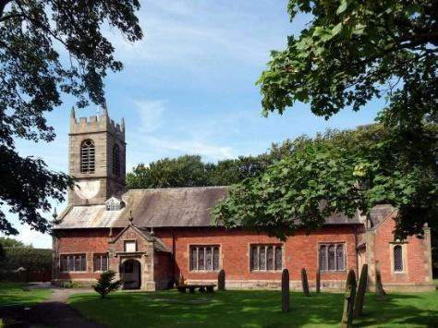
St. Michael and All Angels – Hoole

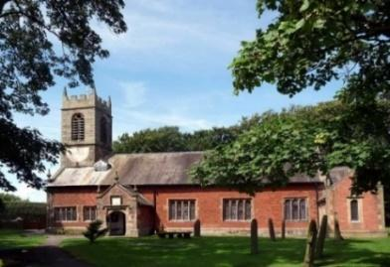

Welcome to our church this morning. Please stay for a chat and a cup of tea or coffee after the 10.30 service- a great way to meet people

Sunday 17th July 2022
CHRISTIAN COMMITMENT
“Remain in my love” John 15:v 9
“Do this in remembrance of me” 1 Corinthians 11: v 24.
First Communion for those newly Confirmed
Reception into the Church of England of Barry McManmon

PRAYER OF THE DAY:Almighty God, send down upon your
Church the riches of your Spirit, and kindle in all who minister the
Gospel your countless gifts of grace; through Jesus Christ our Lord.
Amen.
Sunday School today
Liz will be taking out younger children during the sermon and prayers
Forest Church at 3.45pm on the School field

.

9.00am. Holy Communion (Book of Common Prayer) begins p237

10.30am. Parish Communion (First Communion for recently confirmed)

Readings: 1 Corinthians 11: v 23-39. John 15: v 1-9.

Hymns: 672 – Thine be the glory.
411 – Lord Jesus Christ.
332 – I, the Lord of sea and sky.
H/C Hymns: Suppl. 4 – The Power of the Cross 87 – Broken for me.
READINGS: 1 Corinthians 11: v 23-39. For I received from the Lord what I also passed on to you: the Lord Jesus, on the night he was betrayed, took bread, and when he had given thanks, he broke it and said, ‘This is my body, which is for you; do this in remembrance of me.’ In the same way, after supper he took the cup, saying, ‘This cup is the new covenant in my blood; do this, whenever you drink it, in remembrance of me.’ For whenever you eat this bread and drink this cup, you proclaim the Lord’s death until he comes.
So then, whoever eats the bread or drinks the cup of the Lord in an unworthy manner will be guilty of sinning against the body and blood of the Lord. Everyone ought to examine themselves before they eat of the bread and drink from the cup. For those who eat and drink without discerning the body of Christ eat and drink judgment on themselves.

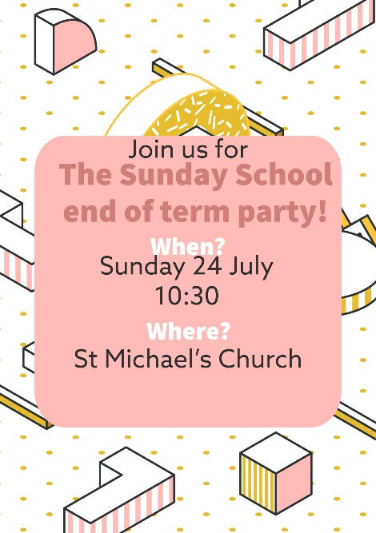
John 15: v 1-9. ‘I am the true vine, and my Father is the gardener. He cuts off every branch in me that bears no fruit, while every branch that does bear fruit he prunes so that it will be even more fruitful. You are already clean because of the word I have spoken to you. Remain in me, as I also remain in you. No branch can bear fruit by itself; it must remain in the vine. Neither can you bear fruit unless you remain in me.
‘I am the vine; you are the branches. If you remain in me and I in you, you will bear much fruit; apart from me you can do nothing. If you do not remain in me, you are like a branch that is thrown away and withers; such branches are picked up, thrown into the fire and burned. If you remain in me and my words remain in you, ask whatever you wish, and it will be done for you. This is to my Father’s glory, that you bear much fruit, showing yourselves to be my disciples.
‘As the Father has loved me, so have I loved you. Now remain in my love.
Prayer: We pray for Barry McManmon, being received into the Church of England today and for all those confirmed last Sunday and taking their first communion today. We pray for Michael and Kelly who are to be married here next Friday. We pray for those who are sick, especially Erica Ivy, Rose Brown, Isobel Wooldridge, Beryl Cottam, Tom Parkinson, Steve Coughlan, Josephine Hodge, Bill and Beryl Carr. We give thanks for the lives of Anne Scott and Neil Dexter and pray for their families and friends.
PARISH WALK
Tuesday 26th July
Meet 4.00pm Blue Anchor Car Park Bretherton
Pub Supper 5.30pm Names to Colin Wilson in church or ring 616978 . Suitable for all ages. Please join us

BIBLE STUDY/ HOUSEGROUP at the Rectory
Monday 18th July- 1 John 5: v 11 - end.
