Parish Dates July 2021 onwards
Monday July 12th 7.30pm Bible Study by Zoom.
Tuesday 20th July 2.00pm Year 6 Leavers’ Service in Church.
7.30pm Bible Study in Church with Compline.
Saturday July 24th 1.30pm – Marriage of John Wilson and Rachel Johnson.
Sunday July 25th 09.00am Holy Communion in Church
10.30am Morning Worship in Church
12 noon Baptism of Elodie Hesketh
Tuesday July 27th 10.15 – 10.45am Prayer time in Church
Saturday July 31st from 10.30am Grand Opening of New Village Hall
Sunday August 1st 09.00am Holy Communion in Church
10.30am Parish Communion in Church
Sunday August 8th 09.00am Holy Communion in Church
10.30am Morning Worship in Church
Thursday August 12th from 11.30am Locals’ Lunch in New Village Hall
Sunday August 15th 09.00am Holy Communion in Church
10.30am Parish Communion in Church
Saturday August 21st Marriage of Liam Greenwood and Amy Woolam.
Sunday August 22nd 09.00am Holy Communion in Church
10.30am Morning Worship in Church
Thursday August 26th from 11.30am Locals’ Lunch in New Village Hall
Sunday August 29th 09.00am Holy Communion in Church
10.30am Parish Communion in Church

Key Future Dates SAVE THE DATE Harvest Festival and Social
Friday Oct 1st 7.00pm Harvest Supper & Parish Social with Quiz
and Entertainment in the New Village Hall.
Sunday Oct 3rd 10.30am HARVEST FESTIVAL

All the above services are ‘Live’ in church
We will aim to have audio recordings of all 10.30 services on the website www.hooleparishchurch.com by Sunday lunch time.
The Zoom link for all church Zoom activities is on the front of website.
Our Facebook page: St Michael and All Angels Church, Hoole,
Rector – Revd Ann Templeman anntempleman@live.co.uk 01772 448515
The Rectory, 69 Liverpool Old Road Much Hoole PR4 4RB
Please take this sheet home with you
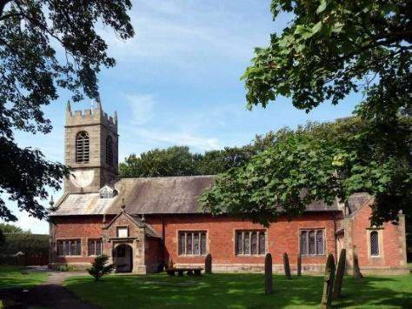
St. Michael and All Angels – Hoole

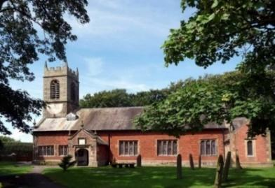

Welcome to our church again this morning. We continue to welcome new friends and welcome back others.

Sunday 18th July 2021 Trinity 7

THE SERVANT OF THE LORD.

“Here is my Servant, whom I uphold, my chosen one
in whom I delight” Isaiah 42: v 1.

PRAYER OF THE DAY: Generous God, you give us gifts and make them
grow: though our faith is small as mustard seed, make it grow to your glory
and the flourishing of your kingdom; through Jesus Christ our Lord. Amen.

No Sunday School today during the service
There are toys for younger children
at the back of church.

9.00am. Holy Communion (Book of Common Prayer) begins p237

10.30am. Parish Communion.

Readings: Isaiah 42: v 1-9. Matthew 12: v 15-21.

Hymns: 205 – Glorious things of thee are spoken (tune 1)
448 – Meekness and Majesty.
195 – From heaven you came.
137 – Crown him with many crowns (omit v 2)
H/C Hymn 310 – I heard the voice of Jesus say. (tune 1)

2.30PM – 4.30PM FAMILY CHURCH COMMUNITY EVENT WITH
ALL AGE SERVICE WITH BISHOP PHILIP.
Hymns: Give me joy in my heart (Sing Hosannah),
God loves me I want to shout it out (on CD),
Why don’t you put your trust in Jesus. (tune – Match of the day)
BIBLE READINGS: Isaiah 42: v 1-9. ‘Here is my servant, whom I uphold, my chosen one in whom I delight; I will put my Spirit on him, and he will bring justice to the nations. He will not shout or cry out, or raise his voice in the streets. A bruised reed he will not break, and a smouldering wick he will not snuff out. In faithfulness he will bring forth justice; he will not falter or be discouraged till he establishes justice on earth. In his teaching the islands will put their hope.’ This is what God the Lord says – the Creator of the heavens, who stretches them out, who spreads out the earth with all that springs from it, who gives breath to its people, and life to those who walk on it: ‘I, the Lord, have called you in righteousness; I will take hold of your hand. I will keep you and will make you to be a covenant for the people and a light for the Gentiles, to open eyes that are blind, to free captives from prison and to release from the dungeon those who sit in darkness.
‘I am the Lord; that is my name! I will not yield my glory to another or my praise to idols. See, the former things have taken place, and new things I declare;
before they spring into being I announce them to you.’

Matthew 12: v 15-21. Aware of this, Jesus withdrew from that place. A large crowd followed him, and he healed all who were ill. He warned them not to tell others about him. This was to fulfil what was spoken through the prophet Isaiah:
“Here is my servant whom I have chosen, the one I love, in whom I delight; I will put my Spirit on him, and he will proclaim justice to the nations. He will not quarrel or cry out; no one will hear his voice in the streets. A bruised reed he will not break, and a smouldering wick he will not snuff out, till he has brought justice through to victory. In his name the nations will put their hope.”[
Prayer. We pray for RUNNING THE RACE - our special community event for the whole church Family with Bishop Philip this afternoon at 2.30pm and pray that many will be encouraged to come along.
We give thanks for the planning permission for our much needed Lodge in the churchyard and pray that we will be able to find the money for this exciting new venture which is essential for the growth of our church.
We give thanks for the baptism of Bella Smith last Sunday, we pray for her parents and the parents of Elodie Hesketh. preparing for Baptism on 25th July.
We pray for Rachel Johnson and John Wilson preparing for marriage on 24th July
We pray for those who are sick, especially Baby Erica Ivy, Patricia Mortimer, Bill and Beryl Carr, Nick Slinger, Alan Fleetwood, Nicola Middleton, Anthony Brogden and Josephine Hodge. We give thanks for the life of Michael Watkins and pray for his family and friends.
REFRESHMENTS AFTER 10.30 SERVICE
Volunteers needed for rota. Please let Barbara Wood know if you can help. bw12252@hotmail.com
FORTNIGHTLY BIBLE STUDIES AND PRAYER TIMES CONTINUE
Join us for Bible Study on Monday 19th July 7.30pm by Zoom
and Tuesday 20th July 7.30pm in Church with Compline
We will be looking at Paul’s 1st letter to the Thessalonians chapter 4-5 Prayer time 10.15 -10.45am in church Tuesday July 27th.
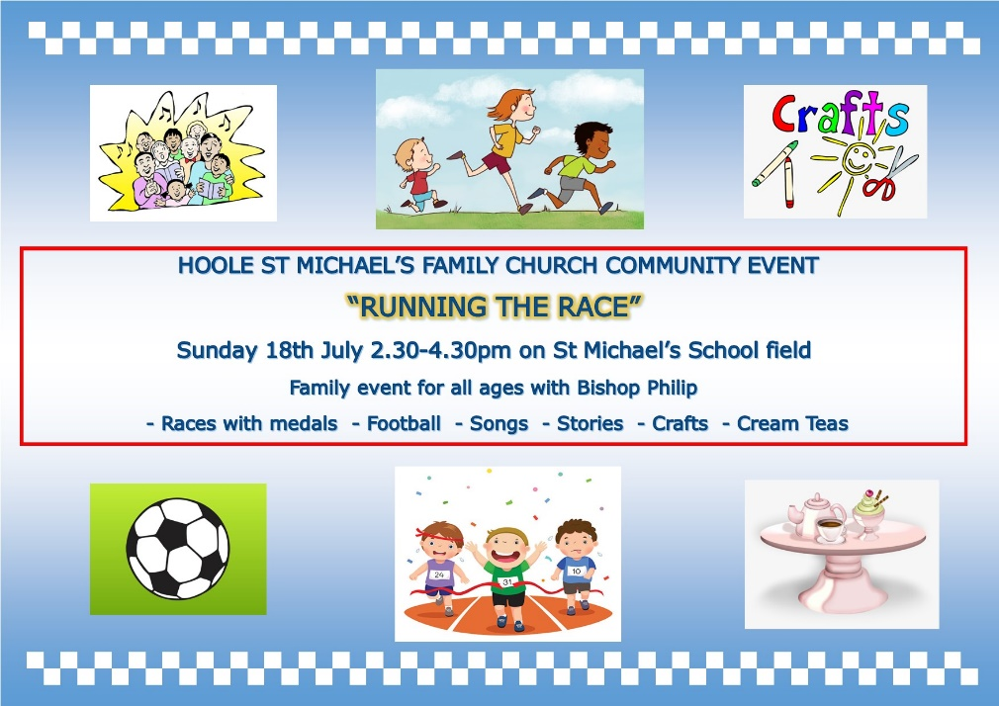

Village Hall. Grand Opening 31st July 10.30am onwards by the Mayor of South Ribble, Cllr Jane Bell.All welcome. Fair ground, stalls, food etc. The Ladies Group will be having a Tombola Stall. Please put donations of prizes in the plastic box near font
After the official opening many of the regular events will then be able to resume, amongst these will be the very popular twice monthly “Local’s Lunch”, the first of which will be held on August 12th.

