PARISH DATES
Monday 22nd July 7.00pm Bible for Beginners in the Lodge.
SOCIAL with clips from THE CHOSEN –please note earlier time
Tuesday 23rd July 10.15am Holy Communion in the Lodge
Sunday 28th July 9.00am Holy Communion
10.30am Morning Worship
5.00pm Pizza & Praise in Church and Lodge.
Tuesday 30th July 10.15am Holy Communion in the Lodge
Sunday 4th August 9.00am Holy Communion
10.30am Parish Communion
4.00pm Holy Communion (Old Mill Court)
Monday 5th August 2.30pm Holy Communion Service at Ribble Court.
Tuesday 6th August 10.15am Holy Communion in the Lodge
Sunday 11th August 9.00am Holy Communion
10.30am Morning Worship & Prayer for Healing
Tuesday 13th August 10.15am Holy Communion in the Lodge
Saturday 17th August 1.30pm THE CELEBRATION OF THE MARRIAGE
OF CAROL SALISBURY & HUGH DENT
Sunday 18th August 9.00am Holy Communion
10.30am Parish Communion.
Tuesday 20th August 10.15am Holy Communion in the Lodge

FUTURE IMPORTANT PARISH DATES 2024
Sunday 1st September 6.00pm – 7.00pm. Public meeting in Venue
re developments in Hoole and St Michael’s Church
Wednesday 4th Sept. 9.30am-11.00am. St Michael’s Little Angels Restarts.
Monday 9th Sept. 7.30pm-9.30pm Alpha Course starts in the Village Hall
Monday 23rd Sept. 7.00-8.30pm Alpha Course continues in the Lodge.
Friday 27th Sept. 7.00pm Harvest Social with Ann & Peter’s Farewell in the Village Hall
Sunday 29th Sept. 10.30am Harvest Thanksgiving – Ann & Peter’s Farewell Service.

Suggested Bible readings for this week:
Monday 22nd July John 20: v 1-2 & 11-18. Tuesday 23rd July Matt. 12: v 46-end.
Wednesday 24th July Matt. 14: v 1-9. Thursday 25th July Matt. 20: v 20-28.
Friday 26th July Matt. 13: v 18-23. Saturday 27th July Matt. 13: v 24-30.

www.hooleparishchurch.com Facebook : St Michael and All Angels Church, Hoole,
Rector Ann Templeman anntempleman@live.co.uk 01772 448515 or 07877659156
PLEASE TAKE THIS SHEET HOME WITH YOU.
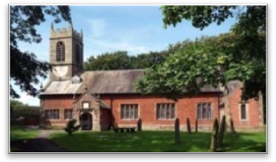
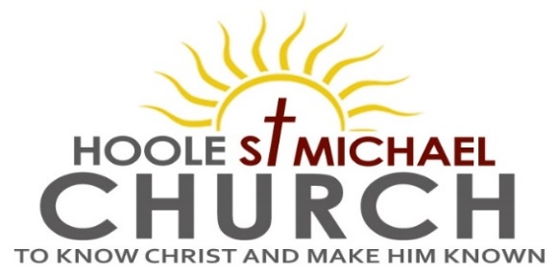

Welcome to our Church today.
Please stay for refreshments in the Lodge which follow the 10.30am service.

Sunday 21st July 2024

GOD’S PROTECTING LOVE

I will say of the Lord, “He is my refuge and my fortress,
my God in whom I trust. (Psalm 91: v 2)

PRAYER OF THE DAY Lord God, your Son left the riches of heaven and became poor for our sake: when we prosper save us from pride, when we are needy save us from despair, that we may trust in you alone; through Jesus Christ our Lord. Amen.

No Sunday School today during the service.
Cream Tea Church at St. Michael’s School at 3.00pm.
Toys/colouring sheets for younger children at the back of church.

9.00am. Holy Communion (Book of Common Prayer p237)

10.30am. Parish Communion.
Readings: Romans 8: v 35 & 37-39.
Psalm 91. (to be read together)

Hymns: Suppl. 5 – Bless the Lord O my soul.
Screen – Safe in the shadow.
219 – God is our strength and refuge.
177 – For all the Saints. (omit verses 4 & 6).
H/C Hymns: Screen – Here is love, vast as the ocean.
658 – There is a Redeemer.

3.00pm. Cream Tea Church at St Michael’s School
with a 1966 World Cup Replay Match.
Reading1: More than Conquerors. Romans 8: v35 & 37-39.
Who shall separate us from the love of Christ? Shall trouble or hardship or persecution or famine or nakedness or danger or sword?
No, in all these things we are more than conquerors through him who loved
us. For I am convinced that neither death nor life, neither angels nor demons, neither the present nor the future, nor any powers, neither height nor depth, nor anything else in all creation, will be able to separate us from the love of God that is in Christ Jesus our Lord.

Reading 2: Psalm 91. (read together)
Whoever dwells in the shelter of the Most High will rest in the shadow of the
Almighty.
I will say of the Lord, ‘He is my refuge and my fortress, my God, in whom I trust.’
Surely he will save you from the fowler’s snare and from the deadly pestilence.
He will cover you with his feathers, and under his wings you will find refuge;
his faithfulness will be your shield and rampart.
You will not fear the terror of night, nor the arrow that flies by day, nor the
pestilence that stalks in the darkness, nor the plague that destroys at midday.
A thousand may fall at your side, ten thousand at your right hand,
but it will not come near you.
You will only observe with your eyes and see the punishment of the wicked.
If you say, ‘The Lord is my refuge,’ and you make the Most High your dwelling, no harm will overtake you, no disaster will come near your tent.
For he will command his angels concerning you to guard you in all your ways;
they will lift you up in their hands, so that you will not strike your foot against a
stone.
You will tread on the lion and the cobra; you will trample the great lion and the
serpent.
‘Because he loves me,’ says the Lord, ‘I will rescue him; I will protect him, for he
acknowledges my name. He will call on me, and I will answer him;
I will be with him in trouble, I will deliver him and honour him.
With long life I will satisfy him and show him my salvation.’

Prayer: We pray for a successful response to our Giving in Grace campaign and the appointment of a new Rector. We continue to pray for all those currently affected by the conflicts and natural disasters in the troubled areas of the world. We pray for a successful Cream Tea Church this afternoon. We pray for the sick, especially Beryl Carr, Jim Ashcroft, Jean Smallwood, Sue Meadows, Judith Stopford and Elaine Read.

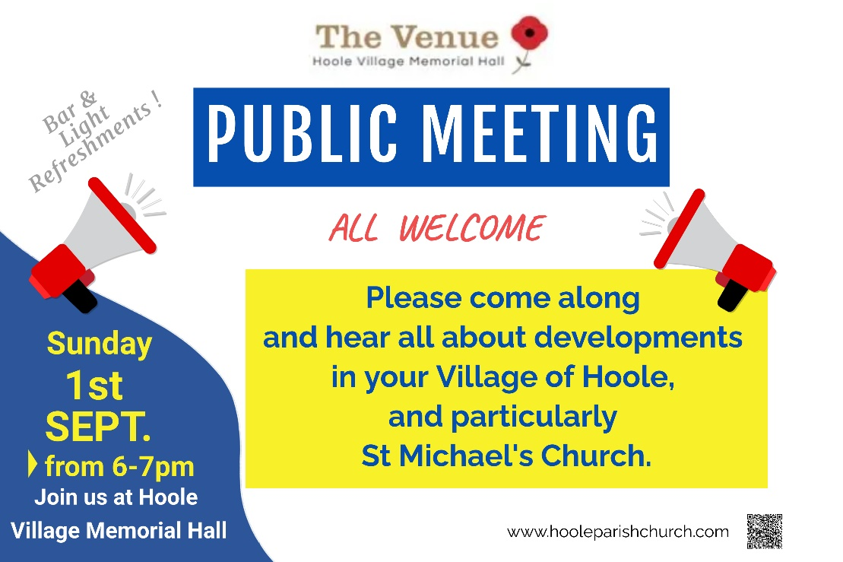


PRAY FOR OUR CHURCH
Please come and join us for Prayer for the future of our church on Tuesdays in the Lodge at 10.15 during our service of Holy Communion

