PARISH DATES
Tuesday 25th July 10.15am Holy Communion in the Lodge.
3.30pm Funeral Service of Brenda Collins

Sunday 30th July 9.00am Holy Communion
10.30am Parish Communion
Tuesday 1st August 10.15am Holy Communion in the Lodge.

Sunday 6th August 9.00am Holy Communion
10.30am Parish Communion*
Tuesday 8th August 10.15am Morning Worship in the Lodge.

Sunday 13th August 9.00am Holy Communion
10.30am Morning Worship*
Tuesday 15th August 10.15am Morning Worship in the Lodge.
Wednesday 16th August 11.00am Toddler Planning Meeting

Sunday 20th August 9.00am Holy Communion
10.30am Morning Worship*
Tuesday 22nd August 10.15am Morning Worship in the Lodge.

Sunday 27th August 9.00am Holy Communion
10.30am Parish Communion*
Tuesday 29th August 10.15am Holy Communion in the Lodge.

* No official Sunday School during August, but there will be informal children’s
activities in the lodge during Sermon and Prayers.

FUTURE DATES FOR YOUR DIARY:
SEPTEMBER 10th 3.45pm - Hogwarts Church
SEPTEMBER 17TH 3.30pm – Celebration of Marriage Service Bishop Jill Duff
SEPTEMBER 29th 7.00pm - Harvest Social and Quiz – Village Hall
OCTOBER 1st 10.30am- Harvest Thanksgiving Service
NOVEMBER 5th 6.00pm - Service of Thanksgiving for Loved Ones
NOVEMBER 11th 10.00 - 2.00 – Parish Quiet Day at Whalley Abbey with Archdeacon Mark

Suggested Bible Readings for this week:
Monday 24th July Matt. 12: v 38-42. Tuesday 25th July Matt. 20: v 20-28.
Wed. 26th July Matt. 13: v 1-9. Thursday 27th July Matt. 13: v 10-17.
Friday 28th July Matt. 13: v 18-23. Saturday 29th July Matt. 13: v 24-30.

www.hooleparishchurch.com Facebook : St Michael and All Angels Church, Hoole,
Rector Ann Templeman anntempleman@live.co.uk 01772 448515 or 07877659156
PLEASE TAKE THIS SHEET HOME WITH YOU.
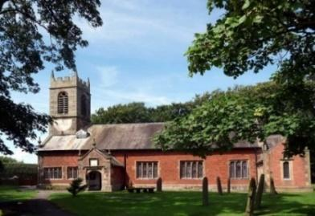
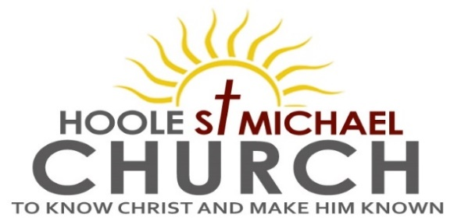

Welcome to our Church today.
Please stay for refreshments in the Lodge which follow the 10.30am service

Sunday 23rd July 2023

SHAKEN AND STIRRED.

“Then I saw a new Heaven and a new earth . . . God Himself will wipe away
every tear from their eyes. There will be no more death”. (Revelation 21).

PRAYER OF THE DAY Generous God, you give us gifts and
make them grow: though our faith is small as mustard seed, make it
grow to your glory and the flourishing of your kingdom; through
Jesus Christ our Lord. Amen.

Sunday School today during the service.
There are toys and colouring sheets for younger children
at the back of church.

9.00am. Holy Communion (Book of Common Prayer) begins p237

10.30am. Morning Worship with Sunday School
Readings: Haggai 2: v 1-9.
Revelation 21: v 1-4 & 22.
Hymns: 450 – Morning has broken.
Screen – All through history.
Canticle 1 – God we praise You.
Suppl. 3 – Before the throne of God above.
555 – Peace, perfect peace.
205 – Glorious things of Thee are spoken (omit v 3).

SHAKEN AND STIRRED!!
Reading 1: Haggai 2: v 1-9. On the twenty-first day of the seventh month, the word of the Lord came through the prophet Haggai: ‘Speak to Zerubbabel governor of Judah, to Joshua the high priest, and to the remnant of the people. Ask them, “Who of you is left who saw this house in its former glory? How does it look to you now? Does it not seem to you like nothing? But now be strong, Zerubbabel,” declares the Lord. “Be strong, Joshua , the high priest. Be strong, all you people of the land,” declares the Lord, “and work. For I am with you. “This is what I covenanted with you when you came out of Egypt. And my Spirit remains among you. Do not fear.”
‘This is what the Lord Almighty says: “In a little while I will once more shake the heavens and the earth, the sea and the dry land. I will shake all nations, and what is desired by all nations will come, and I will fill this house with glory,” says the Lord Almighty. “The silver is mine and the gold is mine,” declares the Lord Almighty. “The glory of this present house will be greater than the glory of the former house,” says the Lord Almighty. “And in this place I will grant peace,” declares the Lord Almighty.’

Reading 2: Revelation 21: Then I saw ‘a new heaven and a new earth,’ for the first heaven and the first earth had passed away, and there was no longer any sea. I saw the Holy City, the new Jerusalem, coming down out of heaven from God, prepared as a bride beautifully dressed for her husband. And I heard a loud voice from the throne saying, ‘Look! God’s dwelling-place is now among the people, and he will dwell with them. They will be his people, and God himself will be with them and be their God. “He will wipe every tear from their eyes. There will be no more death” or mourning or crying or pain, for the old order of things has passed away.’
I did not see a temple in the city, because the Lord God Almighty and the Lamb are its temple……. Only those whose names are written in the Lamb’s book of Life will enter the city.

Prayer: We pray for all those away on holiday at this time. We pray for those who are sick especially Erica Ivy, Daniel Conner, Jean Smallwood, Elaine Cowburn, Shirley Rainsbury, Bill and Beryl Carr. We give thanks for the life of Brenda Collins and pray for her family and friends.

Planning meeting for Little Angels
in August (16th 11am) in the Lodge
Little Angels has had a wonderful start with Toddlers, Babies and Carers
We are appealing now for more helpers to come on a rota on Wed. mornings for the session. If anyone is interested please let us know and come along.
Thanks Mandy and Jenny

