Parish Dates From July 2022
Monday 25th July 7.30pm PCC meeting in the Village Hall.
Tuesday 26th July 10.15am Holy Communion
4.00pm Parish Walk from Blue Anchor pub
Bretherton with Pub supper
Saturday 30th July 1.30pm Marriage Blessing of Emma Duxbury and
Howard Aspinall.
Sunday 31st July 9.00am Holy Communion
10.30am Parish Communion
Tuesday 2nd August 10.15am Holy Communion/Morning Prayer

Sunday 7th August 9.00am Holy Communion
10.30am Parish Communion*
4.00pm Holy Communion Old Mill Court
Tuesday 9th August 10.15am Morning Prayer in church.

Sunday 14th August 9:00am Holy Communion
10.30am Morning Worship*
Tuesday 16th August 10.15am Morning Prayer in church.
1.00pm Ladies Group trip to Lytham Hall.

Sunday 21st August 9.00am Holy Communion
10.30am All Age Worship
Tuesday 23rd August 10.15am Morning Prayer in church.

Sunday 28th August 9.00am Holy Communion
10.30am Parish Communion*
Tuesday 30th August 10.15am Holy Communion in church.
* No Sunday School as such, but some children’s activities during the service.
Sunday School begins again Sunday September 4th.

SOME IMPORTANT DATES FOR YOUR DIARY;
1.Sunday 18th September 10.30am: Opening of the Lodge
Celebration service, Opening by Archdeacon Mark.
Refreshments BBQ and children’s activities
2.Fri 30th Sept 7pm Harvest Supper & Quiz Village Hall
3.Sun 2nd Oct 10.30am Harvest Festival & Gift Day

Website : www.hooleparishchurch.com
Facebook page: St Michael and All Angels Church, Hoole,
Rector – Revd Ann Templeman anntempleman@live.co.uk 01772 448515

SOPlease take this sheet home with you
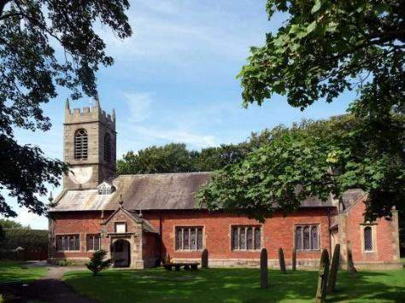
St. Michael and All Angels – Hoole

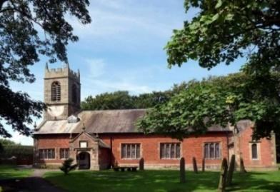

Welcome to our church this morning. Please stay for a chat and a cup of tea or coffee after the 10.30 service- a great way to meet people

Sunday 24th July 2022

THE PRAYER OF DANIEL

O Lord, listen. O Lord, forgive. O Lord, give heed and act. Daniel 9: v 19.

PRAYER OF THE DAY: Creator God, you made us all in your image:
may we discern you in all that we see, and serve you in all that we do;
through Jesus Christ our Lord. Amen.

Sunday School today during the service
with End of Term Party
There are toys and colouring sheets
for younger children at the back of church.

9.00am. Holy Communion (Book of Common Prayer) begins p237

10.30am. Morning Worship with Sunday School.

Readings: Daniel 9: v 1-11a.
Daniel 9: v 11b-19.

Hymns: 450 – Morning has broken.
Screen – Godsuit.
144 – Dear Lord and Father of mankind.
727 – What a friend we have in Jesus.
570 – Praise the Lord, ye heavens, adore him. (tune Austria)

12.00noon. Baptism of Alexander and Joshua Orritt.
READINGS: Daniel 9: v 1-11a. In the first year of Darius the son of Ahasuerus, by descent a Mede, who was made king over the realm of the Chaldeans, in the first year of his reign, I, Daniel, perceived in the books the number of years that, according to the word of the Lord to Jeremiah the prophet, must pass before the end of the desolations of Jerusalem, namely, seventy years.
Then I turned my face to the Lord God, seeking him by prayer and pleas for mercy with fasting and sackcloth and ashes. I prayed to the Lord my God and made confession, saying, “O Lord, the great and awesome God, who keeps covenant and steadfast love with those who love him and keep his commandments, we have sinned and done wrong and acted wickedly and rebelled, turning aside from your commandments and rules. We have not listened to your servants the prophets, who spoke in your name to our kings, our princes, and our fathers, and to all the people of the land.
To you, O Lord, belongs righteousness, but to us open shame, as at this day, to the men of Judah, to the inhabitants of Jerusalem, and to all Israel, those who are near and those who are far away, in all the lands to which you have driven them, because of the treachery that they have committed against you. To us, O Lord, belongs open shame, to our kings, to our princes, and to our fathers, because we have sinned against you.
To the Lord our God belong mercy and forgiveness, for we have rebelled against him and have not obeyed the voice of the Lord our God by walking in his laws, which he set before us by his servants the prophets. All Israel has transgressed your law and turned aside, refusing to obey your voice.

Daniel 9: v 11b-19. The curse and oath that are written in the Law of Moses the servant of God have been poured out upon us, because we have sinned against him. He has confirmed his words, which he spoke against us and
against our rulers who ruled us, by bringing upon us a great calamity. For under the whole heaven there has not been done anything like what has been done against Jerusalem.
As it is written in the Law of Moses, all this calamity has come upon us; yet we have not entreated the favour of the Lord our God, turning from our iniquities and gaining insight by your truth. Therefore the Lord has kept ready the calamity and has brought it upon us, for the Lord our God is righteous in all the works that he has done, and we have not obeyed his voice. And now, O Lord our God, who brought your people out of the land of Egypt with a mighty hand, and have made a name for yourself, as at this day, we have sinned, we have done wickedly.
“O Lord, according to all your righteous acts, let your anger and your wrath turn away from your city Jerusalem, your holy hill, because for our sins, and for the iniquities of our fathers, Jerusalem and your people have become a byword among all who are around us. Now therefore, O our God, listen to the prayer of your servant and to his pleas for mercy, and for your own sake,
O Lord, make your face to shine upon your sanctuary, which is desolate. O my God, incline your ear and hear. Open your eyes and see our desolations, and the city that is called by your name. For we do not present our pleas before you because of our righteousness, but because of your great mercy. O Lord, hear; O Lord, forgive. O Lord, pay attention and act. Delay not, for your own sake, O my God, because your city and your people are called by your name.”

Prayer: We pray for Michael and Kelly who were married here last Friday, and for their sons Alex and Joshua who are to be baptised today. We pray also for Howard and Emma whose marriage is to be blessed here next Saturday.
PARISH WALK
Tuesday 26th July
Meet 4.00pm Blue Anchor Car Park Bretherton
Pub Supper 5.30pm Names to Colin Wilson in church or ring 616978 . Suitable for all ages. Please join us

We pray for those who are sick, especially Erica Ivy, Rose Brown, Isobel Wooldridge, Beryl Cottam, Tom Parkinson, Steve Coughlan, Josephine Hodge, Bill and Beryl Carr. We give thanks for the lives of Anne Scott and Neil Dexter and pray for their families and friends.

BIBLE STUDIES/ HOUSEGROUPS at the Rectory
Now takes a short Summer break please look out for future dates.

Suggested Bible readings this week.
Monday 25th July. Matt. 20: v 20-28. Tuesday 26th July. Matt. 13: v 16-17.
Wed. 27th July. Matt. 13: v 44-46. Thursday 28th July. Matt. 13: v 47-53.
Friday 29th July. John. 12: v 1-8. Saturday 30th July. Matt. 14: v 1-12.

PARISH WALK Tuesday 26th July
Meet 4.00pm Blue Anchor Car Park Bretherton. Pub Supper 6.00pm Names to Colin Wilson in church or ring 616978 . Suitable for all ages. Please join us

