Parish Dates July 2021 onwards
Tuesday July 27th 10.15 – 10.45am Prayer time in Church
Saturday July 31st from 10.30am Grand Opening of New Village Hall
Sunday August 1st 09.00am Holy Communion in Church
10.30am Parish Communion in Church
Sunday August 8th 09.00am Holy Communion in Church
10.30am Morning Worship in Church
Thursday August 12th from 11.30am Locals’ Lunch in New Village Hall
Sunday August 15th 09.00am Holy Communion in Church
10.30am Parish Communion in Church
Saturday August 21st Marriage of Liam Greenwood and Amy Woollam.
Sunday August 22nd 09.00am Holy Communion in Church
10.30am Morning Worship in Church
Thursday August 26th from 11.30am Locals’ Lunch in New Village Hall
Sunday August 29th 09.00am Holy Communion in Church
10.30am Parish Communion in Church
Sunday Sept 5th 09.00am Holy Communion in Church
10.30am Parish Communion in Church
Thursday Sept. 9th from 11.30am Locals’ Lunch in New Village Hall
Sunday Sept 12th 09.00am Holy Communion in Church
10.30am Morning Worship in Church
3.45pm Minecraft Church in School.

Key Future Dates SAVE THE DATE Harvest Festival and Social
Friday Oct 1st 7.00pm Harvest Supper & Parish Social with Quiz
and Entertainment in the New Village Hall.
Sunday Oct 3rd 10.30am HARVEST FESTIVAL

All the above services are ‘Live’ in church
We will aim to have audio recordings of all 10.30 services on the website www.hooleparishchurch.com by Sunday lunch time.
The Zoom link for all church Zoom activities is on the front of website.
Our Facebook page: St Michael and All Angels Church, Hoole,
Rector – Revd Ann Templeman anntempleman@live.co.uk 01772 448515
The Rectory, 69 Liverpool Old Road Much Hoole PR4 4RB
Please take this sheet home with you
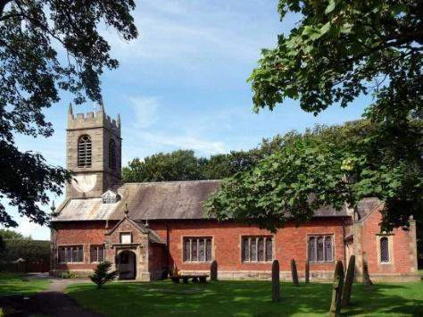
St. Michael and All Angels – Hoole

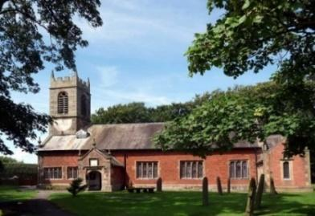

Welcome to our church again this morning. We continue to welcome new friends and welcome back others.

Sunday 25th July 2021 Trinity 8

RUNNING THE RACE - LIVING THE LIFE

“Let us run with perseverance the race marked out for us.
Let us fix our eyes on Jesus” Hebrews 12: v 1-2.

PRAYER OF THE DAY: Lord God, your Son left the riches of
Heaven and became poor for our sake: when we prosper save us from
pride, when we are needy save us from despair, that we may trust in
you alone; through Jesus Christ our Lord. Amen.

No Sunday School today during the service
There are toys for younger children
at the back of church.

9.00am. Holy Communion (Book of Common Prayer) begins p237

10.30am. Morning Worship.

Readings: Hebrews 12: v 1-3. 1. Thessalonians 5: v 12-28.

Hymns: 695 – To God be the glory.
171 – Fill thou my life, O Lord my God.
727 – What a friend we have in Jesus.
332 – I, the Lord of sea and sky.
409 – Lord for the years.

12.00 noon Baptism of Elodie Hesketh
Hymns: 305 – I danced in the morning (Lord of the dance)
Screen – My Lighthouse
666 – The Spirit lives to set us free. (Walk in the light).
BIBLE READINGS: Hebrews 12: v 1-3. Therefore, since we are surrounded by such a great cloud of witnesses, let us throw off everything that hinders and the sin that so easily entangles. And let us run with perseverance the race marked out for us, fixing our eyes on Jesus, the author and perfecter of faith. For the joy that was set before him he endured the cross, scorning its shame, and sat down at the right hand of the throne of God. Consider him who endured such opposition from sinners, so that you will not grow weary and lose heart.

1 Thessalonians 5: v 11-28.
Now we ask you, brothers and sisters, to acknowledge those who work hard among you, who care for you in the Lord and who admonish you. Hold them in the highest regard in love because of their work. Live in peace with each other. And we urge you, brothers and sisters, warn those who are idle and disruptive, encourage the disheartened, help the weak, be patient with everyone. Make sure that nobody pays back wrong for wrong, but always strive to do what is good for each other and for everyone else.
Rejoice always, pray continually, give thanks in all circumstances; for this is God’s will for you in Christ Jesus.
Do not quench the Spirit. Do not treat prophecies with contempt but test them all; hold on to what is good, reject every kind of evil.
May God himself, the God of peace, sanctify you through and through. May your whole spirit, soul and body be kept blameless at the coming of our Lord Jesus Christ. The one who calls you is faithful, and he will do it.
Brothers and sisters, pray for us. Greet all God’s people with a holy kiss. I charge you before the Lord to have this letter read to all the brothers and sisters. The grace of our Lord Jesus Christ be with you.

Prayer. We give thanks for the planning permission for our much needed Lodge in the churchyard and pray that we will be able to find the money for this exciting new venture which is essential for the growth of our church.
We give thanks for the marriage yesterday of Rachel Johnson and John Wilson and we pray for Elodie Hesketh to be baptised today.
We pray for those who are sick, especially Baby Erica Ivy, Patricia Mortimer, Bill and Beryl Carr, Nick Slinger, Alan Fleetwood, Nicola Middleton, Anthony Brogden and Josephine Hodge. We give thanks for the life of Victor Ernest Marsh and pray for his family and friends.
REFRESHMENTS AFTER 10.30 SERVICE
Volunteers needed for rota. Please let Barbara Wood know if you can help. bw12252@hotmail.com

Join us for Prayer time 10.15 -10.45am in church Tuesday July 27th.
There will be a short Summer break in our series of Bible Study.
These will however resume in September on Mondays and on Tuesdays.
Village Hall. Grand Opening next Saturday, 31st July 11.00am The Ladies Group will be having a Tombola Stall. Please put donations of prizes in the plastic box near font
“Locals’ Lunch” resumes August 12th.

