**PARISH DATES**

**Tuesday 30th July 10.15am Holy Communion in the Lodge**

**Sunday 4th August 9.00am Holy Communion**

**10.30am Parish Communion**

**4.00pm Holy Communion (Old Mill Court)**

**Monday 5th August 2.30pm Holy Communion Service at Ribble Court.**

**Tuesday 6th August 10.15am Holy Communion in the Lodge**

**Sunday 11th August 9.00am Holy Communion**

**10.30am Morning Worship & Prayer for Healing**

**Tuesday 13th August 10.15am Holy Communion in the Lodge**

**Saturday 17th August 1.30pm THE CELEBRATION OF THE MARRIAGE**

**OF CAROL SALISBURY & HUGH DENT**

**Sunday 18th August 9.00am Holy Communion**

**10.30am Parish Communion.**

**Tuesday 20th August 10.15am Morning Prayer in the Lodge**

**Sunday 25th August 9.00am Holy Communion**

**10.30am Morning Worship**

**Tuesday 27th August 10.15am Morning Prayer in the Lodge**

**Sunday 1st Sept. 9.00am Holy Communion**

**10.30am Parish Communion with Sunday School.**

**4.00pm Holy Communion (Old Mill Court)**

**FUTURE IMPORTANT PARISH DATES 2024**

**Monday 9th Sept. 7.30pm-9.30pm Alpha Course starts in the Village Hall**

**Monday 23rd Sept. 7.00-8.30pm Alpha Course continues in the Lodge.**

**Friday 27th Sept. 7.00pm Harvest Social with Ann & Peter’s Farewell**

**in the Village Hall**

**Sunday 29th Sept. 10.30am Harvest Thanksgiving – Ann & Peter’s Farewell**

**Service.**

**Suggested Bible readings for this week:**

Monday 29th July Matt. 13: v 31-35. Tuesday 30th July Matt. 13: v 36-43.

Wednesday 31st July Matt. 13: v 44-46. Thursday 1st Aug. Matt. 13: v47-53.

Friday 2nd Aug. Matt. 13: v 54-end. Saturday 3rd Aug. Matt. 14: v 1-12.

[**www.hooleparishchurch.com**](http://www.hooleparishchurch.com)Facebook : **St Michael and All Angels Church, Hoole**,

Rector Ann Templeman anntempleman@live.co.uk 01772 448515 or 07877659156

***PLEASE TAKE THIS SHEET HOME WITH YOU.***

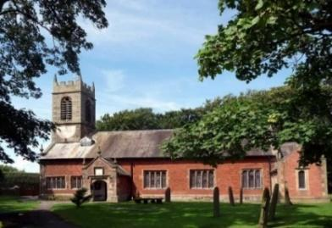

Welcome to our Church today.

Please stay for refreshments in the Lodge which follow the 10.30am service.

***Sunday 28th July 2024***

**GOD’S ETERNAL MAJESTY**

***We have a building from God, an eternal house in heaven. (2 Cor. 5: v 1)***

**PRAYER OF THE DAY Gracious Father,**

**revive your Church in our day,**

**and make her holy, strong and faithful,**

**for your glory’s sake**

**in Jesus Christ our Lord. Amen.**



**Children’s activities in the Lodge during the service.**

**Pizza & Praise in Church and Lodge at 5.00pm.**

**9.00am. Holy Communion (Book of Common Prayer p237)**

**10.30am. Morning Worship.**

**Reading 1: Psalm 90 A prayer of Moses the man of God.**

**Reading 2: 2 Corinthians**  **Our Heavenly Dwelling 4 and 5**

**Hymns: 551 – O worship the King. (omit v 5)**

**Screen – All Through History (if children present)**

**Canticle – 2 (O bless the God of Israel).**

**29 – Amazing grace.**

**411 – Lord Jesus Christ.**

**70 – Be Thou my vision.**

**5.00pm. Pizza & Praise in Church and Lodge.**

**Reading: Psalm 90 (Read by the Congregation)**

**A prayer of Moses the man of God.**

Lord, you have been our dwelling-place  
    throughout all generations.  
Before the mountains were born  
    or you brought forth the whole world,  
    from everlasting to everlasting you are God.

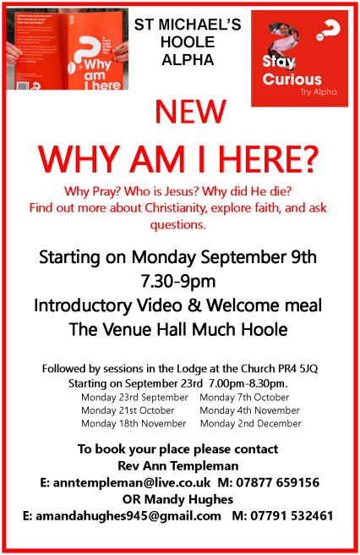You turn people back to dust,  
    saying, ‘Return to dust, you mortals.’  
A thousand years in your sight  
    are like a day that has just gone by,  
    or like a watch in the night.  
Yet you sweep people away in the sleep of death –  
    they are like the new grass of the morning:

In the morning it springs up new,  
    but by evening it is dry and withered.

We are consumed by your anger  
    and terrified by your indignation.  
You have set our iniquities before you,  
    our secret sins in the light of your presence.  
All our days pass away under your wrath;  
    we finish our years with a moan.  
Our days may come to seventy years,  
    or eighty, if our strength endures;  
yet the best of them are but trouble and sorrow,  
    for they quickly pass, and we fly away.  
If only we knew the power of your anger!  
    Your wrath is as great as the fear that is your due.  
Teach us to number our days,  
    that we may gain a heart of wisdom.

Relent, Lord! How long will it be?  
    Have compassion on your servants.  
Satisfy us in the morning with your unfailing love,  
    that we may sing for joy and be glad all our days.  
Make us glad for as many days as you have afflicted us,  
    for as many years as we have seen trouble.  
May your deeds be shown to your servants,  
    your splendour to their children.

May the favour[[a](https://www.biblegateway.com/passage/?search=Psalm%2090&version=NIVUK#fen-NIVUK-15396a)] of the Lord our God rest on us;  
    establish the work of our hands for us –   
    yes, establish the work of our hands.

**Reading: Our Heavenly Dwelling 2 Cor. 4 and 5**

We know that the one who raised the Lord Jesus from the dead will also raise us with Jesus and present us with you to himself. 

Therefore, we do not lose heart. Though outwardly we are wasting away, yet inwardly we are being renewed day by day. For our light and momentary troubles are achieving for us an eternal glory that far outweighs them all.  So we fix our eyes not on what is seen, but on what is unseen, since what is seen is temporary, but what is unseen is eternal.

For we know that if the earthly tent we live in is destroyed, we have a building from God, an eternal house in heaven, not built by human hands.

**Prayer:** We pray for a successful response to our Giving in Grace campaign and the appointment of a new Rector; for Pizza and Praise tonight; for the sick, especially Beryl Carr, Jim Ashcroft, Jean Smallwood, Sue Meadows, Patricia Edwardson, Debbie Meagh, Michelle, Judith Stopford, Elaine Read and Harry Pugh; for Liz Boland for a successful operation tomorrow.

