PARISH DATES
Sunday 2nd July 9.00am Holy Communion
10.30am Parish Communion with Sunday School.
Monday 3rd July 7.30pm Bible for Beginners 2 in the Lodge
Tuesday 4th July 10.15am Holy Communion in the Lodge.
Wednesday 5th July 9.30am-11.30am ST MICHAEL’S LITTLE ANGELS
Thursday 6th July 4.30pm Bible and Biscuits in the Lodge.
Sunday 9th July 9.00am Holy Communion
10.30am Morning Worship
3.00pm CREAM TEA CHURCH ON THE SCHOOL FIELD
Tuesday 11th July 10.15am Morning Prayer in the Lodge.
Wednesday 12th July 9.30am-11.30am ST MICHAEL’S LITTLE ANGELS
Thursday 13th June 4.30pm Chat and Chocolate in the Lodge.
Sunday 16th July 9.00am Holy Communion
10.30am Parish Communion with Sunday School and
Baptism of Francesca and Harry Sutton
Monday 17th July 7.30pm Bible for Beginners 3 in the Lodge
Tuesday 18th July 10.15am Holy Communion in the Lodge.
Wednesday 19th July 9.30am-11.30am ST MICHAEL’S LITTLE ANGELS
LAST ONE BEFORE SUMMER BREAK – RE-STARTS WED. 6th SEPTEMBER
Thursday 20th July 2.00pm St Michael’s School Leavers’ service
4.30pm Bible and Biscuits in the Lodge
Sunday 23rd July 9.00am Holy Communion
10.30am Morning Worship with Sunday School
Tuesday 25th July 10.15am Holy Communion in the Lodge.
Sunday 30th July 9.00am Holy Communion
10.30am Parish Communion

Please email names and addresses of those married in St Michael’s to
jeandew @btinternet.co.m

Suggested Bible Readings for this week:
Monday 3rd July John 20: v 24-29. Tuesday 4th July Matt. 8: v 23-27.
Wed. 5th July Matt. 8: v 28-end. Thursday 6th July Matt. 9: v 1-8.
Friday 7th July Matt. 9: v 9-13. Saturday 8th July Matt. 9: v 14-17.

www.hooleparishchurch.com Facebook : St Michael and All Angels Church, Hoole,
Rector Ann Templeman anntempleman@live.co.uk 01772 448515 or 07877659156
PLEASE TAKE THIS SHEET HOME WITH YOU.
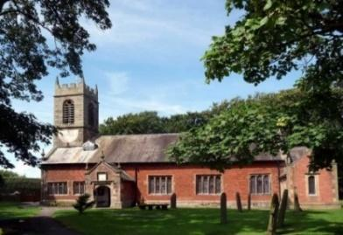
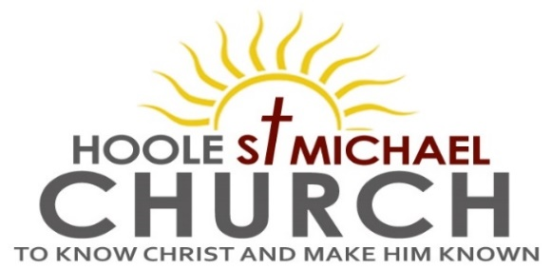

Welcome to our Church today.
Please stay for refreshments in the Lodge which follow the 10.30am service

Sunday 2nd July 2023

BUILDING GOD’S HOUSE.

Give careful thought to your ways – you eat but never have enough
(Haggai 1: v 11).

PRAYER OF THE DAY Gracious Father, by the obedience of Jesus
you brought salvation to our wayward world: draw us into harmony
with your will, that we may find all things restored in him, our
Saviour Jesus Christ. Amen.

Sunday School today during the service.
There are toys and colouring sheets for younger children
at the back of church.

9.00am. Holy Communion (Book of Common Prayer) begins p237

10.30am. Parish Communion with Sunday School.
Reading: Haggai 1: v 1-11.
Hymns: 54 – At the name of Jesus.
Screen – You are shaped for serving God.
332 – I the Lord of sea and sky.
238 – Go forth and tell.

H/C Hymns: Screen – The power of the cross.
Suppl. 10 – Here is love, vast as the ocean.

Reading: Haggai 1: v 1-11. In the second year of King Darius, on the first day of the sixth month, the word of the Lord came through the prophet Haggai to Zerubbabel son of Shealtiel, governor of Judah, and to Joshua son of Jehozadak, the high priest:
This is what the Lord Almighty says: “These people say, ‘The time has not yet come for the Lord’s house to be built.’” Then the word of the Lord came through the prophet Haggai: “Is it a time for you yourselves to be living in your panelled houses, while this house remains a ruin?”
Now this is what the Lord Almighty says: “Give careful thought to your ways. You have planted much, but harvested little. You eat, but never have enough. You drink, but never have your fill. You put on clothes, but are not warm. You earn wages, only to put them in a purse with holes in it.”
This is what the Lord Almighty says: “Give careful thought to your ways. Go up into the mountains and bring down timber and build the house, so that I may take pleasure in it and be honoured,” says the Lord. “You expected much, but see, it turned out to be little. What you brought home, I blew away. Why?” declares the Lord Almighty. “Because of my house, which remains a ruin, while each of you is busy with your own house. Therefore, because of you the heavens have withheld their dew and the earth its crops. I called for a drought on the fields and the mountains, on the grain, the new wine, the olive oil and everything else the ground produces, on people and livestock, and on all the labour of your hands.”

Prayer: We pray for those who are sick especially Erica Ivy, Peter Eckersley, Daniel Conner, Jean Smallwood, Shirley Rainsbury, Bill and Beryl Carr. We give thanks for the life of Tom Parkinson and pray for Susan and his family and friends.

OUR AIMS : ‘TO KNOW CHRIST AND MAKE HIM KNOWN’
Please fill in the questionnaire about how we can help you deepen your own spiritual life and share your faith with others.
BIBLE FOR BEGINNERS and others
SESSION 2 MONDAY 3RD JULY 7.30 in the Lodge
SESSION 3 MONDAY 17TH JULY 7.30 in the Lodge
Going deeper in the bible postponed

