Parish Dates June 2021 onwards
Monday July 5th 7.30pm Bible Study by Zoom
Tuesday July 6th 7.30pm Bible Study in Church with Compline
Thursday July 8th 4.30pm Chat & Chocolate – young people in Church
Sunday July 11th 09.00am Holy Communion in Church
10.30am Morning Worship in Church
12 noon Baptism of Bella Smith
Monday July 12th 7.00pm PCC Meeting in church.
Tuesday July 13th 10.15am – 10.45am Prayer time live in Church
Sunday 18th July OUTREACH WEEKEND
09.00am Holy Communion in Church
10.30am Parish Communion in Church
2.30PM – 4.30PM FAMILY CHURCH COMMUNITY EVENT WITH
ALL AGE SERVICE WITH BISHOP PHILIP.
RACES, FOOTBALL, CREAM TEAS
Tuesday 20th July 2.00pm Year 6 Leavers’ Service in Church.
Saturday July 24th 1.30pm – Marriage of John Wilson and Rachel Johnson.
Sunday July 25th 09.00am Holy Communion in Church
10.30am Morning Worship in Church
12 noon Baptism of Elodie Hesketh
Saturday July 31st from 10.00am Grand Opening of New Village Hall
Sunday August 1st 09.00am Holy Communion in Church
10.30am Parish Communion in Church

Key Future Dates SAVE THE DATE Harvest Festival and Social
Friday Oct 1st 7.00pm Harvest Supper & Parish Social with Quiz
and Entertainment in the New Village Hall.
Sunday Oct 3rd 10.30am HARVEST FESTIVAL

All the above services are ‘Live’ in church
We will aim to have audio recordings of all 10.30 services on the website www.hooleparishchurch.com by Sunday lunch time.
The Zoom link for all church Zoom activities is on the front of website.
Our Facebook page: St Michael and All Angels Church, Hoole,
Rector – Revd Ann Templeman anntempleman@live.co.uk 01772 448515
The Rectory, 69 Liverpool Old Road Much Hoole PR4 4RB
Please take this sheet home with you
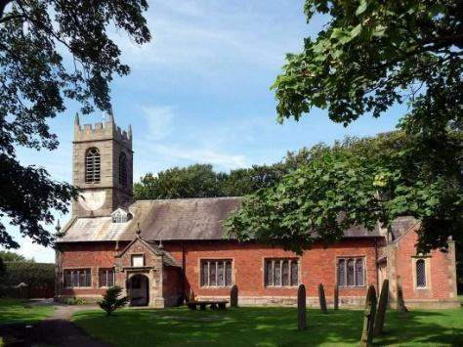
St. Michael and All Angels – Hoole

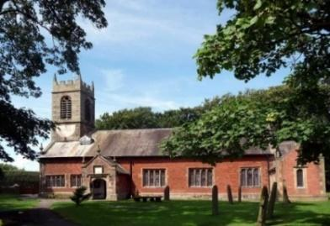

Welcome to our church again this morning. We continue to welcome new friends and welcome back others.

Sunday 4th July 2021 Trinity 5

GOD’S STRENGTH IN OUR WEAKNESS.

But He said to me, “My grace is sufficient for you, for my power is
made perfect in weakness”. 2 Corinthians 12: v 9.

PRAYER OF THE DAY: Almighty God, send down upon your
Church the riches of your Spirit, and kindle in all who minister the
Gospel your countless gifts of grace; through Jesus Christ our Lord.
Amen.

Sunday School today during the service
There are toys for younger children
at the back of church.

9.00am. Holy Communion (Book of Common Prayer) begins p237

10.30am. Parish Communion.

Reading: 2 Corinthians 11: v 30 to 12: v 10.

Hymns : 12 – Alleluia, sing to Jesus.
Children’s song (screen) – You are shaped for serving God.
29 – Amazing Grace.
408 – Lord enthroned in heavenly splendour.
H/C Hymns: Screen – The Power of the Cross.
202 – Give thanks with a grateful heart.
657 – There is a green hill far away.

BIBLE READING: 2 Corinthians 11: v 30 to 12: v 10. If I must boast,
I will boast of the things that show my weakness. The God and Father of the Lord Jesus, who is to be praised for ever, knows that I am not lying. In Damascus the governor under King Aretas had the city of the Damascenes guarded in order to arrest me. But I was lowered in a basket from a window in the wall and slipped through his hands.
I must go on boasting. Although there is nothing to be gained, I will go on to visions and revelations from the Lord. I know a man in Christ who fourteen years ago was caught up to the third heaven. Whether it was in the body or out of the body I do not know – God knows. And I know that this man – whether in the body or apart from the body I do not know, but God knows – was caught up to paradise and heard inexpressible things, things that no one is permitted to tell. I will boast about a man like that, but I will not boast about myself, except about my weaknesses. Even if I should choose to boast, I would not be a fool, because I would be speaking the truth. But I refrain, so no one will think more of me than is warranted by what I do or say, or because of these surpassingly great revelations. Therefore, in order to keep me from becoming conceited, I was given a thorn in my flesh, a messenger of Satan, to torment me. Three times I pleaded with the Lord to take it away from me. But he said to me, ‘My grace is sufficient for you, for my power is made perfect in weakness.’ Therefore I will boast all the more gladly about my weaknesses, so that Christ’s power may rest on me. That is why, for Christ’s sake, I delight in weaknesses, in insults, in hardships, in persecutions, in difficulties. For when I am weak, then I am strong.

Prayer. We pray for RUNING THE RACE - our special community event for the whole church Family with bishop Philip on 18th July at 2.30pm and pray that many will be encouraged to come along.
We give thanks for the planning permission for our much needed Lodge in the churchyard and pray for the PCC as they discuss how to find the money for this exciting new venture which is essential for the growth of our church.
We pray for those preparing for Baptism especially the parents of Bella Smith and Elodie Hesketh. We pray for Rachel Johnson and John Wilson preparing for marriage on 24th July
We pray for those who are sick, especially Baby Erica Ivy, Patricia Mortimer, Bill and Beryl Carr, Nick Slinger, Alan Fleetwood, Nicola Middleton, Anthony Brogden and Josephine Hodge. We give thanks for the life of Michael Watkins and pray for his family and friends. REFRESHMENTS AFTER 10.30 SERVICE
Volunteers needed for rota. Please let Barbara Wood know if you can help. bw12252@hotmail.com
FORTNIGHTLY AND BIBLE STUDIES AND PRAYER TIMES CONTINUE
Join us for Bible Study on Monday 5th July 7.30pm by Zoom
and Tuesday 6th July 7.30pm in Church with Compline
We will be looking at Paul’s first letter to the Thessalonians chapter 4. Prayer time continues from 10.15 am to 10.45am in church
on Tuesday July 13th.
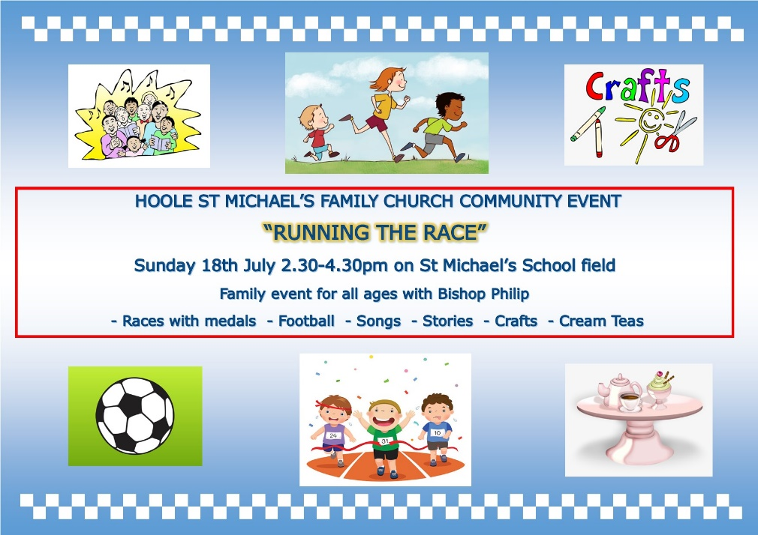

Village Hall. Grand Opening 31st July 10.am onwards by the Mayor of South Ribble, Cllr Jane Bell.All welcome. Fair ground, stalls, food etc. The Ladies Group will be having a Tombola Stall. Please put donations of prizes in the plastic box near font

