PARISH DATES
Tuesday 11th July 10.15am Holy Communion in the Lodge.
Wednesday 12th July 9.30am-11.30am ST MICHAEL’S LITTLE ANGELS
Thursday 13th June 4.30pm Chat and Chocolate in the Lodge.
Saturday 15th July 3.00pm Wedding of Jason Meconi and Hayley Frame.
Sunday 16th July 9.00am Holy Communion
10.30am Parish Communion with Sunday School and
Baptism of Francesca and Harry Sutton
Monday 17th July 7.30pm Bible for Beginners 3 in the Lodge
Tuesday 18th July 10.15am Holy Communion in the Lodge.
Wednesday 19th July 9.30am-11.30am ST MICHAEL’S LITTLE ANGELS
LAST ONE BEFORE SUMMER BREAK – RE-STARTS WED. 6th SEPTEMBER
Thursday 20th July 2.00pm St Michael’s School Leavers Service
4.30pm Bible and Biscuits in the Lodge
Sunday 23rd July 9.00am Holy Communion
10.30am Morning Worship with Sunday School
LAST SUNDAY SCHOOL BEFORE THE SUMMER BREAK
Tuesday 25th July 10.15am Holy Communion in the Lodge.
Sunday 30th July 9.00am Holy Communion
10.30am Parish Communion
Monday 31st July 7.30pm PCC in the Lodge
Sunday 6th August 9.00am Holy Communion
10.30am Parish Communion
FUTURE DATES FOR YOUR DIARY:
SEPTEMBER 10th 3.45pm - Hogwarts Church
SEPTEMBER 17TH 3.30pm – Celebration of Marriage Service Bishop Jill Duff
SEPTEMBER 29th 7.00pm - Harvest Social and Quiz – Village Hall
OCTOBER 1st 10.30am- Harvest Thanksgiving Service
NOVEMBER 5th 6.00pm - Service of Thanksgiving for Loved Ones
NOVEMBER 11th 10.00 - 2.00 – Parish Quiet Day at Whalley Abbey with Archdeacon Mark
Suggested Bible Readings for this week:
Monday 10th July Matt. 9: v 18-26. Tuesday 11th July Matt. 9: v 32-end.
Wed. 12th July Matt. 10: v 1-7. Thursday 13th July Matt. 10: v 7-15.
Friday 14th July Matt. 10: v 16-23. Saturday 15th July Matt. 10: v 24-33.

www.hooleparishchurch.com Facebook : St Michael and All Angels Church, Hoole,
Rector Ann Templeman anntempleman@live.co.uk 01772 448515 or 07877659156
PLEASE TAKE THIS SHEET HOME WITH YOU.
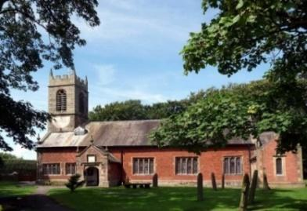
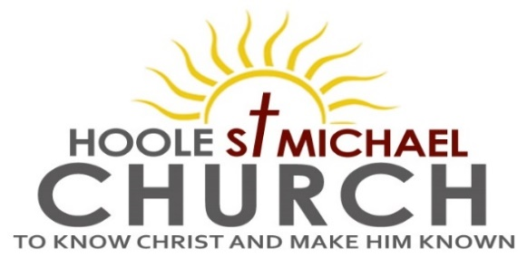

Welcome to our Church today.
Please stay for refreshments in the Lodge which follow the 10.30am service

Sunday 9th July 2023

THE PRESENCE OF GOD.

“I am with you”, says the Lord. (Haggai 1: v 13).

PRAYER OF THE DAY Almighty God, send down upon your
Church the riches of your Spirit, and kindle in all who minister the
Gospel your countless gifts of grace; through Jesus Christ our Lord.
Amen.

No Sunday School today during the service.
Cream Tea Church for all at 3.00pm.
There are toys and colouring sheets for younger children
at the back of church.

9.00am. Holy Communion (Book of Common Prayer) begins p237

10.30am. Morning Worship.
Reading: Haggai 1: v 12-15.
Hymns: 67 – Be still for the presence of the Lord.
Canticle 2 – O bless the God of Israel.
144 – Dear Lord and Father of mankind.
Suppl. 10 – Here is love, vast as the ocean.
551 – O worship the King.
3.00pm: CREAM TEA CHURCH FOR ALL ON THE SCHOOL FIELD

Reading: Haggai 1: v 12-15. Then Zerubbabel, Joshua the high priest, and the whole remnant of the people obeyed the voice of the Lord their God and the message of the prophet Haggai, because the Lord their God had sent him. And the people feared the Lord.
Then Haggai, the Lord’s messenger, gave this message of the Lord to the people: ‘I am with you,’ declares the Lord. So the Lord stirred up the spirit of Zerubbabel , governor of Judah, and the spirit of Joshua , the high priest, and the spirit of the whole remnant of the people.
They came and began to work on the house of the Lord Almighty, their God, on the twenty-fourth day of the sixth month in the second year of King Darius,

Prayer: We pray for Cream Tea Church this afternoon. For Francesca and Harry to be baptised next Sunday and for Jason and Hayley who are to be married next Saturday. We pray for those who are sick especially Erica Ivy, Peter Eckersley, Daniel Conner, Jean Smallwood, Antonietta Broadhurst, Shirley Rainsbury, Beryl Cottam, Bill and Beryl Carr.

OUR AIMS : ‘TO KNOW CHRIST AND MAKE HIM KNOWN’
Please fill in the questionnaire about how we can help you deepen your own spiritual life and share your faith with others.
BIBLE FOR BEGINNERS
SESSION 3 MONDAY 17TH JULY 7.30 in the Lodge
GOING DEEPER IN THE BIBLE
Postponed

Teddy Bears’ Picnic

Calling all little angels…
Please join us on Sunday 9th July…at 3pm at St Michael’s School Ground.
It will be great to see you all. Don’t forget to bring along your teddy too!

