PARISH DATES
Monday 12th June 11.30am Celebration of the Life of Sam Burns
Tuesday 13th June 10.15am Morning Prayer in the Lodge.
Wednesday 14th June 9.30am–11.30am ST MICHAEL’S LITTLE ANGELS
7.30pm Bible Study -Lodge: The Power of Prayer Acts 12 v1-19
Thursday 15th June 4.30pm Chat and Chocolate in the Lodge.
Sunday 18th June 9.00am Holy Communion
10.30am ALL AGE SERVICE
Tuesday 20th June 10.15am Morning Prayer in the Lodge.
7.30pm Ladies Group in the Village Hall (My Life of Work – Colin Wilson)
Wednesday 21st June 9.30am–11.30am ST MICHAEL’S LITTLE ANGELS
Thursday 22nd June 4.30pm Bible and Biscuits in the Lodge.
Sunday 25th June 9.00am Holy Communion
10.30am Parish Communion with Sunday School.
Monday 26th June 7.30pm Bible for Beginners 1 in the Lodge
Tuesday 27th June 10.15am Holy Communion in the Lodge.
2.00pm Funeral Service for Tom Parkinson
Wednesday 28th June 9.30am-11.30am ST MICHAEL’S LITTLE ANGELS
Thursday 29th June 4.30pm Chat and Chocolate in the Lodge.
Friday 30thJune 5.30pm Parish Walk from Dolphin - Fish ‘n Chips supper
Saturday 1st July 10.00am - 12.30pm. Ladies Group Coffee Morning-Lodge;
10.00 – 12.00 noon. Car cleaning on the Car Park.
1.00pm Wedding of Emma and Callum
Sunday 2nd July 9.00am Holy Communion
10.30am Parish Communion with Sunday School.
Monday 3rd July 7.30pm Bible for Beginners 2 in the Lodge
Going deeper with the Bible-Rectory
Tuesday 4th July 10.15am Holy Communion in the Lodge.
Wednesday 5th July 9.30am-11.30am ST MICHAEL’S LITTLE ANGELS
Thursday 6th July 4.30pm Bible and Biscuits in the Lodge.
Sunday 9th July 9.00am Holy Communion
10.30am Morning Worship
3.00pm CREAM TEA CHURCH ON THE SCHOOL FIELD

Bible Readings: Monday 12th June Matt. 5: v 1-12. Tuesday 13th June Matt. 5: v 13-16.
Wed. 14th June Matt. 5: v 17-19. Thursday 15th June Matt. 5: v 20-26.
Friday 16th June Matt. 5: v27-32. Saturday 17th June Matt. 5: v 33-37.
www.hooleparishchurch.com Facebook : St Michael and All Angels Church, Hoole,
Rector Ann Templeman anntempleman@live.co.uk 01772 448515 or 07877659156
PLEASE TAKE THIS SHEET HOME WITH YOU.
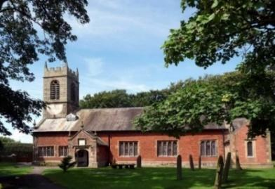
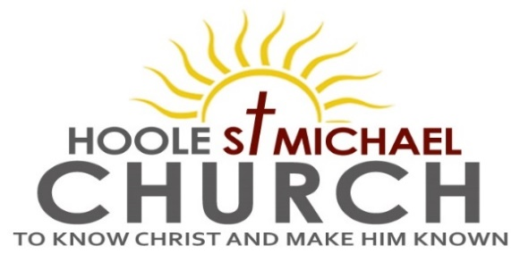

Welcome to our Church today.
Please stay for refreshments in the Lodge which follow the 10.30am service

Sunday 11th June 2023

BARNABAS THE ENCOURAGER.
‘How to rub up people the right way’

‘Barnabas was glad and encouraged them all to remain true to the Lord
with all their hearts’. (Acts11: v 23).

PRAYER OF THE DAY Bountiful God, giver of all gifts, who
poured your Spirit upon your servant Barnabas and gave him grace
to encourage others: help us, by his example, to be generous in our
judgements and unselfish in our service; through Jesus Christ your
Son our Lord, who is alive and reigns with you, in the unity of the
Holy Spirit, one God, now and for ever. Amen.

No Sunday School today during the service.
There are toys and colouring sheets for younger children
at the back of church.

9.00am. Holy Communion (Book of Common Prayer) begins p237

10.30am. Morning Worship.
Reading: Acts 11: v 19-end.
Hymns: Suppl. 5 – Bless the Lord O my soul.
171 – Fill thou my life, O Lord my God.
625 – Take my life, and let it be.
503 – O Jesus, I have promised.
409 – Lord for the years.
3.45pm. HOLIDAY CHURCH IN THE VILLAGE HALL

Reading: Acts 11: v 19-end. Now those who had been scattered by the persecution that broke out when Stephen was killed travelled as far as Phoenicia, Cyprus and Antioch, spreading the word only among Jews. Some of them, however, men from Cyprus and Cyrene, went to Antioch and began to speak to Greeks also, telling them the good news about the Lord Jesus. The Lord’s hand was with them, and a great number of people believed and turned to the Lord.
News of this reached the church in Jerusalem, and they sent Barnabas to Antioch. When he arrived and saw what the grace of God had done, he was glad and encouraged them all to remain true to the Lord with all their hearts. He was a good man, full of the Holy Spirit and faith, and a great number of people were brought to the Lord.
Then Barnabas went to Tarsus to look for Saul, and when he found him, he brought him to Antioch. So for a whole year Barnabas and Saul met with the church and taught great numbers of people. The disciples were called Christians first at Antioch.
During this time some prophets came down from Jerusalem to Antioch. One of them, named Agabus, stood up and through the Spirit predicted that a severe famine would spread over the entire Roman world. (This happened during the reign of Claudius.) The disciples, as each one was able, decided to provide help for the brothers and sisters living in Judea. This they did, sending their gift to the elders by Barnabas and Saul.

Prayer: We pray for those who are sick especially Erica Ivy, Daniel Conner, Jean Smallwood, Shirley Rainsbury, Bill and Beryl Carr. We give thanks for the life of Sam Burns and pray for Dave, their children, family and friends. We commit to you her funeral service and the service to celebrate Sam’s life, tomorrow Monday 12th June. We give thanks too for the life of Tom Parkinson and pray for Susan and his family and friends.

A PARISH WALK will take place on Friday 30th June starting from The Dolphin Inn on Marsh Lane at 5.30pm and ending there with a Fish and Chip supper. Please see Colin Wilson for details and to add your name to the list for supper.

OUR AIMS : ‘TO KNOW CHRIST AND MAKE HIM KNOWN’
Please fill in the questionnaire about how we can help you deepen your own spiritual life and share your faith with others.
BIBLE FOR BEGINNERS
SESSON 1 MONDAY 26TH JUNE 7.30 in the Lodge
SESSION 2 MONDAY 3RD JULY 7.30 in the Lodge
SESSION 3 MONDAY 17TH JULY 7.30 in the Lodge
GOING DEEPER IN THE BIBLE
1.MONDAY 3RD JULY 7.30 in the Rectory
2.MONDAY 17TH JULY 7.30 in the Rectory

- MONDAY 3RD JULY 7.30 in the Rectory
- MONDAY 17TH JULY 7.30 in the Rectory

