PARISH DATES
Tuesday 20th June 10.15am Morning Prayer in the Lodge.
7.30pm Ladies Group in the Village Hall (My Life of Work – Colin Wilson)
Wednesday 21st June 9.30am–11.30am ST MICHAEL’S LITTLE ANGELS
Thursday 22nd June 4.30pm Bible and Biscuits in the Lodge.
Sunday 25th June 9.00am Holy Communion
10.30am Parish Communion with Sunday School.
Monday 26th June 7.30pm Bible for Beginners 1 in the Lodge
Tuesday 27th June 10.15am Holy Communion in the Lodge.
2.00pm Funeral Service for Tom Parkinson
Wednesday 28th June 9.30am-11.30am ST MICHAEL’S LITTLE ANGELS
Thursday 29th June 4.30pm Chat and Chocolate in the Lodge.
Friday 30thJune 5.30pm Parish Walk from Dolphin - Fish ‘n Chips supper
Saturday 1st July 10.00am - 12.30pm. Ladies Group Coffee Morning-Lodge;
10.00 – 12.00 noon. Car cleaning on the Car Park.
1.00pm Wedding of Emma and Callum
Sunday 2nd July 9.00am Holy Communion
10.30am Parish Communion with Sunday School.
Monday 3rd July 7.30pm Bible for Beginners 2 in the Lodge
Going deeper with the Bible-Rectory
Tuesday 4th July 10.15am Holy Communion in the Lodge.
Wednesday 5th July 9.30am-11.30am ST MICHAEL’S LITTLE ANGELS
Thursday 6th July 4.30pm Bible and Biscuits in the Lodge.
Sunday 9th July 9.00am Holy Communion
10.30am Morning Worship
3.00pm CREAM TEA CHURCH ON THE SCHOOL FIELD
Tuesday 11th July 10.15am Holy Communion in the Lodge.
Wednesday 12th July 9.30am-11.30am ST MICHAEL’S LITTLE ANGELS
Thursday 13th June 4.30pm Chat and Chocolate in the Lodge.
Sunday 16th July 9.00am Holy Communion
10.30am Parish Communion with Sunday School.

Suggested Bible Readings for this week:
Monday 19th June Matt. 5: v 38-42. Tuesday 20th June Matt. 5: v 43-end.
Wed. 21st June Matt. 6: v 1-6 & 16-18. Thursday 22nd June Matt. 6: v 7-16.
Friday 23rd June Matt. 6: v 19-23. Saturday 24th June Acts 13: v 14b-26.
www.hooleparishchurch.com Facebook : St Michael and All Angels Church, Hoole,
Rector Ann Templeman anntempleman@live.co.uk 01772 448515 or 07877659156
PLEASE TAKE THIS SHEET HOME WITH YOU.
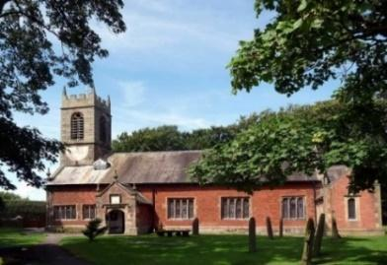
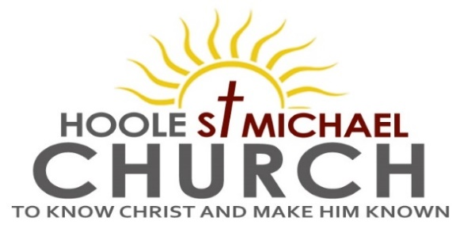

Welcome to our Church today, with a special welcome to
Revd. Pat Belshaw who is leading our worship at 9.00am.
Please stay for refreshments in the Lodge which follow the 10.30am service

Sunday 18th June 2023

JESUS’ COMPASSION FOR ALL.

‘When he saw the crowds, he had compassion on them, because they were harassed and helpless, like sheep without a shepherd.’ (Matthew 9: v 36).

PRAYER OF THE DAY Faithful Creator, whose mercy never
fails: deepen our faithfulness to you and to your living Word,
Jesus Christ our Lord. Amen.

All Age Worship today.
There are toys and colouring sheets for younger children
at the back of church.

9.00am. Holy Communion (Book of Common Prayer) begins p237

10.30am. All Age Worship.
Reading: Matthew 9: v 36 to 10: v 8.
Hymns: 428 – Love divine, all loves excelling.
Screen – All through history.
70 – Be thou my vision.
Suppl. 9 – The Lord’s my Shepherd.
Suppl. 1 – In Christ alone.

Reading: Matthew 9: v 36 to 10: v 8. The Workers Are Few
Jesus went through all the towns and villages, teaching in their synagogues, proclaiming the good news of the kingdom and healing every disease and sickness. When he saw the crowds, he had compassion on them, because they were harassed and helpless, like sheep without a shepherd. Then he said to his disciples, “The harvest is plentiful but the workers are few. Ask the Lord of the harvest, therefore, to send out workers into his harvest field.”

Jesus Sends Out the Twelve
Jesus called his twelve disciples to him and gave them authority to drive out impure spirits and to heal every disease and sickness.
These are the names of the twelve apostles: first, Simon (who is called Peter) and his brother Andrew; James son of Zebedee, and his brother John; Philip and Bartholomew; Thomas and Matthew the tax collector; James and Thaddaeus; Simon the Zealot and Judas Iscariot, who betrayed him.
Jesus sent these twelve out with the following instructions: “Do not go among the Gentiles or enter any town of the Samaritans. Go rather to the lost sheep of Israel. As you go, proclaim this message: ‘The kingdom of heaven has come near.’ Heal the sick, raise the dead, cleanse those who have leprosy, drive out demons. Freely you have received; freely give.

Prayer: We pray for those who are sick especially Erica Ivy, Daniel Conner, Jean Smallwood, Shirley Rainsbury, Bill and Beryl Carr. We give thanks for the life of Sam Burns and pray for Dave, their children, family and friends. We give thanks too for the life of Tom Parkinson, whose funeral will take place on Tuesday June 27th, and pray for Susan and his family and friends.

A PARISH WALK will take place on Friday 30th June starting from The Dolphin Inn on Marsh Lane at 5.30pm and ending there with a Fish and Chip supper. Please see Colin Wilson for details and to add your name to the list for supper.

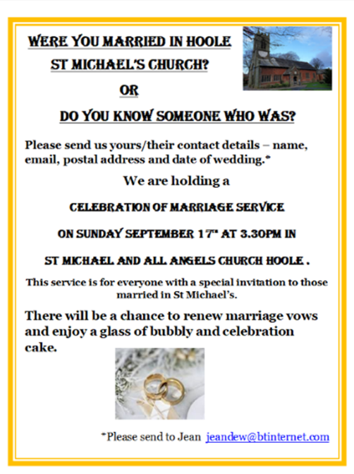
OUR AIMS : ‘TO KNOW CHRIST AND MAKE HIM KNOWN’
Please fill in the questionnaire about how we can help you deepen your own spiritual life and share your faith with others.
BIBLE FOR BEGINNERS
SESSON 1 MONDAY 26TH JUNE 7.30 in the Lodge
SESSION 2 MONDAY 3RD JULY 7.30 in the Lodge
SESSION 3 MONDAY 17TH JULY 7.30 in the Lodge
GOING DEEPER IN THE BIBLE
1.MONDAY 3RD JULY 7.30 in the Rectory
2.MONDAY 17TH JULY 7.30 in the Rectory

- MONDAY 3RD JULY 7.30 in the Rectory
- MONDAY 17TH JULY 7.30 in the Rectory

