Parish Dates From June 2022
Monday 20th June 7.30pm House Group/Bible Study at The Rectory
Tuesday 21st June 10.15am Morning Prayer.
7.30pm Ladies Group meet at the Village Hall
Topic – A Good Cluttering (Peter Kenyon)
Thursday 23rd June 4.30pm Chat & Chocolate in Church.

Sunday 26th June 9.00am Holy Communion
10.30am Morning Worship with Sunday School
Tuesday 28th June 10.15am Morning Prayer.
7.30pm House Group/Bible Study at The Rectory
Friday 1st July 2.00pm Wedding Jonathan Crankshaw & Lucinda Wing
Saturday 2nd July 2.00 – 4.00pm Ladies Group Summer Fete
Village Hall.

Sunday 3rd July 9.00am Holy Communion
10.30am Parish Communion with Sunday School
12.00 Baptism of Tilly and Stanley Sanderson
Monday 4th July 7.30pm House Group/Bible Study at The Rectory
Tuesday 5th July 10.15am Holy Communion .
Thursday 7th July 4.30pm Chat & Chocolate in Church.

Sunday 10th July 9.00am Holy Communion
10.30am CONFIRMATION SERVICE
WITH BISHOP TONY PORTER.
Tuesday 12th July 10.15am Holy Communion/Morning Prayer in church
7.30pm House Group/Bible Study at the Rectory

Sunday 17th July 9:00am Holy Communion
10:30am Parish Communion
3.45pm FOREST CHURCH on school field
Suggested Bible readings this week.
Monday 20th June. Matt. 7: v 1-5. Tuesday 21st June. Matt. 7: v 6 & 12-14.
Wed. 22nd June. Matt. 7: v 15-20. Thursday 23rd June. Matt. 7: v 21-end.
Friday 24th June. Luke 1: v 57- 66 & 80. Saturday 25th June. Matt. 8: v 5-17.

Website : www.hooleparishchurch.com
Facebook page: St Michael and All Angels Church, Hoole,
Rector – Revd Ann Templeman anntempleman@live.co.uk 01772 448515
The Rectory, 69 Liverpool Old Road Much Hoole PR4 4RB
Please take this sheet home with you
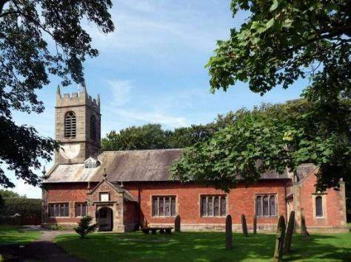
St. Michael and All Angels – Hoole

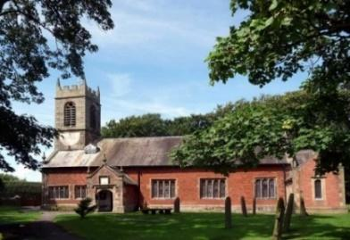

Welcome to our church again this morning. Please stay for a chat and a cup of tea or coffee after the 10.30 service, a great way to meet people

Sunday 19th June 2022 (Trinity 1)

BELSHAZZAR’S FEAST – THE WRITING ON THE WALL

There is a man who has the spirit of God in him. Daniel 5: v 11.

PRAYER OF THE DAY: God of truth, help us to keep your law of
Love and to walk in ways of wisdom, that we may find true life in
Jesus Christ your Son. Amen.

Sunday School today during the service
There are toys and colouring sheets
for younger children at the back of church.

9.00am. Holy Communion (Book of Common Prayer) begins p237

10.30am. Parish Communion with Sunday School

Readings: Daniel 5: various verses.

Hymns: 97 – Christ is made the sure foundation. (tune 1)
Screen – Great big God.
340 – Jerusalem the golden.
205 – Glorious things of thee are spoken. (tune 2)

H/C Hymn: 45 – As the deer pants for the water.

READING: Daniel 5 selected verses.
King Belshazzar gave a great banquet for a thousand of his nobles and drank wine with them. While Belshazzar was drinking his wine, he gave orders to bring in the gold and silver goblets that Nebuchadnezzar his father had taken from the temple in Jerusalem, so that the king and his nobles, his wives and his concubines might drink from them. So they brought in the gold goblets that had been taken from the temple of God in Jerusalem, and the king and his nobles, his wives and his concubines drank from them. As they drank the wine, they praised the gods of gold and silver, of bronze, iron, wood and stone. Suddenly the fingers of a human hand appeared and wrote on the plaster of the wall, near the lampstand in the royal palace. The king watched the hand as it wrote. His face turned pale and he was so frightened that his legs became weak and his knees were knocking.

The queen, hearing the voices of the king and his nobles, came into the banquet hall. ‘May the king live for ever!’ she said. ‘Don’t be alarmed! Don’t look so pale! There is a man in your kingdom who has the spirit of the
holy gods in him. Call for Daniel, and he will tell you what the writing means.’ So Daniel was brought before the king, and the king said to him, ‘Are you Daniel, one of the exiles my father the king brought from Judah. If you can read this writing and explain it to me, you will be clothed in purple and have a gold chain.” Then Daniel answered the king, ‘You may keep your gifts for yourself and give your rewards to someone else. Nevertheless, I will read the writing for the king and tell him what it means.

‘Yor father Nebuchadnezzar acknowledged that the Most High God is sovereign. But you, Belshazzar, his son, have not humbled yourself, though you knew all this. Instead, you have set yourself up against the Lord of heaven. You had the goblets from his temple brought to you, and you and your nobles, your wives and your concubines drank wine from them. You praised the gods of silver and gold, of bronze, iron, wood and stone, which cannot see or hear or understand. But you did not honour the God who holds in his hand your life and all your ways. Therefore he sent the hand that wrote the inscription. ‘This is the inscription that was written:

mene, mene, tekel, parsin
‘Here is what these words mean:

Mene: God has numbered the days of your reign and brought it to an end.

Tekel: You have been weighed on the scales and found wanting.

Parsin: Your kingdom is divided and given to the Medes and Persians.’
That very night Belshazzar, king of the Babylonians, was slain, and Darius the Mede took over the kingdom, at the age of sixty-two.
Prayer: We pray for those preparing for Baptism Confirmation and Marriage. We pray for those who are sick, especially Erica Ivy, Rose Brown, Beryl Cottam, Tom Parkinson, Steve Coughlan, Neil Dexter, and Antonietta Broadhurst, Josephine Hodge, Bill and Beryl Carr. We give thanks for the life of Patricia Mortimer and pray for her family and friends.
BIBLE STUDY/ HOUSEGROUPS at the Rectory at 7.30pm
Monday 20th June:- 1 John 4.
Tuesday 28th June and Monday 4th July:- 1 John 5: v 1-12.
Tuesday 12th July:- 1 John 5: v 13-end.
Hoole Church Ladies Group: Tuesday evening in the Village Hall at 7.30pm "A Good Cluttering" by Peter Kenyon.
Summer outing to Lytham Hall Tuesday 16th August at 1.00pm. Guided tour of the hall followed by afternoon tea. £20. Lifts can be arranged. Contact Honey on 613816 or Sheila on 616850.
The Ladies’ Group Summer Fete is on 2nd July from 2.00pm to 4.00pm at the Village Hall. Donations of raffle and tombola prizes please in the plastic box at the back of the church.

Christian Aid: Summer Concert Hope Methodist Church, New Longton PR4 4AA: Friday June 24th 7.30pm . Donations please, for Christian Aid’s Emergency Appeals in Afghanistan and Ukraine.: Cath Greenlees 613500.
HEARTFELT THANKS TO EVERYONE WHO CONTRIBUTED TO OUR PLATINUM JUBILEE CELEBRATIONS.
OUR FAITHFUL QUEEN
a beautiful book commemorating 70 years of Faithful Service. £5 at back of church for OUR PLATINUM LODGE

PETER’S CRICKET BOOK
THE MAN IN THE MIDDLE – LINKING CRICKET& THE GOSPEL
£5 AT BACK OF CHURCH IN AID OF OUR PLATINUM LODGE

