PARISH DATES
Monday 24th June 7.30pm Bible for Beginners in the Lodge
Tuesday 25th June 10.15am Holy Communion in the Lodge
Wednesday 26th June 9.30am-11.00am St Michael’s Little Angels
Saturday 29th June 10.00am – 12.00noon Ladies Group Coffee Morning
at Banks Farm
Sunday 30th June 9.00am Holy Communion
10.30am Parish Communion.
3.00pm GLADIATORS FAMILY CHURCH
in St. Michael’s School – for all the family.
Monday 1st July 7.30pm Bible for Beginners in the Lodge
Tuesday 2nd July 10.15am Holy Communion in the Lodge
Wednesday 3rd July 9.30am-11.00am St Michael’s Little Angels
Sunday 7th July 9.00am Holy Communion
10.30am Parish Communion with Sunday School
and Prayer for Healing.
4.00pm Holy Communion (Old Mill Court)
Monday 8th July 7.30pm PCC Meeting in the Lodge
Tuesday 9th July 10.15am Holy Communion in the Lodge

PRAY FOR OUR CHURCH
Please come and join us for Prayer for the future of our church on Tuesdays in the Lodge at 10.15 during our service of Holy Communion
LADIES GROUP COFFEE MORNING Saturday 29th June 10.00am – 12.30pm. Banks Farm, Station Road.
BRING & BUY STALL / BOTTLE STALL / RAFFLE / QUIZ.
Entry £5.00 includes Tea / Coffee & Cake All Welcome

Suggested Bible readings for this week:
Monday 24th June Luke 1: v 57-66 & 80. Tuesday 25th June Matt. 7: v 12-14.
Wed.. 26th June Matt. 7: v 15-20. Thursday 27th June Matt. 7: v 21-end.
Friday 28th June Matt. 8: v 1-4. Saturday 29th June Matt. 16: v 13-19.

‘RENDER TO CAESAR...’ HOW SHOULD CHRISTAINS VOTE?
Come along to Bible for Beginners. Monday 24th June at 7.30pm in the Lodge.

www.hooleparishchurch.com Facebook : St Michael and All Angels Church, Hoole,
Rector Ann Templeman anntempleman@live.co.uk 01772 448515 or 07877659156
PLEASE TAKE THIS SHEET HOME WITH YOU.
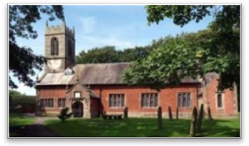
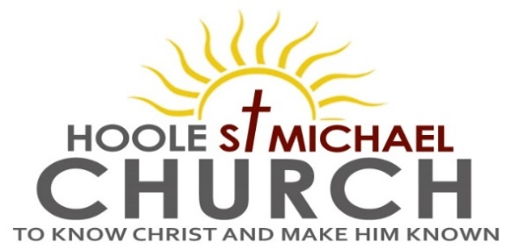

Welcome to our Church today.
Please stay for refreshments in the Lodge which follow the 10.30am service.

Sunday 23rd June 2024

GOD AND SUFFERING

He himself bore our sins in his body on the tree, so that we might die to sins and live for righteousness; by his wounds you have been healed.
(1 Peter 2: v 24.)

PRAYER OF THE DAY
O God, the protector of all who trust in you, without whom nothing
is strong, nothing is holy: increase and multiply upon us your mercy;
that with you as our ruler and guide we may so pass through things
temporal that we lose not our hold on things eternal. Amen.

Sunday School today during the service.
Toys/colouring sheets for younger children at the back of church.

9.00am. Holy Communion (Book of Common Prayer p237)
10.30am. Morning Worship with Sunday School.
Readings: Psalm 37: v 1-7.
1 Peter 2: v 21-24 and 1 Peter 3: v 8-9 & 13-16.
Hymns: 463 – My song is love unknown. (4 verses only)
Screen – God can do anything.
Suppl. 2 – How deep the Father’s love.
Suppl. 4 – O to see the dawn (The power of the cross).
447 – May the mind of Christ my Saviour.

5.00pm. Pizza ‘n Praise in Church and Lodge.

Reading 1: Psalm 37: v 1-7. (Read together)
¹ Do not fret because of those who are evil
or be envious of those who do wrong;
² for like the grass they will soon wither,
like green plants they will soon die away.
³ Trust in the Lord and do good;
dwell in the land and enjoy safe pasture.
⁴ Take delight in the Lord,
and he will give you the desires of your heart.
⁵ Commit your way to the Lord;
trust in him and he will do this:
⁶ he will make your righteous reward shine like the dawn,
your vindication like the noonday sun.
⁷ Be still before the Lord and wait patiently for him;
do not fret when people succeed in their ways,
when they carry out their wicked schemes.

Reading 2: Suffering for Doing Good (from 1 Peter chapters 2 & 3)
To this you were called, because Christ suffered for you, leaving you an example, that you should follow in his steps. ‘He committed no sin, and no deceit was found in his mouth.’ When they hurled their insults at him, he did not retaliate; when he suffered, he made no threats. Instead, he entrusted himself to him who judges justly. ‘He himself bore our sins’ in his body on the cross, so that we might die to sins and live for righteousness; ‘by his wounds you have been healed.’
Finally, all of you, be like-minded, be sympathetic, love one another, be compassionate and humble. Do not repay evil with evil or insult with insult. On the contrary, repay evil with blessing, because to this you were called so that you may inherit a blessing.
Who is going to harm you if you are eager to do good? But even if you should suffer for what is right, you are blessed. ‘Do not fear their threats; do not be frightened.’ But in your hearts revere Christ as Lord. Always be prepared to give an answer to everyone who asks you to give the reason for the hope that you have. But do this with gentleness and respect, keeping a clear conscience, so that those who speak maliciously against your good behaviour in Christ may be ashamed of their slander.
Prayer We pray for a successful response to our Giving in Grace campaign. We continue to pray for all those currently affected by the conflicts and natural disasters in the troubled areas of the world. We pray that all those who will soon be elected into government will lead our country wisely and compassionately. We pray for the sick, especially Hilary Newman, Bill and Beryl Carr, Luca Jensen, Jim Ashcroft, Sue Meadows, Nick Slinger, Judith Stopford and Elaine Read.


