PARISH DATES
Monday 26th June 7.30pm Bible for Beginners 1 in the Lodge
Tuesday 27th June 10.15am Holy Communion in the Lodge.
2.00pm Funeral Service for Tom Parkinson
Wednesday 28th June 9.30am-11.30am ST MICHAEL’S LITTLE ANGELS
Thursday 29th June 4.30pm Chat and Chocolate in the Lodge.
Friday 30th June 5.30pm Parish Walk from Dolphin - Fish ‘n Chips supper
Saturday 1st July 10.00am - 12.30pm. Ladies Group Coffee Morning-Lodge;
10.00 – 12.00 noon. Car cleaning on the Car Park.
1.00pm Wedding of Emma and Callum
Sunday 2nd July 9.00am Holy Communion
10.30am Parish Communion with Sunday School.
Monday 3rd July 7.30pm Bible for Beginners 2 in the Lodge
7.30pm Going deeper with the Bible 1.-Rectory
Tuesday 4th July 10.15am Holy Communion in the Lodge.
Wednesday 5th July 9.30am-11.30am ST MICHAEL’S LITTLE ANGELS
Thursday 6th July 4.30pm Bible and Biscuits in the Lodge.
Sunday 9th July 9.00am Holy Communion
10.30am Morning Worship
3.00pm CREAM TEA CHURCH ON THE SCHOOL FIELD
Tuesday 11th July 10.15am Morning Prayer in the Lodge.
Wednesday 12th July 9.30am-11.30am ST MICHAEL’S LITTLE ANGELS
Thursday 13th June 4.30pm Chat and Chocolate in the Lodge.
Sunday 16th July 9.00am Holy Communion
10.30am Parish Communion with Sunday School.
Monday 17th July 7.30pm Bible for Beginners 3 in the Lodge
7.30pm Going deeper with the Bible 2 -Rectory
Tuesday 18th July 10.15am Holy Communion in the Lodge.
Wednesday 19th July 9.30am-11.30am ST MICHAEL’S LITTLE ANGELS
LAST ONE BEFORE SUMMER BREAK – RE-STARTS WED. 6th SEPTEMBER
Thursday 20th July 2.00pm St Michael’s School Leavers’ service
4.30pm Bible and Biscuits in the Lodge
Suggested Bible Readings for this week:
Monday 26th June Matt. 7: v 1-5. Tuesday 27th June Matt. 7: v 6 & 12-14.
Wed. 28th June Matt. 7: v 15-20. Thursday 29th June Acts 12: v 1-11.
Friday 30th June Matt. 8: v 1-4. Saturday 1st July Matt. 8: v 5-17.
www.hooleparishchurch.com Facebook : St Michael and All Angels Church, Hoole,
Rector Ann Templeman anntempleman@live.co.uk 01772 448515 or 07877659156
PLEASE TAKE THIS SHEET HOME WITH YOU.
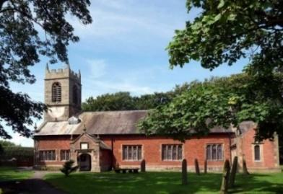
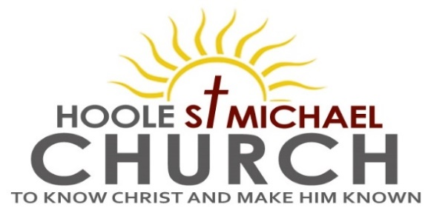

Welcome to our Church today.
Please stay for refreshments in the Lodge which follow the 10.30am service

Sunday 25th June 2023

JESUS IS PRECIOUS.

To you who believe, He is precious (1 Peter 2: v 4).

PRAYER OF THE DAY God our Saviour, look on this wounded
world in pity and in power; hold us fast to your promises of peace
won for us by your Son, our Saviour Jesus Christ. Amen.

Sunday School today during the service.
There are toys and colouring sheets for younger children
at the back of church.

9.00am. Holy Communion (Book of Common Prayer) begins p237

10.30am. Parish Communion with Sunday School.
Reading: 1 Peter: selected verses.
Hymns: Screen – Yet not I, but Christ in me.
Screen – God loves me.
297 – How sweet the name of Jesus sounds.
29 – Amazing Grace.
H/C Hymns: Screen – Jesus Name above all names.
658 – There is a Redeemer.

A PARISH WALK will take place on Friday 30th June starting from The Dolphin Inn on Marsh Lane at 5.30pm and ending there with a Fish and Chip supper. Please see Colin Wilson for details and to add your name to the list for supper.

Reading: 1 Peter: selected verses.
To you who believe He is precious.
Behold, I am laying in Zion a stone, a cornerstone chosen and precious, and whoever believes in Him will not be put to shame. You know that you were not ransomed from the futile ways inherited from your fathers with perishable things such as silver and gold, but with the precious blood of Christ, like that of a lamb without blemish or spot.
He has granted to us His precious and very great promises, that through these you may escape from the corruption that is in the world. For a little while you may have to suffer various trials, so that the genuineness of your faith, more precious than gold which though perishable is tested by fire, may redound to praise and glory and honour at the revelation of Jesus Christ.
For I am the Lord your God. Since you are precious and honoured in my sight, and because I love you, I will give people in exchange for you. (Isaiah 43 v 3-4).

Prayer: We pray for those who are sick especially Erica Ivy, Daniel Conner, Jean Smallwood, Shirley Rainsbury, Bill and Beryl Carr. We give thanks for the life of Sam Burns and pray for Dave, their children, family and friends. We give thanks too for the life of Tom Parkinson, whose funeral will take place on Tuesday June 27th, and pray for Susan and his family and friends.
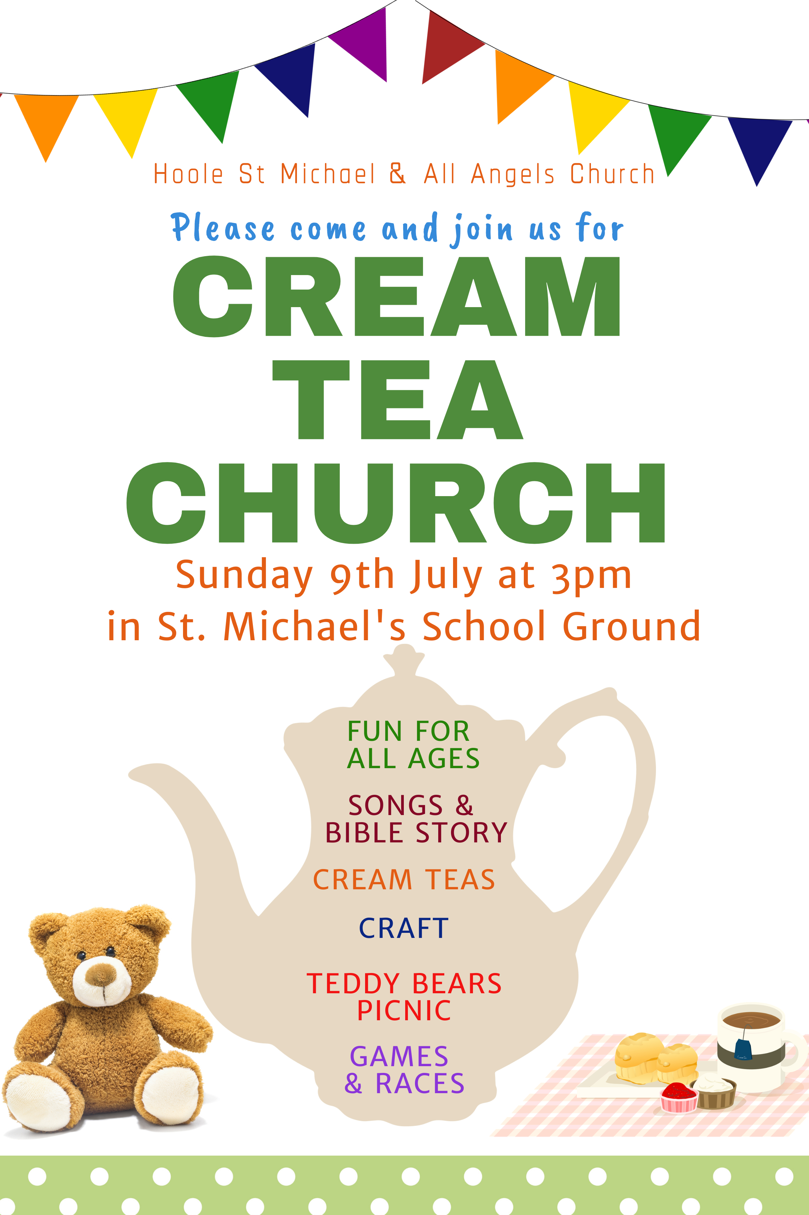

OUR AIMS : ‘TO KNOW CHRIST AND MAKE HIM KNOWN’
Please fill in the questionnaire about how we can help you deepen your own spiritual life and share your faith with others.
BIBLE FOR BEGINNERS
SESSON 1 MONDAY 26TH JUNE 7.30 in the Lodge
SESSION 2 MONDAY 3RD JULY 7.30 in the Lodge
SESSION 3 MONDAY 17TH JULY 7.30 in the Lodge
GOING DEEPER IN THE BIBLE
1.MONDAY 3RD JULY 7.30 in the Rectory
2.MONDAY 17TH JULY 7.30 in the Rectory

- MONDAY 3RD JULY 7.30 in the Rectory
- MONDAY 17TH JULY 7.30 in the Rectory

