Parish Dates June 2021 onwards
Monday June 28th 7.00pm Time of Prayer with Compline on Zoom
Sunday July 4th 09.00am Holy Communion in Church
10.30am Parish Communion in Church
Monday July 5th 7.30pm Bible Study by Zoom
Tuesday July 6th 7.30pm Bible Study in Church with Compline
Thursday July 8th 4.30pm Chat & Chocolate – young people in Church
Sunday July 11th 09.00am Holy Communion in Church
10.30am Morning Worship in Church
Sunday 18th July OUTREACH WEEKEND
09.00am Holy Communion in Church
10.30am Parish Communion in Church
2.30PM – 4.30PM FAMILY CHURCH COMMUNITY EVENT WITH ALL AGE SERVICE WITH BISHOP PHILIP.
RACES, FOOTBALL, CREAM TEAS
Saturday July 24th 1.30pm – Marriage of John Wilson and Rachel Johnson.
Sunday July 25th 09.00am Holy Communion in Church
10.30am Morning Worship in Church
Saturday July 31st from 10.00am Grand Opening of New Village Hall
with Summer Fair.
Sunday August 1st 09.00am Holy Communion in Church
10.30am Parish Communion in Church

Key Future Dates SAVE THE DATE
Harvest Festival and Social Weekend
Friday Oct 1st 7.00pm Harvest Supper & Parish Social with Quiz
and Entertainment in the New Village Hall.
Sunday Oct 3rd 10.30am Harvest Festival and Thanksgiving Service.

All the above services are ‘Live’ in church
We will aim to have audio recordings of all 10.30 services on the website www.hooleparishchurch.com by Sunday lunch time.
The Zoom link for all church Zoom activities is on the front of website.
Our Facebook page: St Michael and All Angels Church, Hoole,
Rector – Revd Ann Templeman anntempleman@live.co.uk 01772 448515
The Rectory, 69 Liverpool Old Road Much Hoole PR4 4RB
Please take this sheet home with you
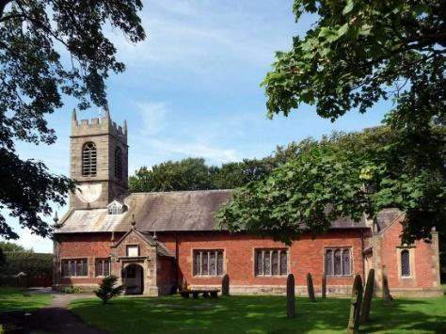
St. Michael and All Angels – Hoole

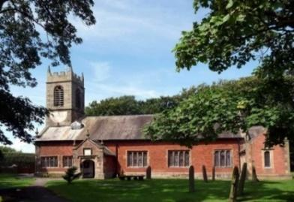

Welcome to our church again this morning. We continue to welcome new friends and welcome back others.

Sunday 27th June 2021 Trinity 4

BE MERCIFUL - DO NOT JUDGE - FORGIVE

“Be merciful, just as your Father is merciful.” Luke 6: v 36.

PRAYER OF THE DAY: Gracious Father, by the obedience
of Jesus you brought salvation to our wayward world: draw us into
harmony with your will, that we may find all things restored in him,
our Saviour Jesus Christ. Amen.

Sunday School today during the service
There are toys for younger children
at the back of church.

9.00am. Holy Communion (Book of Common Prayer) begins p237

10.30am. Morning Worship.

Reading: Luke 6: v 36-42.

Hymns : 54 – At the name of Jesus. (omit v2 & v5)
Children’s song (screen) – Nothing too big, big, big.
Canticle 1 – (tune - Ode to Joy)
144 – Dear Lord and Father of mankind.
202 – Give thanks with a grateful heart (x2)
666 – The Spirit lives to set us free, walk, walk in the light.

BIBLE READING: Luke 6: v 36-42.
‘ Be merciful, just as your Father is merciful.’
‘Do not judge, and you will not be judged. Do not condemn, and you will not be condemned. Forgive, and you will be forgiven. Give, and it will be given to you. A good measure, pressed down, shaken together and running over, will be poured into your lap. For with the measure you use, it will be measured to you.’
He also told them this parable: ‘Can the blind lead the blind? Will they not both fall into a pit? The student is not above the teacher, but everyone who is fully trained will be like their teacher.
‘Why do you look at the speck of sawdust in your brother’s eye and pay no attention to the plank in your own eye? How can you say to your brother, “Brother, let me take the speck out of your eye,” when you yourself fail to see the plank in your own eye? You hypocrite, first take the plank out of your eye, and then you will see clearly to remove the speck from your brother’s eye.

Prayer. We give thanks for the safe arrival of Arthur William Zion Wilson arrived 21st June 9lb 3 oz- Carole and Colin’s first grandchild.
We pray for those who are sick, especially Baby Erica Ivy, Patricia Mortimer, Bill and Beryl Carr, Nick Slinger, Alan Fleetwood, Nicola Middleton, Anthony Brogden and Josephine Hodge. We give thanks for the lives of Michael Harrison, and Thomas Davidson and pray for their families and friends.

RE-INSTATEMENT OF REFRESHMENTS AFTER THE 1030 SERVICE
Volunteers needed for rota. Please let Barbara Wood know if you can help. bw12252@hotmail.com

FORTNIGHTLY AND BIBLE STUDIES AND RPAYER TIMES CONTINUE
Join us for prayer at 7.00pm on Zoom on Monday 28th June
And for Bible Study on Monday 5th July 7.30pm by Zoom
and Tuesday 6th July 7.30pm in Church with Compline
We will be looking at Paul’s first letter to the Thessalonians
chapter 4

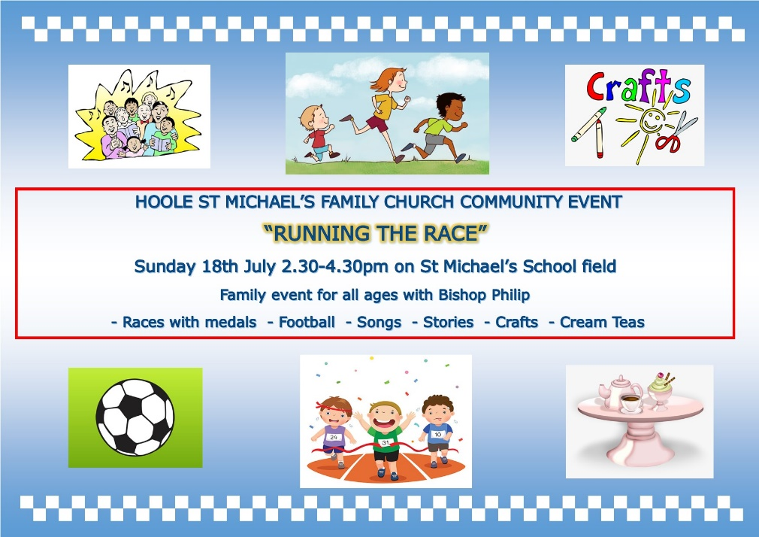

Suggested Bible readings for this week are:-
Mon. June 28th Matthew 8: v 18-22. Tues. June 29th Matthew 16: v 13-19.
Wed. June 30th Matthew 8: v 28-end. Thurs. July 1st Matthew 9: v 1-8.
Fri. July 2nd Matthew 9: v 9-13. Sat. July 3rd John 20: v 24-29.

Village Hall. Grand Opening by the Mayor of South Ribble, Cllr Jane Bell, is now on Saturday July 31st from 10.00am onwards All welcome. There will be a fair ground, stalls, food etc.
Amongst the attractions the Ladies Group will, as usual, be having a Tombola Stall. Please place donations of prizes in the plastic box near font

