PARISH DATES
Monday 1st July 7.30pm Bible for Beginners in the Lodge
Tuesday 2nd July 10.15am Holy Communion in the Lodge
Wednesday 3rd July 9.30am-11.00am St Michael’s Little Angels
11.30am Funeral of Bill Carr.
Sunday 7th July 9.00am Holy Communion
10.30am Parish Communion with Sunday School
and Prayer for Healing.
3.00pm Baptism of Ivy Wilson.
4.00pm Holy Communion (Old Mill Court)
Monday 8th July 7.30pm PCC Meeting in the Lodge
Tuesday 9th July 10.15am Holy Communion in the Lodge
Wednesday 10th July 9.30am-11.00am St Michael’s Little Angels
Sunday 14th July 9.00am Holy Communion
10.30am Morning Worship with Sunday School
Tuesday 16th July 10.15am Holy Communion in the Lodge
Wednesday 17th July 9.30am-11.00am St Michael’s Little Angels
Friday 19th July 2.15pm Year 6 Leavers’ Service in Church.
Sunday 21st July 9.00am Holy Communion
10.30am Parish Communion
3.00pm Family Church Cream tea at St Michael’s
School, with a 1966 World Cup Replay Match.
Monday 22nd July 7.30pm Bible for Beginners with Social in the Lodge.
Tuesday 23rd July 10.15am Holy Communion in the Lodge
Wednesday 24th July 9.30am-11.00am St Michael’s Little Angels
NOTE – Last one for this term.
Sunday 28th July 9.00am Holy Communion
10.30am Morning Worship
5.00pm Pizza & Praise in Church and Lodge.

Suggested Bible readings for this week:
Monday 1st July Matt. 8: v 18-22. Tuesday 2nd July Matt. 8: v 23-27.
Wednesday 3rd July John 20: v 24-29. Thursday 4th July Matt. 9: v 1-8.
Friday 5th July Matt. 9: v 9-13. Saturday 6th July Matt. 9: v 14-17.

BIBLE FOR BEGINNERS with clips from the CHOSEN
Continues on Monday 1st July at 7.30pm in the Lodge then fortnightly

www.hooleparishchurch.com Facebook : St Michael and All Angels Church, Hoole,
Rector Ann Templeman anntempleman@live.co.uk 01772 448515 or 07877659156
PLEASE TAKE THIS SHEET HOME WITH YOU.
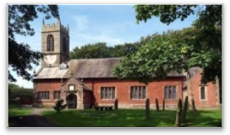
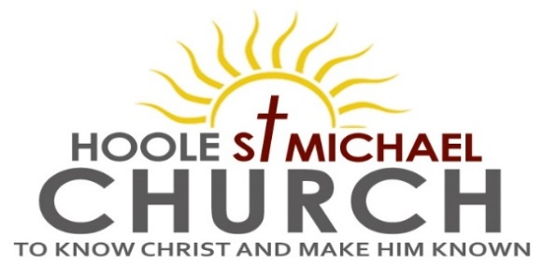

Welcome to our Church today.
Please stay for refreshments in the Lodge which follow the 10.30am service.

Sunday 30th June 2024

THE CHRISTIAN BELONGS TO TWO KINGDOMS

Love the family of believers, fear God, honour the king. (1 Peter 2: v 17.)

PRAYER OF THE DAY
Almighty God, send down upon your Church the riches of your Spirit,
and kindle in all who minister the gospel your countless gifts of grace;
through Jesus Christ our Lord. Amen.

No Sunday School today during the service.
Gladiators Family Church in School at 3.00pm.
Toys/colouring sheets for younger children at the back of church.

9.00am. Holy Communion (Book of Common Prayer p237)
10.30am. Parish Communion.
Readings: 1 Peter 1: v 13-23.
1 Peter 2: v 13-14 & 17.
Hymns: 54 – At the Name of Jesus. (verses 1, 3, 4 &6)
Suppl. 8 – King of Kings Majesty.
Screen – There is a higher throne.
205 – Glorious things of Thee are spoken. (tune 1)
H/C Hymns: Screen – God of glory.
436 – Majesty, worship his majesty.

3.00pm. GLADIATORS FAMILY CHURCH
in St. Michael’s School – for all the family.

Wednesday June 3rd at 11.30am Funeral of Bill Carr.
Reading1: Be Holy. 1 Peter 1: v 13-23.
Therefore, with minds that are alert and fully sober, set your hope on the grace to be brought to you when Jesus Christ is revealed at his coming. As obedient children, do not conform to the evil desires you had when you lived in ignorance. But just as he who called you is holy, so be holy in all you do; for it is written: “Be holy, because I am holy.”
Since you call on a Father who judges each person’s work impartially,
live out your time as foreigners here in reverent fear. For you know that it was not with perishable things such as silver or gold that you were redeemed from the empty way of life handed down to you from your ancestors, but with the precious blood of Christ, a lamb without blemish or defect. He was chosen before the creation of the world, but was revealed in these last times for your sake. Through him you believe in God, who raised him from the dead and glorified him, and so your faith and hope are in God.
Now that you have purified yourselves by obeying the truth so that you have sincere love for each other, love one another deeply, from the heart. For you have been born again, not of perishable seed, but of imperishable, through the living and enduring word of God.

Reading 2: Submission to Rulers and Masters. 1 Peter 2: v 13-14 & 17.
Submit yourselves for the Lord’s sake to every human authority: whether to the king, as the supreme authority, or to governors, who are sent by him to punish those who do wrong and to commend those who do right. Show proper respect to everyone, love the family of believers, fear God, honour the king.

Prayer We pray for a successful response to our Giving in Grace campaign. We continue to pray for all those currently affected by the conflicts and natural disasters in the troubled areas of the world. We pray that all those who will soon be elected into government will lead our country wisely and compassionately. We pray for the sick, especially Hilary Newman, Beryl Carr, Jim Ashcroft, Sue Meadows, Judith Stopford and Elaine Read. We give thanks for the life of Bill Carr and pray for Beryl, Andrew, Debbie and all his family and friends.

PRAY FOR OUR CHURCH
Please come and join us for Prayer for the future of our church on Tuesdays in the Lodge at 10.15 during our service of Holy Communion


