PARISH DATES
Monday 5th June 7.30pm in the Lodge. WHAT DO CHRISTIANS
BELIEVE ABOUT SAME SEX RELATIONSHIPS?
Tuesday 6th June 10.15am Holy Communion in the Lodge.
Wednesday 7th June 9.30am–11.30am ST MICHAEL’S LITTLE ANGELS
Thursday 8th June 4.30pm Bible and Biscuits in the Lodge.
Friday 9th June 9.30- 3.00pm Spirituality Day – St Michael’s School
Sunday 11th June 9.00am Holy Communion
10.30am Morning Worship
3.45pm HOLIDAY CHURCH IN THE VILLAGE HALL
Monday 12th June 11.30am Celebration of the Life of Sam Burns
Tuesday 13th June 10.15am Morning Prayer in the Lodge.
Wednesday 14th June 9.30am–11.30am ST MICHAEL’S LITTLE ANGELS
7.30pm Bible Study -Lodge: The Power of Prayer Acts 12 v1-19
Thursday 15th June 4.30pm Chat and Chocolate in the Lodge.
Sunday 18th June 9.00am Holy Communion
10.30am ALL AGE SERVICE
Tuesday 20th June 10.15am Morning Prayer in the Lodge.
7.30pm Ladies Group in the Village Hall (My Life of Work – Colin Wilson)
Wednesday 21st June 9.30am–11.30am ST MICHAEL’S LITTLE ANGELS
Thursday 22nd June 4.30pm Bible and Biscuits in the Lodge.
Sunday 25th June 9.00am Holy Communion
10.30am Parish Communion with Sunday School.
Monday 26th June 7.30pm Bible for Beginners 1 in the Lodge
Tuesday 27th June 10.15am Holy Communion in the Lodge.
Wednesday 28th June 9.30am-11.30am ST MICHAEL’S LITTLE ANGELS
Thursday 29th June 4.30pm Chat and Chocolate in the Lodge.
Friday 30thJune 5.30pm Parish Walk from Dolphin - Fish ‘n Chips supper
Saturday 1st July 9.30am Ladies Group Coffee Morning-Lodge; Car cleaning
1.00pm Wedding of Emma and Callum
Sunday 2nd July 9.00am Holy Communion
10.30am Parish Communion with Sunday School.
Monday 3rd July 7.30pm Bible for Beginners 2 in the Lodge
7.30pm Going deeper with the Bible-Rectory
Bible Readings: Monday 5th June Mark 12: v 1-12. Tuesday 6th June Mark 12: v 13-17.
Wed. 7th June Mark 12: v 18-27. Thursday 8th June Mark 12: v 28-34.
Friday 9th June Mark 12: v 35-37. Saturday 10th June Mark 12: v 38-end.
www.hooleparishchurch.com Facebook : St Michael and All Angels Church, Hoole,
Rector Ann Templeman anntempleman@live.co.uk 01772 448515 or 07877659156
PLEASE TAKE THIS SHEET HOME WITH YOU.
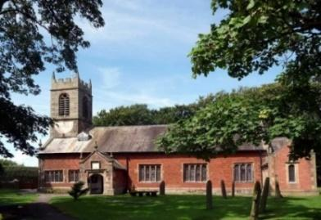
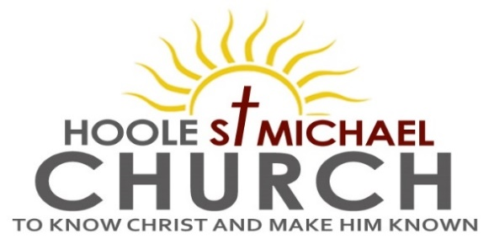

Welcome to our Church today.
Please stay for refreshments in the Lodge which follow the 10.30am service

Sunday 4th June 2023 (Trinity Sunday)

GOD THE FATHER, SON and HOLY SPIRIT.

When the Counsellor comes, whom will I send to you from the Father, the Spirit of truth who goes out from the Father, He will testify about me.
(John 15: v 26).

PRAYER OF THE DAY Holy God, faithful and unchanging:
enlarge our minds with the knowledge of your truth, and draw us
more deeply into the mystery of your love, that we may truly worship
you, Father, Son and Holy Spirit, one God, now and for ever. Amen.

Sunday School today during the service.
There are toys and colouring sheets for younger children
at the back of church.

9.00am. Holy Communion (Book of Common Prayer) begins p237

10.30am. Parish Communion with Sunday School.
Readings: John 15: v 26-27.
John 16: v 5-16.
Hymns: 436 – Majesty, worship His Majesty.
590 – Seek ye first the Kingdom of God (round).
447 – May the mind of Christ my Saviour.
413 – Lord of all hopefulness.
H/C Hymns: Screen – Father we love you.
285 – Holy, holy, holy is the Lord.

4.00pm. Holy Communion (Old Mill Court)

Reading 1: John 15: v 26-27. ‘When the Counsellor comes, whom I will send to you from the Father – the Spirit of truth who goes out from the Father – He will testify about me. And you also must testify, for you have been with me from the beginning.

Reading 2: John 16: v 5-16. Now I am going to him who sent me. None of you asks me, “Where are you going?” Rather, you are filled with grief because I have said these things. But very truly I tell you, it is for your good that I am going away. Unless I go away, the Advocate will not come to you; but if I go, I will send him to you. When he comes, he will prove the world to be in the wrong about sin and righteousness and judgment: about sin, because people do not believe in me; about righteousness, because I am going to the Father, where you can see me no longer; and about judgment, because the prince of this world now stands condemned.
‘I have much more to say to you, more than you can now bear. But when he, the Spirit of truth, comes, he will guide you into all the truth. He will not speak on his own; he will speak only what he hears, and he will tell you what is yet to come. He will glorify me because it is from me that he will receive what he will make known to you. All that belongs to the Father is mine. That is why I said the Spirit will receive from me what he will make known to you.’
Jesus went on to say, ‘In a little while you will see me no more, and then after a little while you will see me.’

Prayer: We pray for those who are sick especially Erica Ivy, Daniel Conner, Jean Smallwood, Shirley Rainsbury, Bill and Beryl Carr. We give thanks for the life of Sam Burns and pray for Dave, their children, family and friends. We commit to you her funeral service and the service to celebrate Sam’s life on Monday 12th June. We give thanks too for the life of Tom Parkinson and pray for his family

WHAT IS THE CHRISTIAN TEACHING ON SAME SEX RELATIONSHIPS?
Monday 5th June 7.30pm in the Lodge

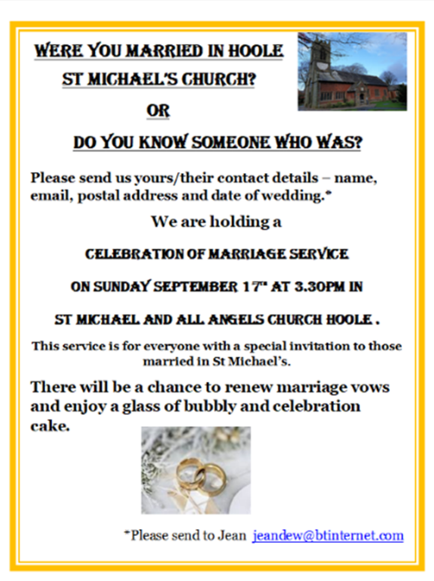
OUR AIMS : ‘TO KNOW CHRIST AND MAKE HIM KNOWN’
Please fill in the questionnaire about how we can help you deepen your own spiritual life and share your faith with others.
BIBLE FOR BEGINNERS
SESSON 1 MONDAY 26TH JUNE 7.30 in the Lodge
SESSION 2 MONDAY 3RD JULY 7.30 in the Lodge
SESSION 3 MONDAY 17TH JULY 7.30 in the Lodge
GOING DEEPER IN THE BIBLE
1.MONDAY 3RD JULY 7.30 in the Rectory
2.MONDAY 17TH JULY 7.30 in the Rectory

- MONDAY 3RD JULY 7.30 in the Rectory
- MONDAY 17TH JULY 7.30 in the Rectory

