Parish Dates June 2021 onwards
Monday June 7th 7.30pm Bible Study by Zoom
Tuesday June 8th 7.30pm Bible Study in Church with Compline
Thursday June 10th 4.30pm Chat & Chocolate – young people in Church

Sunday June 13th 09.00am Holy Communion in Church
10.30am Morning Worship in Church
Monday June 15th 7.00pm Time of Prayer on Zoom

Sunday June 20th 09.00am Holy Communion in Church
10.30am Parish Communion in Church
Note change of time>> 3.00pm MAD HATTERS FAMILY CHURCH
TEA PARTY
Thursday June 24th 4.20pm Chat & Chocolate – young people in Church
Saturday June 26th from 10.00am Grand Opening of New Village Hall
with Summer Fair.

Sunday June 27th 09.00am Holy Communion in Church
10.30am Morning Worship in Church

Sunday July 4th 09.00am Holy Communion in Church
10.30am Parish Communion in Church
Thursday July 8th 4.30pm Chat & Chocolate – young people in Church

Sunday July 11th 09.00am Holy Communion in Church
10.30am Morning Worship in Church

Key Future Dates SAVE THE DATE
16-18th July OUTREACH WEEKEND
Friday July 16th 7.00pm Parish Social with Quiz and Entertainment
in the New Village Hall.
Sunday July 18th 2.00pm – 4.00pm Event for children and families
with Bishop Philip.
All the above services are ‘Live’ in church
We will aim to have recordings of all 10.30 services on the website www.hooleparishchurch.com by Sunday lunch time.
The Zoom link for all church Zoom activities is on the front of website.
Our Facebook page: St Michael and All Angels Church, Hoole,
Rector – Revd Ann Templeman anntempleman@live.co.uk 01772 448515
The Rectory, 69 Liverpool Old Road Much Hoole PR4 4RB
Please take this sheet home with you
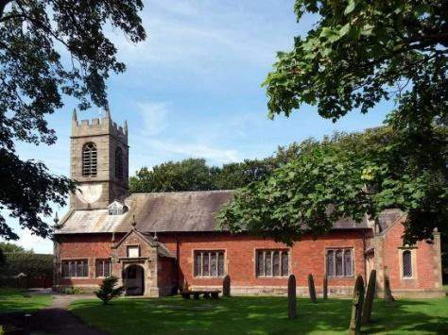
St. Michael and All Angels – Hoole

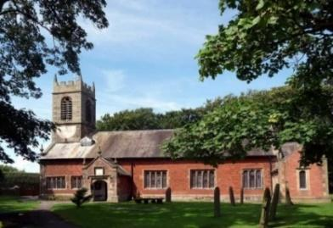

Welcome to our church again this morning. We continue to welcome back friends who have not felt able to attend
over recent months.

Sunday 6th June 2021 Trinity 1

THE APOSTLE PETER’S SERMON

“God has made this Jesus, whom you crucified,
both Lord and Christ.” Acts 2: v 36.

PRAYER OF THE DAY: God of truth, help us to keep your law
of love and to walk in ways of wisdom, that we may find true life
in Jesus Christ your Son. Amen.

Sunday School today during the service
There are toys for younger children
at the back of church.
at the back of church.

9.00am. Holy Communion (Book of Common Prayer) begins p237

10.30am. Parish Communion with Sunday School.
Readings: Acts 2: v 22-28. Acts 2: v 29-41.
Hymns : 565 – Praise, my soul, the King of heaven.
Screen – Children’s song.
475 – Now the green blade riseth.
303 – I cannot tell.
Screen – We rest on Thee. (tune Finlandia. 68)
H/C Hymns 620 – Such love.
167 – Father we love you.

BIBLE READINGS: Acts 2: v 22-28. “Fellow Israelites, listen to this:
Jesus of Nazareth was a man accredited by God to you by miracles, wonders and signs, which God did among you through him, as you yourselves know. This man was handed over to you by God’s deliberate plan and foreknowledge; and you, with the help of wicked men, put him to death by nailing him to the cross. But God raised him from the dead, freeing him from the agony of death, because it was impossible for death to keep its hold on him. David said about him:
“‘I saw the Lord always before me. Because he is at my right hand,
I will not be shaken. Therefore my heart is glad and my tongue rejoices;
my body also will rest in hope, because you will not abandon me to the realm of
the dead, you will not let your holy one see decay. You have made known to
me the paths of life; you will fill me with joy in your presence.

Acts 2: v 29-41. “Fellow Israelites, I can tell you confidently that the patriarch David died and was buried, and his tomb is here to this day. But he was a prophet and knew that God had promised him on oath that he would place one of his descendants on his throne. Seeing what was to come, he spoke of the resurrection of the Messiah, that he was not abandoned to the realm of the dead, nor did his body see decay. God has raised this Jesus to life, and we are all witnesses of it. Exalted to the right hand of God, he has received from the Father the promised Holy Spirit and has poured out what you now see and hear. For David did not ascend to heaven, and yet he said,
“‘The Lord said to my Lord: “Sit at my right hand
until I make your enemies a footstool for your feet.”
“Therefore let all Israel be assured of this: God has made this Jesus, whom you
crucified, both Lord and Christ.”
When the people heard this, they were cut to the heart and said to Peter and the other apostles, “Brothers, what shall we do?”
Peter replied, “Repent and be baptized, every one of you, in the name of Jesus Christ for the forgiveness of your sins. And you will receive the gift of the Holy Spirit. The promise is for you and your children and for all who are far off—for all whom the Lord our God will call.”
With many other words he warned them; and he pleaded with them, “Save yourselves from this corrupt generation.” Those who accepted his message were baptized, and about three thousand were added to their number that day.

Prayer. We pray for those who are sick, especially Baby Erica Ivy, Patricia Mortimer, Beryl Carr, Alan Fleetwood and Josephine Hodge.
We give thanks for the lives of Fiona Spalding and Thomas Davidson and pray for their families and friends. We give thanks for the life of Michael Harrison and pray for his wife Nina and the rest of his family and friends at this sad time.

FORTNIGHTLY BIBLE STUDIES CONTINUE
Mon 7th June 7.30pm by Zoom
and Tuesday 8th June 7.30pm in Church with Compline
We continue to look at Paul’s first letter to the Thessalonians

Village Hall. We were pleased that many people took time to have a look round the New Village Hall over the Bank Holiday weekend and many favourable comments were received.
The official Grand Opening by the Mayor of South Ribble, Cllr Jane Bell, will take place on Saturday June 26th from 10.00am onwards. All welcome. There will be a fair ground, stalls, food and entertainment for all. We look forward to seeing you there.
Amongst the attractions the Ladies Group will, as usual, be having a Tombola Stall. We require prizes for this and any suitable donations may be placed in the plastic box next to the font in church.

