Parish Dates From March 2022
Monday 21st March 7.30pm Housegroup at the Rectory
Tuesday 22nd March 10.15am Morning Prayer.
Thursday 24th March 4.30pm Chat and Chocolate

Sunday 27th March 09.00am Holy Communion
MOTHERING SUNDAY 10.30AM PARISH COMMUNION WITH SUNDAY SCHOOL AND DISTRIBUTION OF FLOWERS
3.00pm Baptism of Arthur Wilson.
Monday 28th March 7.30pm PCC meet at the Village Hall.
Tuesday 29th March 10.15am Holy Communion.
7.30pm Housegroup at the Rectory

Sunday 3rd April 09.00am Holy Communion
10.30am Parish Communion with Sunday School.
4.00pm Holy Communion (Old Mill Court)
Monday 4th April 7.30pm Housegroup at the Rectory
Tuesday 5th April 10.15am Prayer time in Church.

PALM SUNDAY 10TH April 09.00am Holy Communion
10.30AM FAMILY WORSHIP with PONY RIDES (=donkeys!)Meet school playground 10.10am to process to church
Tuesday 12th April 10.15am Morning Prayer.
7.30pm Men’s Fellowship meet in the Village Hall
MAUNDY THURSDAY 14th April 7.00pm PASSOVER MEAL St Michael’s school
GOOD FRIDAY 15TH April 11.00am FAMILY CHURCH
2.00pm AN HOUR AND A HALF at the CROSS incorporating
THE TRIAL BY ST MICHAEL’S PLAYERS

EASTER DAY 17th April 09.00am Holy Communion
10.30am PARISH COMMUNION WITH EASTER EGG
HUNT FOR CHILDREN
Suggested Bible readings this week.
Monday 21st March. John 7: v 10-24. Tuesday 22nd March John 7: v 25-36.
Wed. 23rd March. John 7: v 37-52. Thursday 24th March John 7: v 53 – 8: v 11.
Friday 25th March John 8: v 12-20. Saturday 26th March John 8: v 21-30.

Website : www.hooleparishchurch.com
Facebook page: St Michael and All Angels Church, Hoole,
Rector – Revd Ann Templeman anntempleman@live.co.uk 01772 448515
The Rectory, 69 Liverpool Old Road Much Hoole PR4 4RB
Please take this sheet home with you
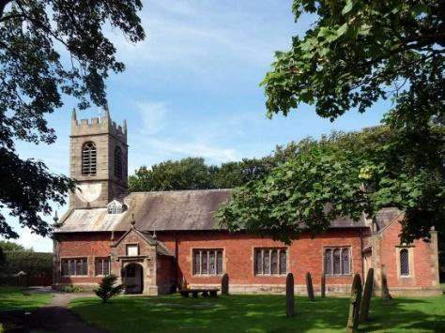
St. Michael and All Angels – Hoole

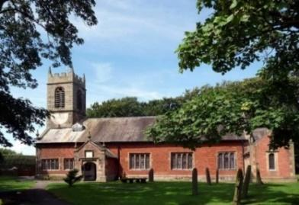

Welcome to our church again this morning. Please stay for a chat and a cup of tea or coffee after the 10.30 service, a great way to meet people

Sunday 20th March 2022 (Lent 3)

JESUS HEALS THE MAN BORN BLIND
Jesus said “I am the Light of the world.”

“One thing I know. I was blind but now I see” John 9: v 25.

PRAYER OF THE DAY: Eternal God, give us insight to discern your
will for us, to give up what harms us, and to seek the perfection we are
promised in Jesus Christ our Lord. Amen.
No Sunday School today during the service
Grandparents’ Church at 3.45pm
in the Village Hall
There are toys and colouring sheets
for younger children at the back of church.

9.00am. Holy Communion (Book of Common Prayer) begins p237
10.30am. Parish Communion.
Readings: John 9: v 1-12 & 17. John 9: v 24-29 & 35-41.
Hymns: 303 – I cannot tell.
29 – Amazing grace (“Was blind but now I see”)
314 – Immortal, Invisible
252 – Guide me, O thou great Redeemer.

H/C Hymns: Screen – God of glory, we exalt your Name.
18 – All I once held dear.
3.45pm: Grandparents’ Church in the Village Hall.
READING: John 9: v 1-12 & 17. As he went along, he saw a man blind from birth. His disciples asked him, ‘Rabbi, who sinned, this man or his parents, that he was born blind?’ ‘Neither this man nor his parents sinned,’ said Jesus ‘but this happened so that the works of God might be displayed in him. As long as it is day, we must do the works of him who sent me. Night is coming, when no one can work. While I am in the world, I am the light of the world.’ After saying this, he spat on the ground, made some mud with the saliva, and put it on the man’s eyes. ‘Go,’ he told him, ‘wash in the Pool of Siloam’ (this word means ‘Sent’). So the man went and washed, and came home seeing.
His neighbours and those who had formerly seen him begging asked, ‘Isn’t this the same man who used to sit and beg?’ Some claimed that he was. Others said, ‘No, he only looks like him.’ But he himself insisted, ‘I am the man.’ ‘How then were your eyes opened?’ they asked. He replied, ‘The man they call Jesus made some mud and put it on my eyes. He told me to go to Siloam and wash. So I went and washed, and then I could see.’
‘Where is this man?’ they asked him. ‘I don’t know,’ he said.
Then they turned again to the blind man, ‘What have you to say about him? It was your eyes he opened.’ The man replied, ‘He is a prophet.’

John 9: v 24-29 & 35-41. A second time they summoned the man who had been blind. ‘Give glory to God by telling the truth,’ they said. ‘We know this man is a sinner.’ He replied, ‘Whether he is a sinner or not, I don’t know.
One thing I do know. I was blind but now I see!’
Then they asked him, ‘What did he do to you? How did he open your eyes?’ He answered, ‘I have told you already and you did not listen. Why do you want to hear it again? Do you want to become his disciples too?’ Then they hurled insults at him and said, ‘You are this fellow’s disciple! We are disciples of Moses! We know that God spoke to Moses, but as for this fellow, we don’t even know where he comes from.’
Jesus heard that they had thrown him out, and when he found him, he said, ‘Do you believe in the Son of Man?’ ‘Who is he, sir?’ the man asked. ‘Tell me so that I may believe in him.’ Jesus said, ‘You have now seen him; in fact, he is the one speaking with you.’ Then the man said, ‘Lord, I believe,’ and he worshipped him. Jesus said,] ‘For judgment I have come into this world, so that the blind will see and those who see will become blind.’ Some Pharisees who were with him heard him say this and asked, ‘What? Are we blind too?’ Jesus said, ‘If you were blind, you would not be guilty of sin; but now that you claim you can see, your guilt remains.
Prayer: We pray for Charlotte Hickey who was baptised last week and Arthur Wilson who is shortly to be baptised. We pray for those who are sick, especially Erica Ivy, Tom Parkinson, Steve Coughlan, Beryl Cottam, Barbara Wood, Antonietta Broadhurst and Roy Sanderson.

A Prayer for Ukraine
God of peace and justice, we pray for the people of Ukraine today.
We pray for peace and the laying down of weapons.
We pray for all those who fear for tomorrow,
that your Spirit of comfort would draw near to them.
We pray for those with power over war or peace,
for wisdom, discernment and compassion to guide their decisions. Above all, we pray for all your precious children, at risk and in fear, that you would hold and protect them.
We pray in the name of Jesus, the Prince of Peace. Amen

Thank you so much to everybody who has donated items to the Ukraine. We understand that all the items donated last week have now arrived in Ukraine.
Items still needed are FOOD, MEDICAL SUPPLIES & TOILETRIES.
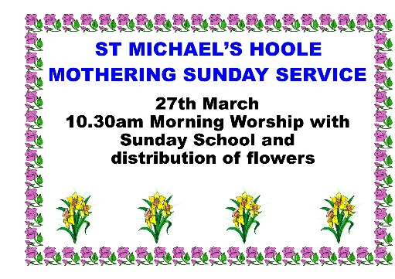

LENT BIBLE STUDIES AT THE RECTORY 7.30PM
Monday 21 March - John 7 v 37 – 52– Living Water
Tuesday 29 March - John 10 v 1 – 21 – Jesus The Good Shepherd
Monday 4 April - John 13 v 1 – 20 - Jesus washes the disciples’ feet
MAUNDY THURSDAY 14 APRIL PASSOVER MEAL 7pm in St Michael’s School

