**Parish Dates March 2021 onwards**

**Tuesday 23rd March 7.30pm Zoom Bible Study**

**Thursday 25th March 7.30pm Short time of Prayer via Zoom**

**Sunday 28th March 09.00am Holy Communion in Church**

**PALM SUNDAY 10.30am PALM SUNDAY SERVICE in Church**

**with distribution of palms.**

**Thursday April 1st 6.00pm MAUNDY THURSDAY service of**

**Holy Communion in church**

**Friday April 2nd 11.00am GOOD FRIDAY Family Church**

**GOOD FRIDAY 2.00pm An Hour at the Cross in St Michael’s.**

**Sunday April 4th  09.00am Holy Communion in Church**

**EASTER SUNDAY 10.30am Easter Sunday Service of Holy Communion**

**with Children’s EASTER EGG HUNT in the Churchyard.**

**THERE WILL ALSO BE AN EASTER TRAIL ROUND THE VILLAGE FOR FAMILIES FROM**

**WEDNESDAY 31st MARCH UNTIL EASTER SATURDAY.**

**Sunday April 11th 09.00am Holy Communion in Church**

**10.30am Morning Worship in Church**

**Sunday April 18th 09.00am Holy Communion in Church**

**10.30am Parish Communion in Church**

**All the above services are ‘Live’ in church**

**We will aim to have recordings of all 10.30 services on the website www.hooleparishchurch.com by Sunday lunch time.**

**The Zoom link for our Bible studies on Tuesdays and Prayer times on Thursdays is on the front page of the website.**

Our Facebook page: **St Michael and All Angels Church, Hoole**, our website is www.hooleparishchurch.com

Rector – Revd Ann Templeman anntempleman@live.co.uk 01772 448515

The Rectory, 69 Liverpool Old Road Much Hoole PR4 4RB

*Please take this sheet home with you*

**St. Michael and All Angels – Hoole**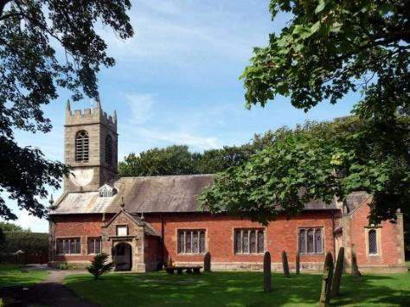

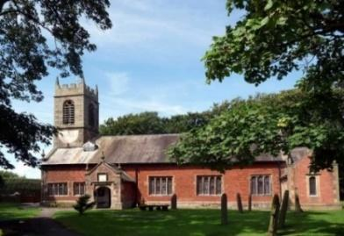

***Welcome to our church again this morning. A special welcome to those who may not have been in church for some time. Please observe social distancing, but stay close to Christ.***

***Sunday 21st March 2021 Lent 5.***

**THE PASSION OF CHRIST**

**“Yet not what I will, but what you will.”** *Mark 14: v 36.*

**PRAYER OF THE DAY: Gracious Father, you gave up your Son**

**out of love for the world: lead us to ponder the mysteries of his**

**passion, that we may know eternal peace through the shedding of our**

**Saviour’s blood, Jesus Christ our Lord. Amen.**

**No Sunday School today during the service**

There are toys for younger children

at the back of church.

**Lion King Family Church at 3.45pm**

**

**9.00am. Holy Communion (Book of Common Prayer) begins p237**

**10.30am. Parish Communion.**

**Reading: Mark 14: v 32-42.**

**Hymns : 463 (v 1,5 & 6) – My song is love unknown.**

**Supplement 2: How deep the Father’s love.**

**535 – O sacred head, surrounded.**

**657 – There is a green hill far away.**

**H/C Hymns: 658 – There is a Redeemer. 738 – When I survey.**

**3.45pm. LION KING FAMILY CHURCH (Zoom)**

**BIBLE READINGS**: **Mark 14: v 32-42.** They went to a place called Gethsemane, and Jesus said to his disciples, “Sit here while I pray.” He took Peter, James and John along with him, and he began to be deeply distressed and troubled. “My soul is overwhelmed with sorrow to the point of death,” he said to them. “Stay here and keep watch.”

Going a little farther, he fell to the ground and prayed that if possible the hour might pass from him. *“Abba*, Father,” he said, “everything is possible for you. Take this cup from me. Yet not what I will, but what you will.”

Then he returned to his disciples and found them sleeping.  “Simon,” he said to Peter, “are you asleep? Couldn’t you keep watch for one hour? 

Watch and pray so that you will not fall into temptation.  The spirit is willing, but the flesh is weak.” But these verses don't end with that.

Once more he went away and prayed the same thing. When he came back, he again found them sleeping, because their eyes were heavy. They did not know what to say to him.

Returning the third time, he said to them, “Are you still sleeping and resting? Enough! The hour has come. Look, the Son of Man is delivered into the hands of sinners. Rise! Let us go! Here comes my betrayer!”

**Prayer.** We continue to pray for those recently confirmed. We pray too for those who are sick, especially Michael Pulvermacher, Betty Clough, Debbie, Baby Erica Ivy, Joan Gleave, Eva Coxhead, Beryl Carr, and Keith Norton. We give thanks for the life of Colin Clark, whose funeral took place on Thursday and pray for his family and friends. We also give thanks for the life of Betty Clough whose funeral is to take place on Monday 29th March and pray for her family. We pray also for the families of Michael Scott, Ann Rooke, Tommy Lyon and the Spencer family who have all suffered recent bereavements.

**LENT AND BIBLE STUDIES** **Bishops’ Lent book**

For all Christians Lent is a time to take stock and spend more time with God.Please help yourself to a free Lent book from the back of the churchwhich will take you through the whole of Mark’s Gospel.

**This week’s readings are:-:**

**Mon.** March 22nd Mark 11: v 12-19. **Tues.** March 23rd Mark 11: v 20-26. **Wed.** March 24th Mark 11: v 27-33. **Thurs.** March 25th Mark 12: v 1-12.

**Fri.** March 26th Mark 12: v 13-17. **Sat.** March 27th Mark 12: v 18-27.

**Bible studies by Zoom**

We use the Tuesday reading each week as the basis for our **Zoom Bible study which are weekly on Tuesdays throughout Lent at 7. 30pm** **continuing on March 23rd** (Zoom link on website).

**Prayer in Lent There is a short time of** **prayer each week on Zoom on Thursdays at 7.30pm continuing on March 25th.**

