Parish Dates From March 2023

Monday 27th March 7.30pm PCC meeting in the lodge
Tuesday 28th March 10.15am Holy Communion in the Lodge.
Wednesday 29th March 7.15pm PREPARING FOR EASTER 2 in the Lodge
Thursday 30th March 9.00am School Easter Service in Church
4.30pm Bible and Biscuits in the Lodge.
Sunday 2nd April 9.00am Holy Communion
PALM SUNDAY 10.10am Palm Sunday service
HOLY WEEK BEGINS with donkey procession from school to church.
Tuesday 4th April 10.15am Holy Communion in the Lodge.
Thursday 6th April 7.00pm PASSOVER MEAL
MAUNDY THURSDAY in ST MICHAEL’S SCHOOL
Friday 7th April 11:00am An Hour at the Cross in Church
GOOD FRIDAY 11:00am A Children’s Hour at the Cross in the Lodge
12.00noon Hunger Lunch in the Lodge in aid of FOMO.
Sunday 9th April 9.00am Holy Communion
EASTER SUNDAY 10.30am Parish Communion with Easter Egg Hunt.
Tuesday 11th April 10.15am Morning Worship in the Lodge.
Sunday 16th April 9.00am Holy Communion
10.30am Morning Worship with Sunday School
Tuesday 18th April 10.15am Holy Communion in the Lodge.
Thursday 20th April 4.30pm Bible and Biscuits in the Lodge.
Sunday 23rd April 9.00am Holy Communion
10.30am Morning Worship with Sunday School
Tuesday 25th April 10.15am Holy Communion in the Lodge.
Thursday 27th April 4.30pm Chat and Chocolate in the Lodge.
Friday 28th April 7.00pm CHARITY DINNER in the Village Hall.
Sunday 30th April 9.00am Holy Communion
10.30am Holy Communion with Sunday School.
Tuesday 2nd May 10.15am Holy Communion in the Lodge.
Thursday 4th May 4.30pm Bible and Biscuits in the Lodge.
Sunday 7th May 10.30am CIVIC SERVICE with Sunday School.
CORONATION 12.00noon COMMUNITY CELEBRATIONS
WEEKEND on St Michael’s School Field.
Monday 8th May 10.00am-4.00pm Local History Festival in Village Hall.
www.hooleparishchurch.com
Facebook page: St Michael and All Angels Church, Hoole,
Rector Ann Templeman anntempleman@live.co.uk 01772 448515 or 07877659156
PLEASE TAKE THIS SHEET HOME WITH YOU.
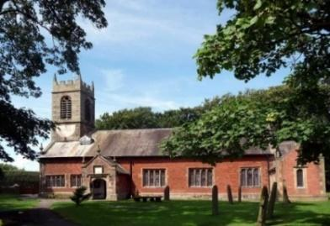
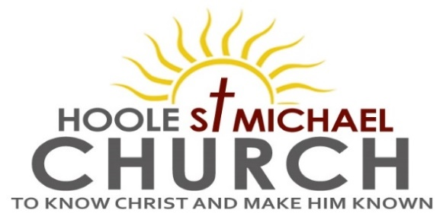

Welcome to our Church today.
Please stay for refreshments in the Lodge after the service.

Sunday 26th March 2023

PASSION SUNDAY – THE SUFFERING (PASSION) OF JESUS.

He Himself bore our sins in His body on the tree, that we might die to sins and live for righteousness. By His wounds you have been healed. 1 Peter 2 v 24.

PRAYER OF THE DAY Most merciful God, who by the death
and resurrection of your Son Jesus Christ delivered and saved the
world: grant that by faith in him who suffered on the cross we may
triumph in the power of his victory; through Jesus Christ your Son
our Lord, who is alive and reigns with you, in the unity of the Holy
Spirit, one God, now and for ever. Amen.
Sunday School today during the service.
There are toys and colouring sheets for younger children
at the back of church.

9.00am. Holy Communion (Book of Common Prayer) begins p237

10.30am. Morning Worship with Sunday School.
Reading: 1 Peter 2: v 18-25.
Hymns: 337 – I will sing the wondrous story.
Screen – All through history.
Suppl. 4 – O to see the dawn (The power of the cross)
Suppl. 10 – Here is love, vast as the ocean.
658 – There is a Redeemer.
Screen – Yet not I , but Christ in me.

Reading: 1 Peter 2: v 18-25. Servants, in reverent fear of God submit yourselves to your masters, not only to those who are good and considerate, but also to those who are harsh. For it is commendable if someone bears up under the pain of unjust suffering because they are conscious of God. But how is it to your credit if you receive a beating for doing wrong and endure it? But if you suffer for doing good and you endure it, this is commendable before God. To this you were called, because Christ suffered for you, leaving you an example, that you should follow in his steps.
“He committed no sin, and no deceit was found in his mouth.”
When they hurled their insults at him, he did not retaliate; when he suffered, he made no threats. Instead, he entrusted himself to him who judges justly. He himself bore our sins in his body on the tree, so that we might die to sins and live for righteousness; by his wounds you have been healed. For you were like sheep going astray, but now you have returned to the Shepherd and Overseer of your souls.
Prayer: We pray for all the Outreach events planned for the King’s Coronation. We pray for babies Erica Ivy and Albie, we pray for others who are sick especially Sam Burns, Christine Barker, Jim Ashcroft, Daniel Connor, Shirley Rainsbury, Bill and Beryl Carr, Josephine Hodge and Antonietta Broadhurst. We give thanks for the life of Mona Lewis and pray for her family and friends.

PASSOVER MEAL
Maundy Thursday, 6th April at 7.00pm
St Michael’s Primary School.
Suitable for the whole family
This is a lovely way to enjoy a meal together and discover more about the background of our Communion service.
Please give your name to one of the churchwardens or sign the list at the back of the church
There is no charge but we invite donations of around £7 per adult
(£2 children) Please see Hilary Newman to help with salad or potatoes

Suggested Bible Readings this week
Monday 27th March Luke 17: v 11-37. Tuesday 28th March Luke 18: v 1-17.
Wed. 29th March Luke 18: v 18-43. Thursday 30th March Luke 19: v 1-27.
Friday 31st March Luke 19: v 28-48. Saturday 1st April Luke 20: v 1-26.

CORONATION CHARITY DINNER FRIDAY 28TH APRIL at the VENUE, MUCH HOOLE VILLAGE HALL 7.00PM
Please hand in your booking form asap

CORONATION WEEKEND MAY 6TH/7TH
Sunday May 7th 10.30am
CIVIC SERVICE in St Michael’s Church
COMMUNITY CELEBRATIONS ON ST MICHAEL’S SCHOOL FIELD WITH BBQ, and FOOTBALL MATCH
Monday May 8th
LOCAL HISTORY FESTIVAL 10-4.00PM IN THE VENUE

