Parish Dates
Monday March 28th 2.00pm Funeral of Betty Clough
Thursday April 1st 6.00pm MAUNDY THURSDAY service of
Holy Communion in church

Friday April 2nd 11.00am GOOD FRIDAY Family Church
GOOD FRIDAY 2.00pm An Hour at the Cross in St Michael’s.

Sunday April 4th 09.00am Holy Communion in Church
EASTER SUNDAY 10.30am Easter Sunday Service of Holy Communion
with Children’s EASTER EGG HUNT in the Churchyard.

Sunday April 11th 09.00am Holy Communion in Church
10.30am Morning Worship in Church
Sunday April 18th 09.00am Holy Communion in Church
10.30am Parish Communion in Church
Sunday April 25th 09.00am Holy Communion in Church
10.30am Morning Worship in Church ….
Sunday May 16th 10.00am Morning Worship
11.00am APCM
All the above services are ‘Live’ in church
We will aim to have recordings of all 10.30 services on the website www.hooleparishchurch.com by Sunday lunch time.
Please join our
EASTER TRAIL round the Village
from Wed. 31st March - Sat. 3rd April
To participate, please collect your entry form/clue sheet from the church porch . Prize for all entries and overall winner. Prizes will be given out on Easter Sunday

Our Facebook page: St Michael and All Angels Church, Hoole, our website is www.hooleparishchurch.com
Rector – Revd Ann Templeman anntempleman@live.co.uk 01772 448515
The Rectory, 69 Liverpool Old Road Much Hoole PR4 4RB
Please take this sheet home with you
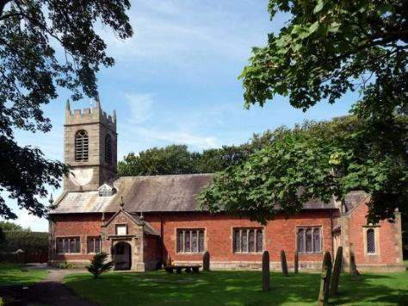
St. Michael and All Angels – Hoole

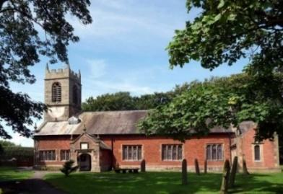

Welcome to our church again this morning. A special welcome to those who may not have been in church for some time. Please observe social distancing, but stay close to Christ.

Sunday 28th March 2021 Palm Sunday.

THE SERVANT KING

“Hosanna! Blessed is He who comes in the Name of the Lord.”
Mark 11: v 9.

PRAYER OF THE DAY: True and humble king, hailed by the
crowd as Messiah: grant us the faith to know you and love you,
that we may be found beside you on the way of the cross,
which is the path of glory. Amen.

There will be children’s activities during the 10.30am service.

9.00am. Holy Communion (Book of Common Prayer) begins p237

10.30am. Palm Sunday Service, with distribution of palms.
Reading: Mark 11: v 1-11.
Hymns : 14 – All glory, laud and honour.
Video – Great Big God.
Supp. 8 – King of Kings, Majesty.
165 – From Heaven you came.
905 – We have a King who rides a donkey.
766 – You shall go out with joy.
BIBLE READINGS: Mark 11: v 1-11. As they approached Jerusalem and came to Bethphage and Bethany at the Mount of Olives, Jesus sent two of his disciples, saying to them,
‘Go to the village ahead of you, and just as you enter it, you will find a colt tied there, which no one has ever ridden. Untie it and bring it here. If anyone asks you, “Why are you doing this?” say, “The Lord needs it and will send it back here shortly.”’

They went and found a colt outside in the street, tied at a doorway. As they untied it, some people standing there asked,
‘What are you doing, untying that colt?’
They answered as Jesus had told them to, and the people let them go. When they brought the colt to Jesus and threw their cloaks over it, he sat on it. Many people spread their cloaks on the road, while others spread branches they had cut in the fields. Those who went ahead and those who followed shouted,

‘Hosanna!’
‘Blessed is he who comes in the name of the Lord!’
‘Blessed is the coming kingdom of our father David!’
‘Hosanna in the highest heaven!’

Jesus entered Jerusalem and went into the temple courts. He looked around at everything, but since it was already late, he went out to Bethany with the Twelve.
Prayer. We pray for those who are sick, especially Michael Pulvermacher, Debbie, Baby Erica Ivy, Joan Gleave, Eva Coxhead, and Beryl Carr. We give thanks for the lives of Colin Clark and Betty Clough and we pray for their families and friends. We pray also for the families of Michael Scott, Ann Rooke, Tommy Lyon and the Spencer family who have all suffered recent bereavements.

There will be no Bible Study this week but please join us in church for :
Maundy Thursday: Holy Communion at 6.00pm
Good Friday: FAMILY SERVICE at 11.00am
AN HOUR AT THE CROSS 2.00pm.
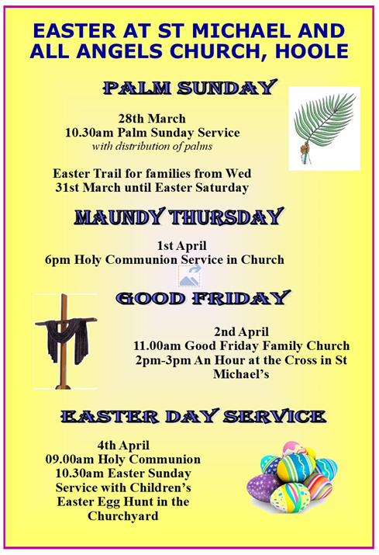
Water Aid Collection for 2020-2021 Ends at Easter. If you have any “Jars of Change” which you would like to be included in this year’s donation, can you please do one of the following:
- Bring it into Church and hand to a Churchwarden
- Bring it into Church and place in the right hand drawer of the desk next to the kitchen
- Give Barbara Wood a call – 07745 208617- and she will collect.

