Parish Dates March 2021 onwards
Tuesday 9th March 7.30pm Zoom Bible Study
Thursday 11th March 7.30pm Short time of Prayer via Zoom
Friday 12th March 7.30pm Zoom Quiz and Social
Sunday 14th March MOTHERING SUNDAY
09.00am Holy Communion in Church
10.30am Holy Communion in Church
First Communion for Confirmation candidates
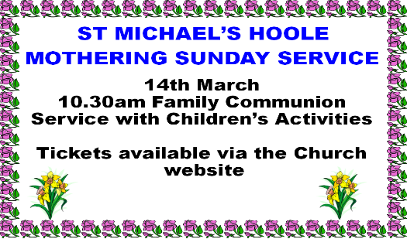

Monday 15th March 7.30pm PCCmeeting by Zoom
Tuesday 16th March 7.30pm Zoom Bible Study
Thursday 18th March 7.30pm Short time of Prayer via Zoom
Sunday 21st March 09.00am Holy Communion in Church
10.30am Parish Communion in Church
3.45pm LION KING FAMILY CHURCH (ZOOM)
Tuesday 23rd March 7.30pm Zoom Bible Study
Thursday 25th March 7.30pm Short time of Prayer via Zoom
Sunday 28th March 09.00am Holy Communion in Church
PALM SUNDAY 10.30am PALM SUNDAY SERVICE in Church
with distribution of palms.
We will aim to have recordings of the 10.30 services on the website hooleparishchurch.com by Sunday lunch time.

The Zoom link for our Zoom bible studies and prayer times is on the front page of the website.
Our Facebook page: St Michael and All Angels Church, Hoole, our website is www.hooleparishchurch.com
Rector – Revd Ann Templeman anntempleman@live.co.uk 01772 448515
The Rectory, 69 Liverpool Old Road Much Hoole PR4 4RB
Please take this sheet home with you
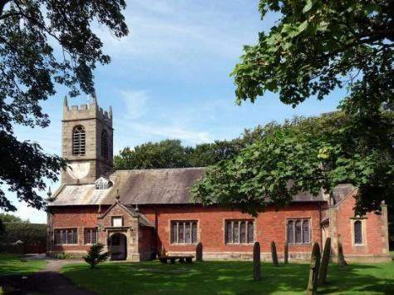
St. Michael and All Angels – Hoole

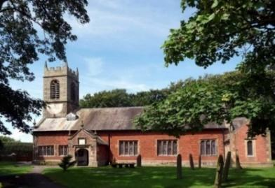

Welcome to our services today, we extend a special welcome to Bishop Jill Duff to conduct our 10.30am service of Confirmation Please observe social distancing, but stay close to Christ.

Sunday 7th March 2021 Lent 3.

CLEAN AND UNCLEAN.

“There is nothing outside that by going in, can make a person unclean.
Rather, it is that what comes out which makes a person unclean.”
Mark 7: v 15.

PRAYER OF THE DAY: Eternal God, give us insight
to discern your will for us, to give up what harms us, and to seek the
perfection we are promised in Jesus Christ our Lord. Amen.

The children will be staying in the service today.
There are toys for younger children at the back.

9.00am. Holy Communion
Reading: Mark 7: v 1-23.

10.30am. Service of Confirmation.

Reading: Mark 1: v 40-45.

Hymns : Supplement 1 – In Christ Alone.
Supplement 4 (Ch) – My Lighthouse.
285 – Holy Holy Holy is the Lord.
419 – Shine Jesus Shine.
766 – You shall go out with Joy.
BIBLE READINGS: Mark 7: v 1-23 abridged. The Pharisees and some of the teachers of the law who had come from Jerusalem gathered round Jesus and saw some of his disciples eating food with hands that were defiled, that is, unwashed. So the Pharisees and teachers of the law asked Jesus, ‘Why don’t your disciples live according to the tradition of the elders instead of eating their food with defiled hands?’ He replied, ‘Isaiah was right when he prophesied about you hypocrites; as it is written:
‘“These people honour me with their lips,
but their hearts are far from me.
They worship me in vain;
their teachings are merely human rules.”
You have let go of the commands of God and are holding on to human traditions.’
Again, Jesus called the crowd to him and said, ‘Listen to me, everyone, and understand this. Nothing outside a person can defile them by going into them. Rather, it is what comes out of a person that defiles them.’
After he had left the crowd and entered the house, his disciples asked him about this parable. ‘Are you so dull?’ he asked. ‘Don’t you see that nothing that enters a person from the outside can defile them? For it doesn’t go into their heart but into their stomach, and then out of the body.’ (In saying this, Jesus declared all foods clean.)
He went on: ‘What comes out of a person is what defiles them. For it is from within, out of a person’s heart, that evil thoughts come – sexual immorality, theft, murder, adultery, greed, malice, deceit, lewdness, envy, slander, arrogance and folly. All these evils come from inside and defile a person.’.

Prayer. We pray for those to be Confirmed this morning, Riley Burns, Harrison Coomer, Morgan Cooper, Joe Higham, Isla Peterson Adam Smith, Grace Wignall, Shelley Cuff and Lisa Higham.
We pray too for those who are sick, especially Michael Pulvermacher, Joan Gleave, Eva Coxhead, Baby Erica Ivy, Beryl Carr, Pat Mortimer, Tommy Lyon, Keith Norton and the Kearney family. We give thanks for the lives of Colin Clark and Michael Scott and pray that their families and friends may know your comfort and peace. We pray too for Alison Spencer and Beryl Blakeley as they mourn the loss of their brothers.
ALL SERVICES WILL BE LIVE AGAIN FROM NOW ON BUT WE ALSO HOPE TO PUT A RECORDING OF THE 10.30AM SERVICE ON OUR WEBSITE BY SUNDAY LUNCHTIME.
LENT AND BIBLE STUDIES Bishops’ Lent book For all Christians Lent is a time to take stock and spend more time with God. Please help yourself to a free Lent book from the back of the church which will take you through the whole of Mark’s Gospel.

Bible studies by Zoom
We will then use the Tuesday reading each week as the basis for our Zoom Bible study which will be weekly on Tuesdays throughout Lent at 7. 30pm continuing on March 9th (Zoom link on website).

Prayer in Lent There will also be a short time of prayer each week on Zoom on Thursdays at 7.30pm continuing on March 11th.
MOTHERING SUNDAY AND FIRST COMMUNION
14TH MARCH AT 10.30AM
Flowers will be distributed
CHILDREN’S ACTIVITIES
DON’T FORGET ZOOM QUIZ AND SOCIAL
WITH CAROLE AND COLIN
FRIDAY 12TH MARCH 7.30PM

