Parish Dates From May 2022

Monday 16th May 7.30pm Bible Study at the Rectory
Tuesday 17th May 10.15am Holy Communion.
7.30pm Ladies Group meet in the Village Hall
A talk entitled “Jacinda Hesketh and her Scandalous Sister”.

Sunday 22nd May 09.00am Holy Communion
10.30am Morning Worship with Sunday School.
Tuesday 24th May 10.15am Prayer time in church.
Thursday 26th May 9.00am School Service in Church
ASCENSION DAY 7.30pm HOLY COMMUNION

Sunday 29th May 09.00am Holy Communion
10.30am Parish Communion with Sunday School.
Saturday 4th June 1.00pm Wedding of Charles Redshaw &
Megan Demmon
Sunday 5th June QUEEN’S PLATINUM JUBILEE
PENTECOST 10.30am Civic service of celebration in Church (see poster inside) 12.00noon – 4.00pm Village BBQ and Picnic
on the School field.

Sunday 12th June TRINITY SUNDAY
Tuesday 14th June 10.15am Holy Communion
7.30pm House Group/Bible Study at the Rectory.

OUR FAITHFUL QUEEN
a beautiful book commemorating 70 years of Faithful Service. £5 at back of church
Christian Aid Week is from May 15th - 22nd. Help is required delivering envelopes, to offer help please contact Cath Greenlees:
Suggested Bible readings this week.
Monday 16th May John 14: v 21-26. Tuesday 17th May John 14: v 27-end.
Wednesday 18th May John 15: v 1-9. Thursday 19th May John 15: v 9-11.
Friday 20th May John 15: v 12-17. Saturday 21st May John 15: v 18-21.

Website : www.hooleparishchurch.com
Facebook page: St Michael and All Angels Church, Hoole,
Rector – Revd Ann Templeman anntempleman@live.co.uk 01772 448515
The Rectory, 69 Liverpool Old Road Much Hoole PR4 4RB
Please take this sheet home with you
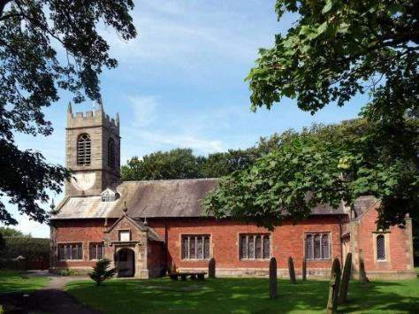
St. Michael and All Angels – Hoole

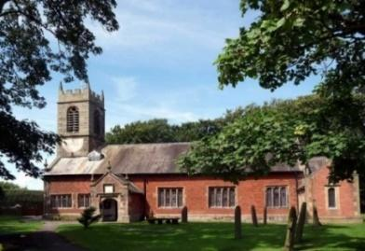

Welcome to our church again this morning. Please stay for a chat and a cup of tea or coffee after the 10.30 service, a great way to meet people

Sunday 15th May 2022 (Easter 5)

Alleluia, Christ is Risen - - - He is Risen indeed, Alleluia.

GOD IS IN CONTROL

For God has worked all things together for good
for those who love him. Romans 8: v 28.

PRAYER OF THE DAY: Risen Christ, your wounds declare your
love for the world and the wonder of your risen life: give us
compassion and courage to risk ourselves for those we serve,
to the glory of God the Father. Amen.
No Sunday School today during the service
Royal Church at 3.45pm in the Village Hall
There are toys and colouring sheets
for younger children at the back of church.

9.00am. Holy Communion (Book of Common Prayer) begins p237

10.30am. Parish Communion.
Reading: Daniel: Chapter 1.
Hymns: 12 – Alleluia, sing to Jesus.
Screen/Service booklet – The Gloria.
Sheet 3 – Before the throne of God above.
303 – I cannot tell.
H/C Hymns: Sheet 2 – How deep the Father’s Love.
Sheet 6 – We rest on Thee.
3.45pm: Royal Church in the Village Hall.

READING: Daniel 1: In the third year of the reign of Jehoiakim king of Judah, Nebuchadnezzar king of Babylon came to Jerusalem and besieged it. And the Lord delivered Jehoiakim king of Judah into his hand, along with some of the articles from the temple of God. These he carried off to the temple of his god in Babylonia and put in the treasure-house of his god.
Then the king ordered Ashpenaz, chief of his court officials, to bring into the king’s service some of the Israelites from the royal family and the nobility – young men without any physical defect, handsome, showing aptitude for every kind of learning, well informed, quick to understand, and qualified to serve in the king’s palace. He was to teach them the language and literature of the Babylonians. The king assigned them a daily amount of food and wine from the king’s table. They were to be trained for three years, and after that they were to enter the king’s service. Among those who were chosen were some from Judah: Daniel, Hananiah, Mishael and Azariah. The chief official gave them new names: to Daniel, the name Belteshazzar; to Hananiah, Shadrach; to Mishael, Meshach; and to Azariah, Abednego.
But Daniel resolved not to defile himself with the royal food and wine, and he asked the chief official for permission not to defile himself in this way. Now God had caused the official to show favour and compassion to Daniel, but the official told Daniel, ‘I am afraid of my lord the king, who has assigned your^{[c]} food and drink. Why should he see you looking worse than the other young men of your age? The king would then have my head because of you.’
Daniel then said to the guard whom the chief official had appointed over Daniel, Hananiah, Mishael and Azariah, ‘Please test your servants for ten days: give us nothing but vegetables to eat and water to drink. Then compare our appearance with that of the young men who eat the royal food, and treat your servants in accordance with what you see.’ So he agreed to this and tested them for ten days.
At the end of the ten days they looked healthier and better nourished than any of the young men who ate the royal food. So the guard took away their choice food and the wine they were to drink and gave them vegetables instead. To these four young men God gave knowledge and understanding of all kinds of literature and learning. And Daniel could understand visions and dreams of all kinds.
At the end of the time set by the king to bring them into his service, the chief official presented them to Nebuchadnezzar. The king talked with them, and he found none equal to Daniel, Hananiah, Mishael and Azariah; so they entered the king’s service. In every matter of wisdom and understanding about which the king questioned them, he found them ten times better than all the magicians and enchanters in his whole kingdom.
And Daniel remained there until the first year of King Cyrus.

Prayer: We pray for those who are sick, especially Erica Ivy, Beryl Cottam, Tom Parkinson, Steve Coughlan, Neil Dexter, and Antonietta Broadhurst. We give thanks for the life of Stuart Tighe and pray for his family and friends.

BIBLE STUDY/ HOUSEGROUP CONTINUES ON MON 16TH MAY 7.30PM AT THE RECTORY. We will be continuing to look at 1 John.
This session will be on 1 John 2 v 28- 3 v 10.

LIFE IN ALL ITS FULLNESS - THE BLACKPOOL PLEASURE BEACH GLOBE ARENA.
Saturday the 28th May at 7pm Archbishop Stephen
will be speaking about what it means to follow Jesus and how He brings life in all its fullness.
Please do come yourself but please make sure you also bring a few friends and begin to pray now about who you could bring and that this evening will see many people come to Jesus for the first time. It is good this event is taking place during the ten day period of Thy Kingdom Come, when we pray for five people to come to faith, and you may wish to use this as part of that process. More information and free tickets can be found by clicking on this link. Seating and free parking will be allocated on a first come, first served basis so please do book quickly once you are sure you will attend.
