Parish Dates May 2021 onwards
Monday May 17th 7.00pm Thy Kingdom Come Prayer time (Zoom)
7.30pm PCC Meeting on Zoom.
Tuesday May 18th 10.15am Thy Kingdom Come Prayer time (in Church)
Thursday May 20th 7.00pm Thy Kingdom Come Prayer time (Zoom)
Saturday May 22nd 2.30pm. Wedding of Sarah and Craig
7.30pm. Parish Quiz and Social.

Sunday May 23rd 09.00am Holy Communion in Church
PENTECOST 10.30am Morning Worship in Church
3.45pm LIFT OFF FAMILY CHURCH
In Church and Churchyard.
Monday May 24th 7.30pm Bible Study by Zoom
Tuesday May 25th 7.30pm Bible Study in Church with Compline
Thursday May 27th 4.30pm Chat & Chocolate – young people in Church.

Sunday May 30th 09.00am Holy Communion in Church
TRINITY SUNDAY 10.30am Parish Communion in Church
Monday May 31st 7.00pm Time of Prayer in Church.

Sunday June 6th 09.00am Holy Communion in Church
10.30am Parish Communion in Church
Monday June 7th 7.30pm Bible Study by Zoom
Tuesday June 8th 7.30pm Bible Study in Church with Compline
Thursday June 10th 4.30pm Chat & Chocolate – young people in Church

Key Future Dates
16-18th July OUTREACH WEEKEND
Friday July 16th 7.00pm Parish Social with Quiz and Entertainment
in the New Village Hall.
Sunday July 18th 2.00pm – 4.00pm Event for children and families
with Bishop Philip.
All the above services are ‘Live’ in church
We will aim to have recordings of all 10.30 services on the website www.hooleparishchurch.com by Sunday lunch time.
The Zoom link for all church Zoom activities is on the front of website.
Our Facebook page: St Michael and All Angels Church, Hoole,
Rector – Revd Ann Templeman anntempleman@live.co.uk 01772 448515
The Rectory, 69 Liverpool Old Road Much Hoole PR4 4RB
Please take this sheet home with you
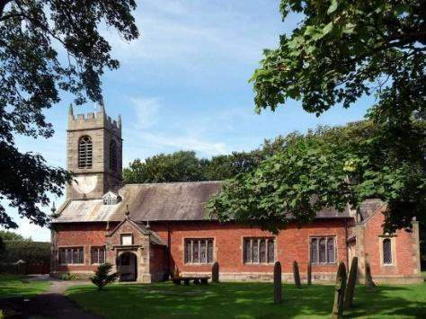
St. Michael and All Angels – Hoole

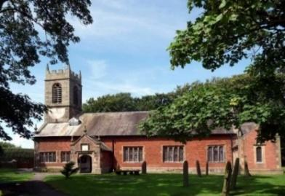

Welcome to our church again this morning. We are pleased to welcome back friends, who have not felt able to attend during the last twelve months.

Sunday 16th May 2021 Easter 7. (Sunday after Ascension)

Alleluia, Christ is Risen - - - He is Risen indeed, Alleluia.

THY KINGDOM COME – THE POWER OF PRAYER

“So Peter was kept in prison, but the Church was earnestly praying
to God for him” Acts 12: v 5.

PRAYER OF THE DAY: Risen, ascended Lord, as we rejoice at
your triumph, fill your Church on earth with power and compassion,
that all who are estranged by sin may find forgiveness and know your
peace, to the glory of God the Father. Amen.

Sunday School today during the service
There are toys for younger children
at the back of church.
at the back of church.

10.00am. Parish Communion with Sunday School.
Readings: Acts 12: v 1-10. Acts 12: v 11-19.
Hymns : 695 – To God be the glory.
Supp. 8 – King of Kings, Majesty.
727 – What a friend we have in Jesus.
H/C Hymns: Supp. 2 – How deep the Father’s love.
Supp. 4 – O to see the dawn (The power of the cross) 11.00am. ANNUAL CHURCH MEETING
Final Hymn. Supp. 1 – In Christ alone.
BIBLE READINGS: Acts 12: v 1-10.
It was about this time that King Herod arrested some who belonged to the church, intending to persecute them. He had James, the brother of John, put to death with the sword. When he saw that this met with approval among the Jews, he proceeded to seize Peter also. This happened during the Festival of Unleavened Bread. After arresting him, he put him in prison, handing him over to be guarded by four squads of four soldiers each. Herod intended to bring him out for public trial after the Passover.
So Peter was kept in prison, but the church was earnestly praying to God for him. The night before Herod was to bring him to trial, Peter was sleeping between two soldiers, bound with two chains, and sentries stood guard at the entrance.
Suddenly an angel of the Lord appeared and a light shone in the cell. He struck Peter on the side and woke him up. ‘Quick, get up!’ he said, and the chains fell off Peter’s wrists.
Then the angel said to him, ‘Put on your clothes and sandals.’ And Peter did so. ‘Wrap your cloak round you and follow me,’ the angel told him. Peter followed him out of the prison, but he had no idea that what the angel was doing was really happening; he thought he was seeing a vision. They passed the first and second guards and came to the iron gate leading to the city. It opened for them by itself, and they went through it. When they had walked the length of one street, suddenly the angel left him.

Acts 12: v 11-19.
Peter then came to himself and said, ‘Now I know without a doubt that the Lord has sent his angel and rescued me from Herod’s clutches and from everything the Jewish people were hoping would happen.’
When this had dawned on him, he went to the house of Mary the mother of John, also called Mark, where many people had gathered and were praying. Peter knocked at the outer entrance, and a servant named Rhoda came to answer the door. When she recognised Peter’s voice, she was so overjoyed she ran back without opening it and exclaimed, ‘Peter is at the door!’
‘You’re out of your mind,’ they told her. When she kept insisting that it was so, they said, ‘It must be his angel.’
But Peter kept on knocking, and when they opened the door and saw him, they were astonished. Peter motioned with his hand for them to be quiet and described how the Lord had brought him out of prison. ‘Tell James and the other brothers and sisters about this,’ he said, and then he left for another place.
In the morning, there was no small commotion among the soldiers as to what had become of Peter. After Herod had a thorough search made for him and did not find him, he cross-examined the guards and ordered that they be executed.

Prayer. We pray for those who are sick, especially Baby Erica Ivy, Patricia Mortimer, Michael Harrison, Beryl Carr, Alan Fleetwood and Josephine Hodge.

FORTNIGHTLY BIBLE STUDIES CONTINUE
Mon 24th May 7.30pm by Zoom
and Tuesday 25^{h} May 7.30pm in Church with Compline
We will be looking at chapter 1 of Paul’s letter to the Thessalonians

THY KINGDOM COME
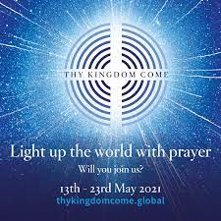
THY KINGDM COME the global wave of prayer takes
Place from Ascension to Pentecost,
There will be special times of prayer on:
Monday 17th May, 7pm – 7.30pm on Zoom.
Tuesday 18th May, 10.15am – 10.45am in Church.
Thursday 20th May, 7pm – 7.30pm on Zoom.
Please join us

There are prayer resources in Church and on the website for each day. Why not pray for 5 friends, along with thousands of other Christians around the world that they might come to know the Lord Jesus for themselves.

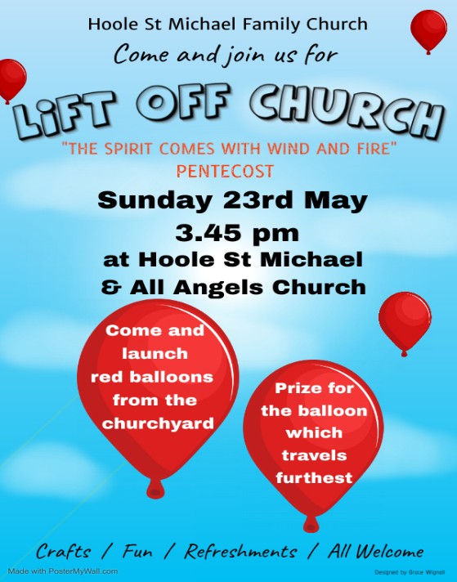

PARISH QUIZ AND SOCIAL. The next of our very popular Parish Quiz and Social Evenings , again hosted by Colin and Carol Wilson, will take place by Zoom on Saturday May 22nd at 7.30pm. (See the website for the Zoom link)

