PARISH DATES
Monday 20th May 7.30pm Bible for Beginners in the Lodge
Tuesday 21st May 10.15am Holy Communion in the Lodge
Wednesday 22nd May 9.30am-11.00am St Michael’s Little Angels
Sunday 26th May 9.00am Holy Communion
Giving in Grace 10.30am Morning Worship with Sunday School
Thy Kingdom Come 5.00pm Pizza ‘n Praise in Church & Lodge.
Tuesday 28th May 10.15am Holy Communion in the Lodge
Wednesday 29th May NO St Michael’s Little Angels (Half term)
Friday 31st May 1.00pm Wedding of Pippa and Scott.
Sunday 2nd June Celebration of God’s Gifts – Gift Day
PLEASE MAKE SURE YOU HAVE TAKEN A PACK ABOUT HOW YOU CAN SUPPORT ST MICHAEL’S
9.00am Holy Communion
10.30am Parish Communion with Sunday School
4.00pm Holy Communion (Old Mill Court).
Monday 3rd June 2.30pm Holy Communion (Ribble Court)
7.30pm Bible for Beginners in the Lodge
Tuesday 4th June 10.15am Holy Communion in the Lodge
Wednesday 5th June 9.30am-11.00am St Michael’s Little Angels
Sunday 9th June 9.00am Holy Communion
10.30am Parish Communion with Sunday School.
Tuesday 11th June 10.15am Morning Prayer in the Lodge
Wednesday 12th June 9.30am-11.00am St Michael’s Little Angels
Sunday 16th June 9.00am Holy Communion
10.30am Morning Worship with Sunday School.
Tuesday 18th June 10.15am Morning Prayer in the Lodge
Wednesday 19th June 9.30am-11.00am St Michael’s Little Angels
Thursday 20th June 2.00pm Ladies Group meet in the Village Hall.
Sunday 23rd June 9.00am Holy Communion 10.30am Morning Worship.
Sunday 30th June 3.45pm GLADIATORS FAMILY CHURCH
in St. Michael’s School – for all the family.
Suggested Bible readings for this week:
Monday 20th May Mark 9: v 14-29. Tuesday 21st May Mark 9: v 30-37.
Wednesday. 22nd May Mark 9: v 38-40. Thursday 23rd May Mark 9: v 41-end. Friday 24th May Mark 10: v 1-12. Saturday 25th May Mark 10: v 13-16.
www.hooleparishchurch.com Facebook : St Michael and All Angels Church, Hoole,
Rector Ann Templeman anntempleman@live.co.uk 01772 448515 or 07877659156
PLEASE TAKE THIS SHEET HOME WITH YOU.
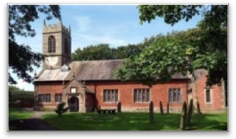
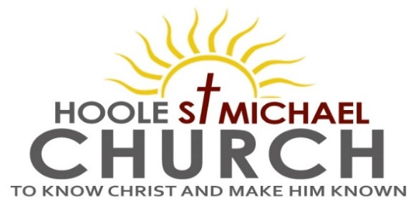

Welcome to our Church today. With a special welcome to Christy Sawyer, who is preaching today.
Please stay for refreshments in the Lodge after the 10.30am service.

Sunday 19th May 2024 Pentecost

THE SPIRIT CHANGES EVERYTHING

“They were filled with the Holy Spirit. . . . . Selling their possessions,
they gave to anyone as had need.” (from Acts 2)

PRAYER OF THE DAY Holy Spirit, sent by the Father, ignite in us
your holy fire; strengthen your children with the gift of faith, revive
your Church with the breath of love, and renew the face of the earth,
through Jesus Christ our Lord. Amen

Children’s activities today during the service.
Lift off Church in the Village Hall with Christy at 3.45pm.

9.00am. Holy Communion (Book of Common Prayer p237)
10.30am. Parish Communion.
Readings: Acts 2: v 1-12.
Acts 2: v 42-47.
Hymns: 67 – Be still for the presence of the Lord.
676 – This is the day that the Lord has made.
625 – Take my life, and let it be.
114 – Come down, O Love divine.
H/C Hymns: Screen – We are one in the Spirit.
615 – Spirit of the living God, fall afresh on me.

3.45pm: Lift off Church in the Village Hall with Christy.

Bible Reading 1: The Holy Spirit comes at Pentecost. Acts 2: v 1-12.
When the day of Pentecost came, they were all together in one place. Suddenly a sound like the blowing of a violent wind came from heaven and filled the whole house where they were sitting. They saw what seemed to be tongues of fire that separated and came to rest on each of them. All of them were filled with the Holy Spirit and began to speak in other tongues as the Spirit enabled them.
Now there were staying in Jerusalem God-fearing Jews from every nation under heaven. When they heard this sound, a crowd came together in bewilderment, because each one heard their own language being spoken. Utterly amazed, they asked: ‘Aren’t all these who are speaking Galileans? Then how is it that each of us hears them in our native language? Parthians, Medes and Elamites; residents of Mesopotamia, Judea and Cappadocia, Pontus and Asia, Phrygia and Pamphylia, Egypt and the parts of Libya near Cyrene; visitors from Rome (both Jews and converts to Judaism); Cretans and Arabs – we hear them declaring the wonders of God in our own tongues!’ Amazed and perplexed, they asked one another, ‘What does this mean?’

Bible Reading 2: The fellowship of the believers. Acts 2: v 42-47.
They devoted themselves to the apostles’ teaching and to fellowship, to the breaking of bread and to prayer. Everyone was filled with awe at the many wonders and signs performed by the apostles. All the believers were together and had everything in common. They sold property and possessions to give to anyone who had need.
Every day they continued to meet together in the temple courts. They broke bread in their homes and ate together with glad and sincere hearts, praising God and enjoying the favour of all the people. And the Lord added to their number daily those who were being saved.

Prayer We pray for our church and the ‘Giving in Grace’ series of services. We continue to pray for all those affected by the conflicts in the troubled areas of the world. We pray for those who were confirmed last week. We pray for the sick, especially Sue Meadows, Nick Slinger, Ben Allen, Edward Kenyon, Judith Stopford and Elaine Read.

BIBLE FOR BEGINNERS with clips from the CHOSEN
Continues on Monday 20th May at 7.30pm in the Lodge then fortnightly
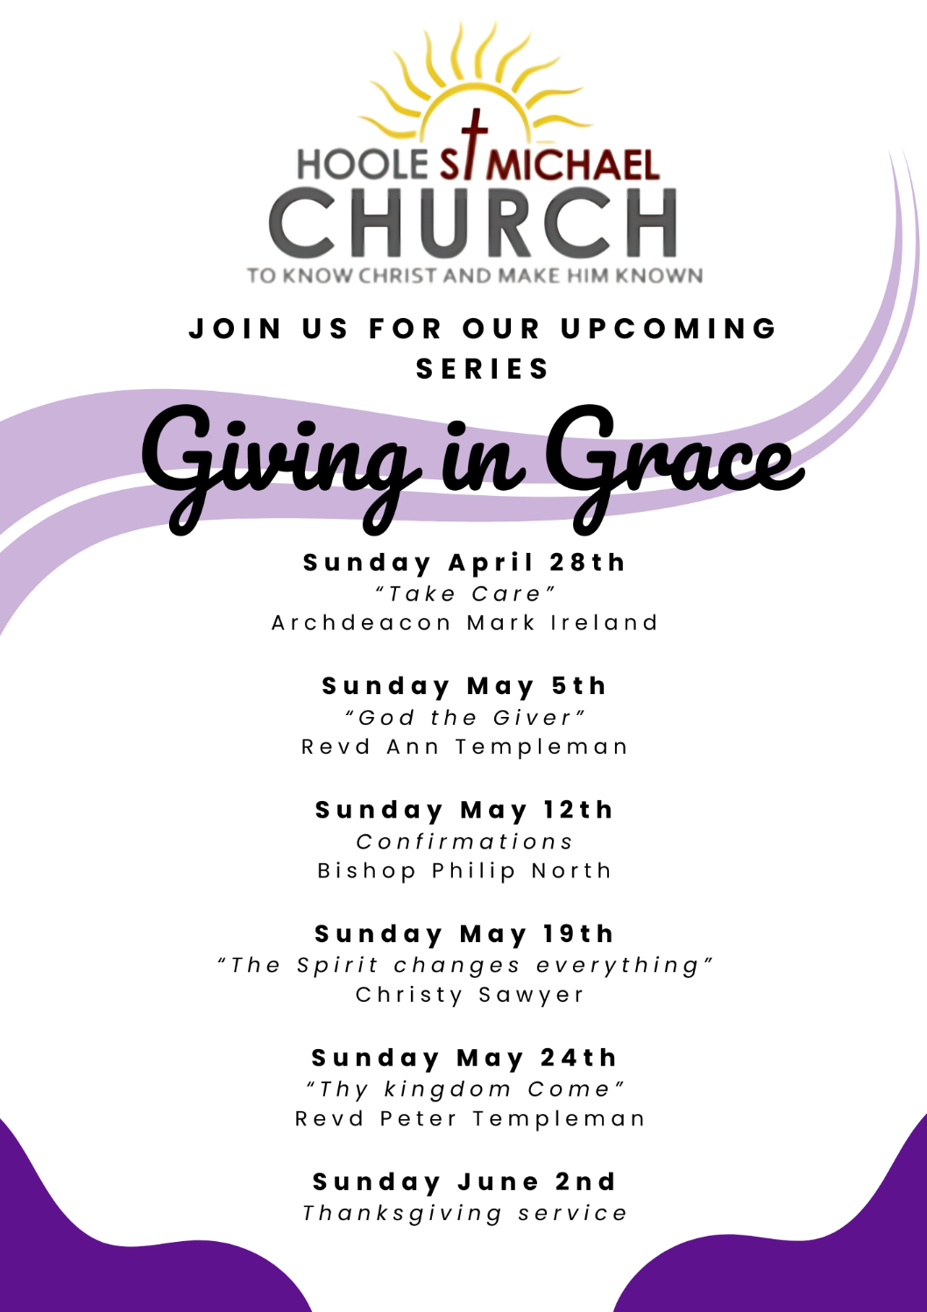
PRAY FOR OUR CHURCH
Please come and join us for Prayer for the future of our church on Tuesdays in the Lodge at 10.15 during our service of Holy Communion

