Parish Dates From April 2022
Tuesday 3rd May 10.15am Morning Prayer.
Groundworks for the New Lodge begin.

Sunday 8th May 10.00am PARISH COMMUNION WITH SUNDAY
SCHOOL
11.00 ANNUAL CHURCH MEETING IN
SCHOOL WITH JACOB’S JOIN LUNCH

Monday 9th May 7.30pm PCC meeting in the Village Hall.
Tuesday 10th May 10.15am Holy Communion.
7.30pm Bible Study at the Rectory
7.30pm Men’s Fellowship AGM in the Village Hall

Sunday 15th May 09.00am Holy Communion
10.30am Parish Communion.
3.45pm ROYAL CHURCH in the Village Hall.
Monday 16th May 7.30pm Bible Study at the Rectory
Tuesday 17th May 10.15am Prayer time in church.
7.30pm Ladies Group meet in the Village Hall

Sunday 22nd May 09.00am Holy Communion
10.30am Morning Worship with Sunday School.
Tuesday 24th May 10.15am Holy Communion.
Thursday 26th May 9.00am School Service in Church
ASCENSION DAY 7.30pm HOLY COMMUNION

Sunday 29th May 09.00am Holy Communion
10.30am Parish Communion with Sunday School.
Sunday 5th June QUEEN’S PLATINUM JUBILEE
PENTECOST (see poster inside)

Suggested Bible readings this week.
Monday 2nd May John 14: v 1-14. Tuesday 3rd May John 6: v 30-35.
Wednesday 4th May John 6: v 35-40. Thursday 5th May John 6: v 44-51.
Friday 6th May John 6: v 52-59. Saturday 7th May John 6: v 60-69.

Website : www.hooleparishchurch.com
Facebook page: St Michael and All Angels Church, Hoole,
Rector – Revd Ann Templeman anntempleman@live.co.uk 01772 448515
The Rectory, 69 Liverpool Old Road Much Hoole PR4 4RB
Please take this sheet home with you

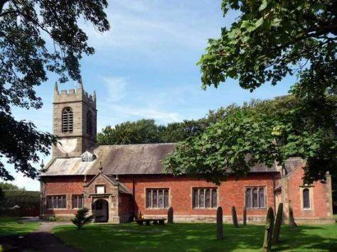
St. Michael and All Angels – Hoole

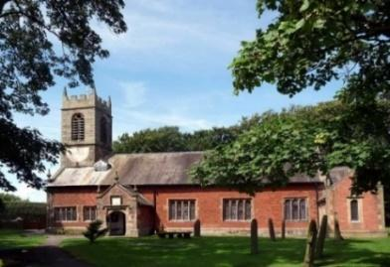

Welcome to our church again this morning, with a special welcome to Bishop Tony, who is leading our worship today. Please stay for a chat and a cup of tea or coffee after the 10.30 service, a great way to meet people

Sunday 1st May 2022 (Easter 3)

Alleluia, Christ is Risen - - - He is Risen indeed, Alleluia.

DO YOU LOVE ME

“Simon son of John, do you love Me more than these” John 21: v 16.

PRAYER OF THE DAY: Risen Christ, you filled your disciples with
boldness and fresh hope: strengthen us to proclaim your risen life
and fill us with your peace, to the glory of God the Father. Amen.

Sunday School today during the service
There are toys and colouring sheets
for younger children at the back of church.

9.00am. Holy Communion (Book of Common Prayer) begins p237

10.30am. Parish Communion with Sunday School.
Reading: John 21: v 1-19.

Hymns: 672 – Thine be the glory.
Screen – Never be shaken.
29 – Amazing grace.
511 – O Lord my God. (How great Thou art)

H/C Hymns: 8 – Alleluia, Alleluia, give thanks to the risen Lord.
620 – Such love.

4.00pm. Holy Communion (Old Mill Court)
READING: John 21: v 1-19. Afterwards Jesus appeared again to his disciples, by the Sea of Galilee. It happened this way: Simon Peter, Thomas (also known as Didymus), Nathanael from Cana in Galilee, the sons of Zebedee, and two other disciples were together. ‘I’m going out to fish,’ Simon Peter told them, and they said, ‘We’ll go with you.’ So they went out and got into the boat, but that night they caught nothing.
Early in the morning, Jesus stood on the shore, but the disciples did not realise that it was Jesus. He called out to them, ‘Friends, haven’t you any fish?’ ‘No,’ they answered. He said, ‘Throw your net on the right side of the boat and you will find some.’ When they did, they were unable to haul the net in because of the large number of fish.
Then the disciple whom Jesus loved said to Peter, ‘It is the Lord!’ As soon as Simon Peter heard him say, ‘It is the Lord,’ he wrapped his outer garment round him (for he had taken it off) and jumped into the water. The other disciples followed in the boat, towing the net full of fish, for they were not far from shore, about a hundred metres. When they landed, they saw a fire of burning coals there with fish on it, and some bread.
Jesus said to them, ‘Bring some of the fish you have just caught.’ So Simon Peter climbed back into the boat and dragged the net ashore. It was full of large fish, 153, but even with so many the net was not torn. Jesus said to them, ‘Come and have breakfast.’ None of the disciples dared ask him, ‘Who are you?’ They knew it was the Lord. Jesus came, took the bread and gave it to them, and did the
same with the fish. This was now the third time Jesus appeared to his disciples after he was raised from the dead.
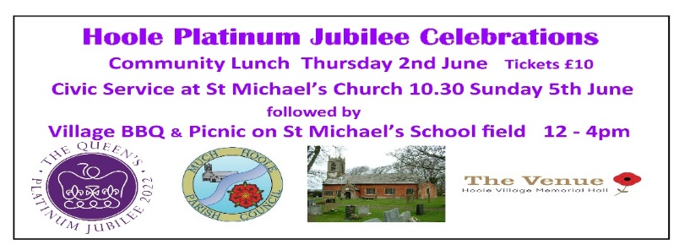
When they had finished eating, Jesus said to Simon Peter, ‘Simon son of John, do you love me more than these?’ ‘Yes, Lord,’ he said, ‘you know that I love you.’
Jesus said, ‘Feed my lambs.’ Again Jesus said, ‘Simon son of John, do you love me?’ He answered, ‘Yes, Lord, you know that I love you.’
Jesus said, ‘Take care of my sheep.’ The third time he said to him, ‘Simon son of John, do you love me?’ Peter was hurt because Jesus asked him the third time, ‘Do you love me?’ He said, ‘Lord, you know all things; you know that I love you.’
Jesus said, ‘Feed my sheep. Very truly I tell you, when you were younger you dressed yourself and went where you wanted; but when you are old you will stretch out your hands, and someone else will dress you and lead you where you do not want to go.’ Jesus said this to indicate the kind of death by which Peter would glorify God. Then he said to him, ‘Follow me!’

Prayer: We pray for those who are sick, especially Erica Ivy, Beryl Cottam, Tom Parkinson, Steve Coughlan, Neil Dexter, Antonietta Broadhurst and Stuart Tighe.

Christian Aid Week is from May 15th - 22nd. Help is required delivering envelopes, to offer help please contact Cath Greenlees: 01772-613500.

SPACE FOR PRAYER
Prayer is our conversation with God; He wants us to come to him with all our worries and our thanks, here in the church we have put aside a space. (under the gallery at the front). Please feel free to sit in private prayer, give us your requests and know that God through Jesus is listening.

ANNUAL CHURCH MEETING SUNDAY MAY 8th.
There will only be one morning service in Church on May 8th at 10.00am. 11.00am Annual Church Meeting in School followed by a Jacob’s Join Lunch. Please sign the list at the back of the church if you can contribute to the lunch.
All members of the electoral roll should have received an invitation by email, together with the Annual Report, Agenda and Minutes attached. The Annual report is also on the website and hard copies are available from church.

OUR FAITHFUL QUEEN
a beautiful book commemorating 70 years
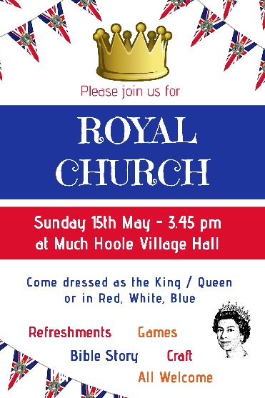
of Faithful Service. £5 at back of church

The Community Lunch which begins the Queen’s Platinum Jubilee Celebrations on Thursday June 2nd is a ticket only event @ £10.00 available from Stan, or ring 01772 615708 or 07747 607552.

