Parish Dates From May 2022

Tuesday 24th May 10.15am Prayer time in church.
Thursday 26th May 9.00am School Service in Church
ASCENSION DAY 7.30pm HOLY COMMUNION

Sunday 29th May 09.00am Holy Communion
10.30am Parish Communion with Sunday School
12noon Baptism of Alysia and Bobbie
. Tuesday 31st May 10.15am Holy Communion in Church
7.30pm House Group/Bible Study at The Rectory
Saturday 4th June 1.00pm Wedding of Charles & Megan
Sunday 5th June QUEEN’S PLATINUM JUBILEE
PENTECOST 10.30AM CIVIC SERVICE OF CELEBRATION (see poster below) 12.00 – 4.00 VILLAGE BBQ & PICNIC
on the SCHOOL FIELD
Monday 6th June 7.30pm House Group/Bible Study at The Rectory
Tuesday 7th June 10.15am Holy Communion
Thursday 9th June 4:30pm Chat & Chocolate
OUR FAITHFUL QUEEN
a beautiful book commemorating 70 years of Faithful Service. £5 at back of church
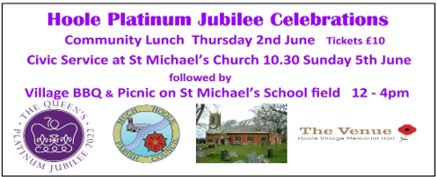

Website : www.hooleparishchurch.com
Facebook page: St Michael and All Angels Church, Hoole,
Rector – Revd Ann Templeman anntempleman@live.co.uk 01772 448515
The Rectory, 69 Liverpool Old Road Much Hoole PR4 4RB
Please take this sheet home with you
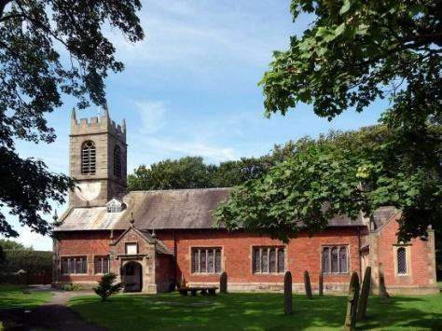
St. Michael and All Angels – Hoole

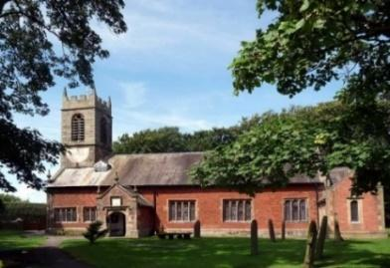

Welcome to our church again this morning. Please stay for a chat and a cup of tea or coffee after the 10.30 service, a great way to meet people

Sunday 22nd May 2022 (Easter 6)

Alleluia, Christ is Risen - - - He is Risen indeed, Alleluia.

NEBUCHADNEZZAR’S DREAM,
GOD’S WISDOM AND GOD’S ETERNAL KINGDOM

The God of Heaven will set up a kingdom that will never be destroyed.
Daniel 2: v 44.
PRAYER OF THE DAY: God our redeemer, you have delivered us from the powers of darkness and brought us into the kingdom of your Son: grant, that as by his death, he has recalled us to life, so by his continual presence in us he may raise us to eternal joy: through Jesus Christ your Son our Lord Amen.

Sunday School today during the service
There are toys and colouring sheets
for younger children at the back of church.

9.00am. Holy Communion (Book of Common Prayer) begins p237

10.30am. Morning Worship
Readings: Daniel 2: v 1-7 & 19-48

Hymns: 54 – (tune 2) At the name of Jesus.
Screen – You are shaped for serving God.
314 – Immortal, invisible, God only wise.
461 – My Jesus my Saviour
70 - Be Thou My Vision

READING 1: Daniel 2 v 1-7 & 19-23. In the second year of his reign, Nebuchadnezzar had dreams; his mind was troubled and he could not sleep. So the king summoned the magicians, enchanters, sorcerers and astrologers to tell him what he had dreamed. When they came in and stood before the king, he said to them, ‘I have had a dream that troubles me and I want to know what it means.’
Then the astrologers answered the king, ‘May the king live for ever! Tell your servants the dream, and we will interpret it.’
The king replied to the astrologers, ‘This is what I have firmly decided: if you do not tell me what my dream was and interpret it, I will have you cut into pieces and your houses turned into piles of rubble. But if you tell me the dream and explain it, you will receive from me gifts and rewards and great honour. So tell me the dream and interpret it for me.’ Once more they replied, ‘Let the king tell his servants the dream, and we will interpret it.’
During the night the mystery was revealed to Daniel in a vision. Then Daniel praised the God of heaven and said: ‘Praise be to the name of God for ever and ever; wisdom and power are his. He changes times and seasons; he deposes kings and raises up others. He gives wisdom to the wise and knowledge to the discerning. He reveals deep and hidden things; he knows what lies in darkness,
and light dwells with him. I thank and praise you, God of my ancestors: you have given me wisdom and power, you have made known to me what we asked of you,
you have made known to us the dream of the king.’
2: Daniel 2 (from) v 24-48.
Then Daniel went to Arioch, whom the king had appointed to execute the wise men of Babylon, and said to him, ‘Do not execute the wise men of Babylon. Take me to the king, and I will interpret his dream for him.’ Arioch took Daniel to the king at once and said, ‘I have found a man among the exiles from Judah who can tell the king what his dream means.’
The king asked Daniel ‘Are you able to tell me what I saw in my dream and interpret it?’ Daniel replied, ‘No wise man, enchanter, magician or diviner can explain to the king the mystery he has asked about, but there is a God in heaven who reveals mysteries. He has shown King Nebuchadnezzar what will happen in days to come. Your dream and the visions that passed through your mind as you were lying in bed are these: ‘As Your Majesty was lying there, your mind turned to things to come, and the revealer of mysteries showed you what is going to happen.
As for me, this mystery has been revealed to me, not because I have greater wisdom than anyone else alive, but so that Your Majesty may know the interpretation and that you may understand what went through your mind. ‘Your Majesty looked, and there before you stood a large statue – an enormous, dazzling statue, awesome in appearance. The head of the statue was made of pure gold, its chest and arms of silver, its belly and thighs of bronze, its legs of iron, its feet partly of iron and partly of baked clay. While you were watching, a rock was cut out, but not by human hands. It struck the statue on its feet of iron and clay and smashed them.
Your Majesty, you are the king of kings. The God of heaven has given you dominion and power and might and glory; Finally, there will be a fourth kingdom, strong as iron. ‘In the time of those kings, the God of heaven will set up a kingdom that will never be destroyed, nor will it be left to another people. It will crush all those kingdoms and bring them to an end, but it will itself endure for ever.
Then King Nebuchadnezzar fell prostrate before Daniel and paid him honour. The king said to Daniel, ‘Surely your God is the God of gods and the Lord of kings and a revealer of mysteries, for you were able to reveal this mystery.’
Then the king placed Daniel in a high position and lavished many gifts on him. He made him ruler over the entire province of Babylon and placed him in charge of all its wise men.
Prayer: We pray for those who are sick, especially Erica Ivy, Beryl Cottam, Tom Parkinson, Steve Coughlan, Neil Dexter, and Antonietta Broadhurst. We give thanks for the life of Stuart Tighe and pray for his family and friends.

ASCENSION DAY THURSDAY 26TH JUNE
HOLY COMMMUNION 7.30PM
No bible study this week so everyone can come to the Ascension Day service.
BIBLE STUDY/ HOUSEGROUP CONTINUES ON Monday 31st May and Tues 7th June 7.30pm at the Rectory: 1 John 3 v11-24
LIFE IN ALL ITS FULLNESS - THE BLACKPOOL PLEASURE BEACH GLOBE ARENA.
Saturday the 28th May at 7pm Archbishop Stephen
will be speaking about what it means to follow Jesus and how He brings life in all its fullness.
Please do come yourself but try also to bring a few friends. Please pray about who you could bring and that this evening will see many people come to Jesus for the first time. It is good this event is taking place during the ten day period of Thy Kingdom Come, when we pray for five people to come to faith, and you may wish to use this as part of that process. More information and free tickets can be found by clicking on the link on the Diocesan website. Seating and free parking will be allocated on a first come, first served basis. We have a number of cars going with spare seats . Please let me know if you would like tickets and/or a lift. Rev Ann

