Parish Dates From May 2022
Tuesday 31st May 10.15am Holy Communion in Church
7.30pm House Group/Bible Study at The Rectory
Saturday 4th June 1.00pm Wedding of Charles & Megan
Sunday 5th June QUEEN’S PLATINUM JUBILEE
PENTECOST 10.30AM CIVIC SERVICE OF CELEBRATION (see poster below) 12.00 – 4.00 VILLAGE BBQ & PICNIC
on the SCHOOL FIELD
Monday 6th June 7.30pm House Group/Bible Study at The Rectory
Tuesday 7th June 10.15am Holy Communion
Thursday 9th June 4:30pm Chat & Chocolate
Sunday 12th June 9.00am Holy Communion
TRINITY SUNDAY 10.30am Morning Worship with Sunday School.
12noom Baptism of JamieBurns
Tuesday 14th June 10.15am Holy Communion/Morning Prayer.
7.30pm House Group/Bible Study at The Rectory
Sunday 19th June 9.00am Holy Communion
10.30am Parish Communion with Sunday School
OUR FAITHFUL QUEEN
a beautiful book commemorating 70 years of Faithful Service. £5 at back of church

Website : www.hooleparishchurch.com
Facebook page: St Michael and All Angels Church, Hoole,
Rector – Revd Ann Templeman anntempleman@live.co.uk 01772 448515
The Rectory, 69 Liverpool Old Road Much Hoole PR4 4RB
Please take this sheet home with you
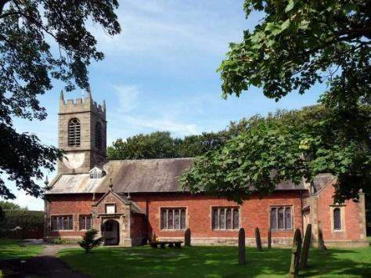
St. Michael and All Angels – Hoole

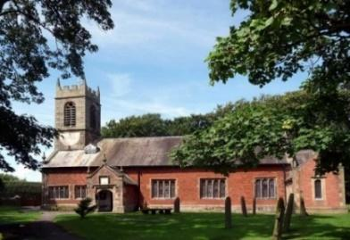

Welcome to our church again this morning. Please stay for a chat and a cup of tea or coffee after the 10.30 service, a great way to meet people

Sunday 29th May 2022 (Easter 7)

Alleluia, Christ is Risen - - - He is Risen indeed, Alleluia.

GOD’S JUDGEMENT AND SAVING LOVE

“For Yours is the Kingdom, the power and the glory,
for ever and ever, Amen.” Matthew 6: v 13.

PRAYER OF THE DAY: Risen, ascended Lord, as we rejoice at
your triumph, fill your Church on earth with power and compassion,
that all who are estranged by sin may find forgiveness and know your
peace, to the glory of God the Father. Amen.

Sunday School today during the service
There are toys and colouring sheets
for younger children at the back of church.

9.00am. Holy Communion (Book of Common Prayer) begins p237

10.30am. Parish Communion with Sunday School
Readings: Daniel 4: v 1, 4-5, 19, 24-25, 27-37.

Hymns: 489 – O God beyond all praising.
Screen – Nothing's too big, big, big.
372 – Judge eternal, throned in splendour.
205 – (tune 1) Glorious things of Thee are spoken.
H/C Hymns: Screen – The power of the cross.
Suppl. 2 – How deep the Father’s love.

12.00noon: Baptism of Alysia and Bobbie. (see inside)
.

READING: Daniel 4: (a summary)
King Nebuchadnezzar,
To the nations and peoples of every language, who live in all the earth:
May you prosper greatly! I, Nebuchadnezzar, was at home in my palace, contented and prosperous. I had a dream that made me afraid. As I was lying in bed, the images and visions that passed through my mind terrified me.
Then Daniel (also called Belteshazzar) was greatly perplexed for a time, and his thoughts terrified him. So the king said, ‘Belteshazzar, do not let the dream or its meaning alarm you.’ Belteshazzar answered, ‘My lord, if only the dream applied to your enemies and its meaning to your adversaries ‘This is the interpretation, Your Majesty, and this is the decree the Most High has issued against my lord the king: you will be driven away from people and will live with the wild animals; you will eat grass like the ox and be drenched with the dew of heaven. Seven times will pass by for you until you acknowledge that the Most High is sovereign over all kingdoms on earth and gives them to anyone he wishes.
Therefore, Your Majesty, be pleased to accept my advice: renounce your sins by doing what is right, and your wickedness by being kind to the oppressed. It may be that then your prosperity will continue.’ All this happened to King Nebuchadnezzar. Twelve months later, as the king was walking on the roof of the royal palace of Babylon, he said, ‘Is not this the great Babylon I have built as the royal residence, by my mighty power and for the glory of my majesty?’
Even as the words were on his lips, a voice came from heaven, ‘This is what is decreed for you, King Nebuchadnezzar: your royal authority has been taken from you. You will be driven away from people and will live with the wild animals; you will eat grass like the ox. Seven times will pass by for you until you acknowledge that the Most High is sovereign over all kingdoms on earth and gives them to anyone he wishes.’
Immediately what had been said about Nebuchadnezzar was fulfilled. He was driven away from people and ate grass like the ox. His body was drenched with the dew of heaven until his hair grew like the feathers of an eagle and his nails like the claws of a bird.
At the end of that time, I, Nebuchadnezzar, raised my eyes towards heaven, and my sanity was restored. Then I praised the Most High; I honoured and glorified him who lives for ever.
His dominion is an eternal dominion; his kingdom endures from generation to generation. All the peoples of the earth are regarded as nothing. He does as he pleases with the powers of heaven and the peoples of the earth. No one can hold back his hand or say to him: ‘What have you done?’
At the same time that my sanity was restored, my honour and splendour were returned to me for the glory of my kingdom. My advisors and nobles sought me out, and I was restored to my throne and became even greater than before. Now I, Nebuchadnezzar, praise and exalt and glorify the King of heaven, because everything he does is right and all his ways are just. And those who walk in pride he is able to humble.

Prayer: We pray for Alysia and Bobbie being baptised today; for those who are sick, especially Erica Ivy, Beryl Cottam, Tom Parkinson, Steve Coughlan, Neil Dexter, Bill and Beryl Carr, Christine Bzrker, Josephine Hodge and Antonietta Broadhurst.

BIBLE STUDY/ HOUSEGROUP CONTINUES ON Monday 31st May and Tues 7th June 7.30pm at the Rectory: 1 John 3 v11-24

THY KINGDOM COME
LIGHT UP THE WORLD 26th May to 6th June
LET US PRAY
When I pray coincidences happen, when I don’t, they don’t
(William Temple – Former Archbishop of Canterbury 1942 – 1944)
Who will you be praying for this #Thy Kingdom Come?

Download the app:
Apple: https://apple.co/3MC6d1j
Android: https://bit.ly/389mg7O and space to pray for your five people.

Suggested Bible readings this week.
Monday 30th May. John 16: v 29-end. Tuesday 31st May Luke 1: v 39-49.
Wednesday 1st June John 17: v 11-19. Thursday 2nd June John 17: v 20-end.
Friday 3rd June John 21: v 15-19. Saturday 4th June John 21: v 20-end.

