Parish Dates May 2021 onwards
Sunday 9th May 09.00am Holy Communion in Church
10.30am Morning Worship in Church
Monday 10th May 7.30pm Bible Study by Zoom or
Tuesday 11th May 7.30pm Bible Study in Church with Compline
THY KINGDOM COME A GLOBAL WAVE OF PRAYER
ASCENSION DAY TO PENTECOST
Thursday 13th May 6.00pm ASCENSION DAY Holy Communion
Sunday 16th May 10.00am Parish Communion. One Service this week followed by 11.00am ANNUAL CHURCH MEETING IN CHURCH
Monday 17th May 7.00-7.30pm Thy Kingdom Come Prayer time on Zoom
7.30pm PCC meeting on Zoom
Tuesday 18th May 10.15pm -10.45am Thy Kingdom Come Prayer t time in church
Thursday 20th May 7.00-7.30pm Thy Kingdom Come Prayer time
on Zoom
Saturday 22nd May 2.30pm Wedding of Sarah and Craig
Sunday 23rd May 09.00am Holy Communion in Church
PENTECOST 10.30am Morning Worship in Church
3.45pm LIFT OFF FAMILY CHURCH
in church and churchyard
Sunday 30th May 09.00am Holy Communion in Church
TRINITY SUNDAY 10.30am Parish Communion in Church
Key Future Dates
16-18th July OUTREACH WEEKEND
Friday July 16th 7.00pm Parish Social with Quiz and Entertainment
in the New Village Hall.
Sunday July 18th 2.00pm – 4.00pm Event for children and families
with Bishop Philip.
All the above services are ‘Live’ in church
We will aim to have recordings of all 10.30 services on the website www.hooleparishchurch.com by Sunday lunch time.
The Zoom link for all church Zoom activities is on the front of website.
Rector – Revd Ann Templeman anntempleman@live.co.uk 01772 448515
The Rectory, 69 Liverpool Old Road Much Hoole PR4 4RB
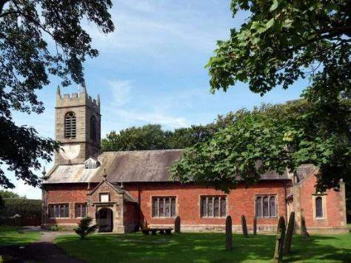
St. Michael and All Angels – Hoole

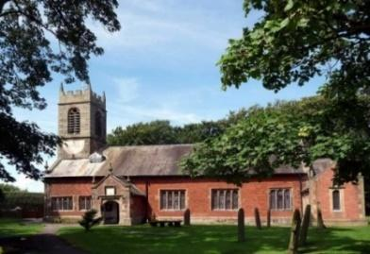

Welcome to our church again this morning. We are pleased to welcome back friends, who have not felt able to attend during the last twelve months.

Sunday 2nd May 2021 Easter 5.

Alleluia, Christ is Risen - - - He is Risen indeed, Alleluia.

EXPLAINING THE GOSPEL.

“How can I understand” the Ethiopian said, “unless someone
explains the reading to me.” Acts 8: v 31.

PRAYER OF THE DAY: Risen Christ, your wounds declare
your love for the world and the wonder of your risen life: give us
compassion and courage to risk ourselves for those we serve,
to the glory of God the Father. Amen.

Sunday School today during the service
There are toys for younger children
at the back of church.
at the back of church.

9.00am. Holy Communion (Book of Common Prayer) begins p237

10.30am. Parish Communion with Sunday School.
Readings: Acts 6: v 1-7 & Acts 8 v: 4-8.
Acts 8: v 26-40
Hymns : 489 – O God beyond all praising.
Screen – All through history.
411 – Lord Jesus Christ, you have come to us.
70 – Be Thou my vision.
H/C Hymns: 620 – Such love. 35 – A new commandment.
BIBLE READINGS: Acts 6: v 1-7 & Acts 8 v: 4-8. In those days when the number of disciples was increasing, the Hellenistic Jews among them complained against the Hebraic Jews because their widows were being overlooked in the daily distribution of food. So the Twelve gathered all the disciples together and said, ‘It would not be right for us to neglect the ministry of the word of God in order to wait on tables. Brothers and sisters, choose seven men from among you who are known to be full of the Spirit and wisdom. We will turn this responsibility over to them and will give our attention to prayer and the ministry of the word.’
This proposal pleased the whole group.
They chose Stephen, a man full of faith and of the Holy Spirit; also Philip, Procorus, Nicanor, Timon, Parmenas, and Nicolas from Antioch, a convert to Judaism. They presented these men to the apostles, who prayed and laid their hands on them. So the word of God spread. The number of disciples in Jerusalem increased rapidly, and a large number of priests became obedient to the faith.

Those who had been scattered preached the word wherever they went. Philip went down to a city in Samaria and proclaimed the Messiah there. When the crowds heard Philip and saw the signs he performed, they all paid close attention to what he said. ⁷ For with shrieks, impure spirits came out of many, and many who were paralysed or lame were healed. So there was great joy in that city.

Acts 8: v 26-40. Now an angel of the Lord said to Philip, ‘Go south to the road – the desert road – that goes down from Jerusalem to Gaza.’ So he started out, and on his way he met an Ethiopian eunuch, an important official in charge of all the treasury of the Kandake (which means ‘queen of the Ethiopians’). This man had gone to Jerusalem to worship, and on his way home was sitting in his chariot reading the Book of Isaiah the prophet. The Spirit told Philip, ‘Go to that chariot and stay near it.’ Then Philip ran up to the chariot and heard the man reading Isaiah the prophet. ‘Do you understand what you are reading?’ Philip asked.
‘How can I,’ he said, ‘unless someone explains it to me?’ So he invited Philip to come up and sit with him. This is the passage of Scripture the eunuch was reading:

‘He was led like a sheep to the slaughter, and as a lamb before its shearer is
silent, so he did not open his mouth. In his humiliation he was deprived of
justice. Who can speak of his descendants? For his life was taken from the earth.’

The eunuch asked Philip, ‘Tell me, please, who is the prophet talking about, himself or someone else?’ Then Philip began with that very passage of Scripture and told him the good news about Jesus. As they travelled along the road, they came to some water and the eunuch said, ‘Look, here is water. What can stand in the way of my being baptised?’ And he gave orders to stop the chariot. Then both Philip and the eunuch went down into the water and Philip baptised him. When they came up out of the water, the Spirit of the Lord suddenly took Philip away, and the eunuch did not see him again, but went on his way rejoicing. Philip, however, appeared at Azotus and travelled about, preaching the gospel in all the towns until he reached
Caesarea.

Prayer. We pray for those who are sick, especially Baby Erica Ivy, Joanne, Patricia Mortimer, Michael Harrison and Beryl Carr. We give thanks for the lives of Michael Pulvermacher and Joan Gleave and we pray for their families and friends.

FORTNIGHTLY BIBLE STUDIES CONTINUE
Mon 10th May 7.30pm by Zoom
and Tuesday 11th May 7.30pm in Church with Compline
This being the first of a new series looking at
St Paul’s letter to the Thessalonians

Please note: THE ANNUAL CHURCH MEETING (APCM) date has been changed from 25th April to 16th May 2021. The meeting will take place in church at 11.00am.

THERE WILL ONLY BE ONE SERVICE ON 16TH MAY AT 10.00AM. THE HOPE IS THAT MEMBERS OF BOTH CONGREGATIONS WILL WANT TO ATTEND CHURCH AT 10am AND JOIN TOGETHER IN THE ANNUAL CHURCH MEETING at 11.00am.

Year End Reports & Accounts 2020 are available to view on our website
www.hooleparishchurch.com
A limited number of hard copies will be available in Church.
This week’s Bible readings are:-
Mon. May 3rd Acts 14: v 5-18 - - - John 14: v 21-26.
Tues. May 4th Acts 14: v 19-end - - - John 14: v 27-end.
Wed. May 5th Acts 15: v 1-6 - - - John 15: v 1-8.
Thurs. May 6th Acts 15: v 7-21 - - - John 15: v 9-11.
Fri. May 7th Acts 15: v 22-31 - - - John 15: v 12-17.
Sat. May 8th Acts 16: v 1-10 - - - John 15: v 18-21.

Please take this sheet home with you

