Parish Dates May 2021 onwards
Tuesday June 1st 7.00pm Time of Prayer on Zoom

Sunday June 6th 09.00am Holy Communion in Church
10.30am Parish Communion in Church
Monday June 7th 7.30pm Bible Study by Zoom
Tuesday June 8th 7.30pm Bible Study in Church with Compline
Thursday June 10th 4.30pm Chat & Chocolate – young people in Church

Sunday June 13th 09.00am Holy Communion in Church
10.30am Morning Worship in Church
Monday June 15th 7.00pm Time of Prayer on Zoom

Sunday June 20th 09.00am Holy Communion in Church
10.30am Parish Communion in Church
3.45pm MAD HATTERS FAMILY CHURCH
TEA PARTY
Thursday June 24th 4.20pm Chat & Chocolate – young people in Church
Saturday June 26th from 10.00am Grand Opening of New Village Hall
with Summer Fair.

Sunday June 27th 09.00am Holy Communion in Church
10.30am Morning Worship in Church

Sunday July 4th 09.00am Holy Communion in Church
10.30am Parish Communion in Church
Key Future Dates SAVE THE DATE
16-18th July OUTREACH WEEKEND
Friday July 16th 7.00pm Parish Social with Quiz and Entertainment
in the New Village Hall.
Sunday July 18th 2.00pm – 4.00pm Event for children and families
with Bishop Philip.
All the above services are ‘Live’ in church
We will aim to have recordings of all 10.30 services on the website www.hooleparishchurch.com by Sunday lunch time.
The Zoom link for all church Zoom activities is on the front of website.
Our Facebook page: St Michael and All Angels Church, Hoole,
Rector – Revd Ann Templeman anntempleman@live.co.uk 01772 448515
The Rectory, 69 Liverpool Old Road Much Hoole PR4 4RB
Please take this sheet home with you
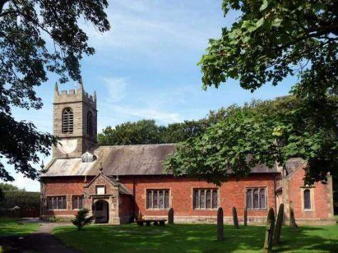
St. Michael and All Angels – Hoole

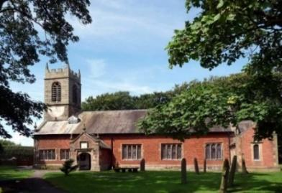

Welcome to our church again this morning. We are pleased to welcome Revd. Richard Plant to lead our worship whilst
Ann and Peter are on holiday.

Sunday 30th May 2021 Trinity

TRINITY SUNDAY THREE IN ONE

“The wind blows wherever it pleases. You hear its sound, but you cannot tell where it comes from or where it is going. So it is with everyone born of the Spirit.” John 3: v 8.

PRAYER OF THE DAY: Holy God, faithful and unchanging:
enlarge our minds with the knowledge of your truth, and draw us
more deeply into the mystery of your love, that we may truly worship
you, Father, Son and Holy Spirit, one God, now and for ever. Amen.

Sunday School today during the service
There are toys for younger children
at the back of church.
at the back of church.

9.00am. Holy Communion (Book of Common Prayer) begins p237

10.30am. Parish Communion with Sunday School.
Reading: John 3: v 1-17.
Hymns : 6 – All creatures of our God and King.
Screen – Nothing too Big Big Big.
Sheet – Glory be to God in Heaven (see inside)
695 – To God be the Glory.
H/C Hymns 67 – Be still for the presence of the Lord.
Sheet 4 – Oh to see the dawn. (The Power of the Cross)

BIBLE READING: John 3: v 1-17.
Now there was a Pharisee, a man named Nicodemus who was a member of the Jewish ruling council. He came to Jesus at night and said, ‘Rabbi, we know that you are a teacher who has come from God. For no one could perform the signs you are doing if God were not with him.’
Jesus replied, ‘Very truly I tell you, no one can see the kingdom of God unless they are born again.’ ‘How can someone be born when they are old?’ Nicodemus asked. ‘Surely they cannot enter a second time into their mother’s womb to be born!’
Jesus answered, ‘Very truly I tell you, no one can enter the kingdom of God unless they are born of water and the Spirit. Flesh gives birth to flesh, but the Spirit gives birth to spirit. You should not be surprised at my saying, “You must be born again.” The wind blows wherever it pleases. You hear its sound, but you cannot tell where it comes from or where it is going. So it is with everyone born of the Spirit.’ ‘How can this be?’ Nicodemus asked.
‘You are Israel’s teacher,’ said Jesus, ‘and do you not understand these things? Very truly I tell you, we speak of what we know, and we testify to what we have seen, but still you people do not accept our testimony. I have spoken to you of earthly things and you do not believe; how then will you believe if I speak of heavenly things? No one has ever gone into heaven except the one who came from heaven – the Son of Man. Just as Moses lifted up the snake in the wilderness, so the Son of Man must be lifted up, that everyone who believes may have eternal life in him.’ For God so loved the world that he gave his one and only Son, that whoever believes in him shall not perish but have eternal life. For God did not send his Son into the world to condemn the world, but to save the world through him.

Prayer. We pray for those who are sick, especially Baby Erica Ivy, Patricia Mortimer, Michael Harrison, Beryl Carr, Fiona Spalding, Alan Fleetwood and Josephine Hodge.

FORTNIGHTLY BIBLE STUDIES CONTINUE
Mon 7th June 7.30pm by Zoom
and Tuesday 8th June 7.30pm in Church with Compline
We continue to look at Paul’s first letter to the Thessalonians

HYMN: Glory be to God in Heaven.

Glory be to God in heaven,
Songs of Joy and peace we bring,
Thankful heart and voices raising,
To creation’s Lord we sing:
Lord, we thank you.
Lord we bless you,
Glory be to God our King,
Glory be to God our King.

Lamb of God, who on your shoulders
Bore the load of this world’s sin,
Only Son of God the Father,
You have brought us peace within:
Lord have mercy,
Christ have mercy,
Now your glorious reign begin,
Now your glorious reign begin.

Edwin le Grice © Kevin Mayhew
Printed under license CCL 1917737

Village Hall. Phase one of the New Village Hall is almost complete and initially set for a soft opening (under covid restrictions) over this weekend including Bank Holiday Monday tomorrow. Please take time to have a look round.
The official Grand Opening by the Mayor of South Ribble, Cllr Jane Bell, will take place on Saturday June 26th from 10.00am onwards. All welcome. There will be a fair ground, stalls, food and entertainment for all. We look forward to seeing you there.

