Parish Dates May 2021 onwards
Monday May 10th 7.30pm Bible Study by Zoom
Tuesday May 11th 7.30pm Bible Study in Church with Compline
THY KINGDOM COME: A GLOBAL WAVE OF PRAYER
ASCENSION DAY TO PENTECOST (see notice inside)
Thursday May 13th 6.00pm ASCENSION DAY Holy Communion.

Sunday May 16th 10.00am Parish Communion
One service only this week followed by at
11.00am ANNUAL CHURCH MEETING.
Monday May 17th 7.00pm Thy Kingdom Come Prayer time (Zoom)
7.30pm PCC Meeting on Zoom.
Tuesday May 18th 10.15am Thy Kingdom Come Prayer time (in Church)
Thursday May 20th 7.00pm Thy Kingdom Come Prayer time (Zoom)
Saturday May 22nd 2.30pm Wedding of Sarah and Craig

Sunday May 23rd 09.00am Holy Communion in Church
PENTECOST 10.30am Morning Worship in Church
3.45pm LIFT OFF FAMILY CHURCH
In Church and Churchyard.
Monday May 24th 7.30pm Bible Study by Zoom
Tuesday May 25th 7.30pm Bible Study in Church with Compline

Sunday May 30th 09.00am Holy Communion in Church
TRINITY SUNDAY 10.30am Parish Communion in Church

16-18th July OUTREACH WEEKEND
Friday July 16th 7.00pm Parish Social with Quiz and Entertainment
in the New Village Hall.
Sunday July 18th 2.00pm – 4.00pm Event for children and families
with Bishop Philip.
All the above services are ‘Live’ in church
We will aim to have recordings of all 10.30 services on the website www.hooleparishchurch.com by Sunday lunch time.
The Zoom link for all church Zoom activities is on the front of website.
Our Facebook page: St Michael and All Angels Church, Hoole,
Rector – Revd Ann Templeman anntempleman@live.co.uk 01772 448515
The Rectory, 69 Liverpool Old Road Much Hoole PR4 4RB
Please take this sheet home with you
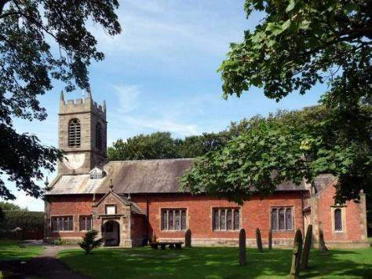
St. Michael and All Angels – Hoole

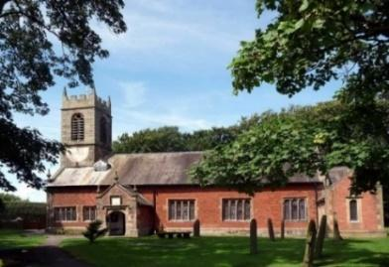

Welcome to our church again this morning. We are pleased to welcome back friends, who have not felt able to attend during the last twelve months.

Sunday 9th May 2021 Easter 6.

Alleluia, Christ is Risen - - - He is Risen indeed, Alleluia.

GOD HAS NO FAVOURITES.

“Everyone who believes in Jesus receives forgiveness of sins
through his name” Acts 10: v 23.

PRAYER OF THE DAY: Risen Christ, by the lakeside you
renewed your call to your disciples: help your Church to obey your
command and draw the nations to the fire of your love,
to the glory of God the Father. Amen.

Sunday School today during the service
There are toys for younger children
at the back of church.
at the back of church.

9.00am. Holy Communion (Book of Common Prayer) begins p237

10.30am. Morning Worship with Sunday School.
Readings: Acts 10: v 1-8 & Acts 10 v: 9-23.
Acts 10: v 23-26 --- v 34&35 --- v 39-44 --- v46b&47.
Hymns : 249 – Great is thy faithfulness.
Screen – God Loves Me
Supp. – Bless the Lord O my Soul (Ten thousand reasons).
503 – v I, 3 & 5: O Jesus I have promised.
332 – I the Lord of sea and sky.
BIBLE READINGS: Acts 10: v 1-8 & Acts 10 v: 9-23. Cornelius calls for Peter
At Caesarea there was a man named Cornelius, a centurion in what was known as the Italian Regiment. He and all his family were devout and God-fearing; he gave generously to those in need and prayed to God regularly. One day at about three in the afternoon he had a vision. He distinctly saw an angel of God, who came to him and said, ‘Cornelius!’ Cornelius stared at him in fear. ‘What is it, Lord?’ he asked.
The angel answered, ‘Your prayers and gifts to the poor have come up as a memorial offering before God. Now send men to Joppa to bring back a man named Simon who is called Peter. He is staying with Simon the tanner, whose house is by the sea.’ When the angel who spoke to him had gone, Cornelius called two of his servants and a devout soldier who was one of his attendants.
He told them everything that had happened and sent them to Joppa.

Peter’s vision About noon the following day as they were on their journey and approaching the city, Peter went up on the roof to pray. He became hungry and wanted something to eat, and while the meal was being prepared, he fell into a trance. He saw heaven opened and something like a large sheet being let down to earth by its four corners. It contained all kinds of four-footed animals, as well as reptiles and birds. Then a voice told him, ‘Get up, Peter. Kill and eat.’
‘Surely not, Lord!’ Peter replied. ‘I have never eaten anything impure or unclean.’
The voice spoke to him a second time, ‘Do not call anything impure that God has made clean.’ This happened three times, and immediately the sheet was taken back to heaven. While Peter was wondering about the meaning of the vision, the men sent by Cornelius found out where Simon’s house was and stopped at the gate. They called out, asking if Simon who was known as Peter was staying there.
While Peter was still thinking about the vision, the Spirit said to him, ‘Simon, three^{[a]} men are looking for you. So get up and go downstairs. Do not hesitate to go with them, for I have sent them.’
Peter went down and said to the men, ‘I’m the one you’re looking for. Why have you come?’ The men replied, ‘We have come from Cornelius the centurion. He is a righteous and God-fearing man, who is respected by all the Jewish people. A holy angel told him to ask you to come to his house so that he could hear what you have to say.’ Then Peter invited the men into the house to be his guests.

Acts 10: v 23-26 -- v 34&35 -- v 39-44 -- v46b&47. Peter at Cornelius’ house
The next day Peter started out with them, and some of the believers from Joppa went along. The following day he arrived in Caesarea. Cornelius was expecting them and had called together his relatives and close friends. As Peter entered the house, Cornelius met him and fell at his feet in reverence. But Peter made him get up. ‘Stand up,’ he said, ‘I am only a man myself.’

Then Peter began to speak: ‘I now realise how true it is that God does not show favouritism but accepts from every nation the one who fears him and does what is right.
‘We are witnesses of everything he did in the country of the Jews and in Jerusalem. They killed him by hanging him on a cross, but God raised him from the dead on the third day and caused him to be seen. He was not seen by all the people, but by witnesses whom God had already chosen – by us who ate and drank with him after he rose from the dead. He commanded us to preach to the people and to testify that he is the one whom God appointed as judge of the living and the dead. All the prophets testify about him that everyone who believes in him receives forgiveness of sins through his name.’
While Peter was still speaking these words, the Holy Spirit came on all who heard the message. .
Then Peter said, ‘Surely no one can stand in the way of their being baptised with water. They have received the Holy Spirit just as we have.’

Prayer. We pray for those who are sick, especially Baby Erica Ivy, Patricia Mortimer, Michael Harrison, Beryl Carr and Josephine Hodge.
THY KINGDOM COME
From Ascension to Pentecost there will be a Global
Wave of prayer called Thy Kingdom Come. In
addition to the services at Ascension and Pentecost,
there will be special times of prayer on:
Monday 17th May, 7pm – 7.30pm on Zoom.
Tuesday 18th May, 10.15am – 10.45am in Church.
Thursday 20th May, 7pm – 7.30pm on Zoom.
Please join us
There will be prayer resources in Church throughout this time, Why not pray for 5 friends, along with thousands of other Christians around the world that they might come to know the Lord Jesus for themselves.

FORTNIGHTLY BIBLE STUDIES CONTINUE
Mon 10th May 7.30pm by Zoom
and Tuesday 11th May 7.30pm in Church with Compline
This is the first of a new series on St Paul’s letter to the Thessalonians

Please note: THE ANNUAL CHURCH MEETING (APCM)
will take place on 16th May 2021 in Church 11.00am.

THERE WILL ONLY BE ONE SERVICE ON 16TH MAY AT 10.00AM, SO THAT MEMBERS OF BOTH CONGREGATIONS MAY ATTEND CHURCH AT 10am, AND JOIN TOGETHER FOR THE APCM at 11.00am.
Year End Reports & Accounts 2020 are available to view on our website Also a limited number of hard copies are available in church.

