Parish Dates November 2021 onwards
Monday 22nd November 3.30pm Bereavement group tea
Tuesday 23rd November 10.15 – 10.45am Holy Communion in Church
7.30pm Bible Study at the Rectory
Sunday 28th November ADVENT SUNDAY
09.00am Holy Communion
10.30am Morning Worship and the baptism of Thomas Lamb
4.00pm Holy Communion Old Mill Court
Monday 29th November 4.00pm Griefshare Video at the Rectory
Tuesday 30th November 10.15 – 10.45am Prayer time in Church
7.30pm Bible Study at the Rectory
Thursday 2nd December 4:30pm Chat & Chocolate
Sunday 5th December 09.00am Holy Communion
10.30am Parish Communion
3.45pm TOY AND CHRISTINGLE SERVICE
Monday 6th December 7.30pm Bible Study at the Rectory
Thursday 7th December 7.30pm Ladies Group meet
Thursday Dec 9th from 11.30am Christmas Locals’ Lunch in Village Hall.
Sunday 12th December 09.00am Holy Communion
10.30am Morning Worship with Sunday School
Tuesday 14th December 7.30pm Housegroup Social. Bring &share supper
Thursday 16th December 2.15pm School carol service in Church
4:30pm Chat & Chocolate
Sunday 19th December 09.00am Holy Communion
10.30am Parish Communion & Sunday School
6.00pm CAROLS BY CANDLELIGHT
CHRISTMAS EVE 4.00pm CRIB SERVICE
11.30pm MIDNIGHT COMMUNION
CHRISTMAS DAY 10.30am FAMILY SERVICE WITH CAROLS AND COMMUNION
Sunday 26th December 10.30am Parish Communion
SAVE THE DATE
Friday 21st January 7.00pm -10.30pm New Year Parish Social: Music from 70s and 80s in the Village Hall.
Website : www.hooleparishchurch.com
Facebook page: St Michael and All Angels Church, Hoole,
Rector – Revd Ann Templeman anntempleman@live.co.uk 01772 448515The Rectory, 69 Liverpool Old Road Much Hoole PR4 4RB
Please take this sheet home with you
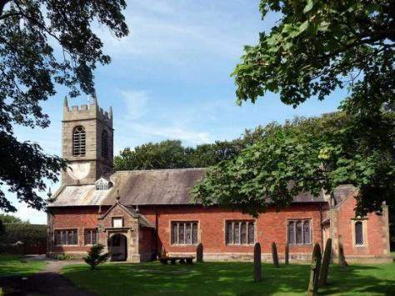
St. Michael and All Angels – Hoole

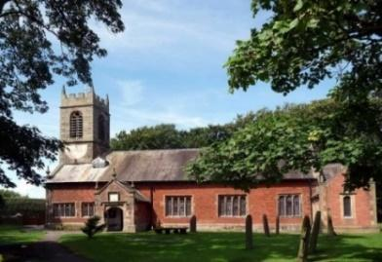

Welcome to our church again this morning. Please stay for a chat and a cup of tea or coffee after the 10.30 service, a great way to meet people.

Sunday 21st November 2021 Christ the King

THE FIRST IN YOUR LIFE

“Why do you call me good?” Jesus answered, “No one is good – except
God alone.” Mark 10: v 18.

PRAYER OF THE DAY: God the Father, help us to hear the call of
Christ the King and to follow in his service, whose kingdom has no
end; for he reigns with you and the Holy Spirit, one God, one glory.
Amen.
No Sunday School today during the service
Narnia Church at 3.45pm.
There are toys and colouring sheets
for younger children at the back of church.

9.00am. Holy Communion (Book of Common Prayer) begins p237

10.30am. Parish Communion.

Reading: Mark 10: v 17-31.
Hymns: 54 – At the name of Jesus (tune 2).
590 – Seek ye first.
303 – I cannot tell.
137 – Crown him with many crowns (omit v 2)
H/C Hymns: Supp. 8 – King of Kings Majesty. 374 – Just as I am.

3.45pm. Narnia Family Church in the Village Hall.
BIBLE READING: Mark 10: v 17-31. As Jesus started on his way, a man ran up to him and fell on his knees before him. ‘Good teacher,’ he asked, ‘what must I do to inherit eternal life?’ ‘Why do you call me good?’ Jesus answered. ‘No one is good – except God alone. You know the commandments: “You shall not murder, you shall not commit adultery, you shall not steal, you shall not give false testimony, you shall not defraud, honour your father and mother.”’
‘Teacher,’ he declared, ‘all these I have kept since I was a boy.’ Jesus looked at him and loved him. ‘One thing you lack,’ he said. ‘Go, sell everything you have and give to the poor, and you will have treasure in heaven. Then come, follow me.’
At this the man’s face fell. He went away sad, because he had great wealth.
Jesus looked round and said to his disciples, ‘How hard it is for the rich to enter the kingdom of God!’
The disciples were amazed at his words. But Jesus said again, ‘Children, how hard it is to enter the kingdom of God! It is easier for a camel to go through the eye of a needle than for someone who is rich to enter the kingdom of God.’
The disciples were even more amazed, and said to each other, ‘Who then can be saved?’ Jesus looked at them and said, ‘With man this is impossible, but not with God; all things are possible with God.’ Then Peter spoke up, ‘We have left everything to follow you!’
‘Truly I tell you,’ Jesus replied, ‘no one who has left home or brothers or sisters or mother or father or children or fields for me and the gospel will fail to receive a hundred times as much in this present age: homes, brothers, sisters, mothers, children and fields – along with persecutions – and in the age to come eternal life. But many who are first will be last, and the last first.’

Prayer. We pray for the success of Narnia Church taking place this afternoon. We pray for those who are sick, especially Baby Erica Ivy, Patricia Mortimer, Rose Wood, Nicola Middleton, Tom Parkinson, Joanna Pulvermacher, Josephine Hodge and Steve Coughlan.

LANCASHIRE DAY AT OLD MILL COURT: Takes place on Saturday Nov 27th at 2.00pm. Tea, Cakes, Quiz, Raffle plus entertainment, all for £10.00. All proceeds for St Michael’s ‘New Lodge, Buy a Brick Fund’. For tickets or further information ring Antonietta on 01772 301629 or 07835 517383. Or simply don your shawls and flat caps and come along on the day, everyone welcome.

WEEKLY GIVING ENVELOPES 2022: The envelopes for 2022 should be in Church at the beginning of December. Please collect them as soon as possible . Please return tax status slips in the box fao Treasurer. Please ask if you would like to join the envelope scheme or change to Standing Order.
PLEASE TAKE A FREE ADVENT BOOKLET for BIBLE READING AND PRAYER

BIBLE STUDIES: THE PARABLES OF JESUS
Tues Nov 23rd 7.30pm in the Rectory: Parable of the Tenants Mat21 v 33-46
Join us Tuesdays 10.15am - 10.45am in church: 23rd Nov Holy Communion

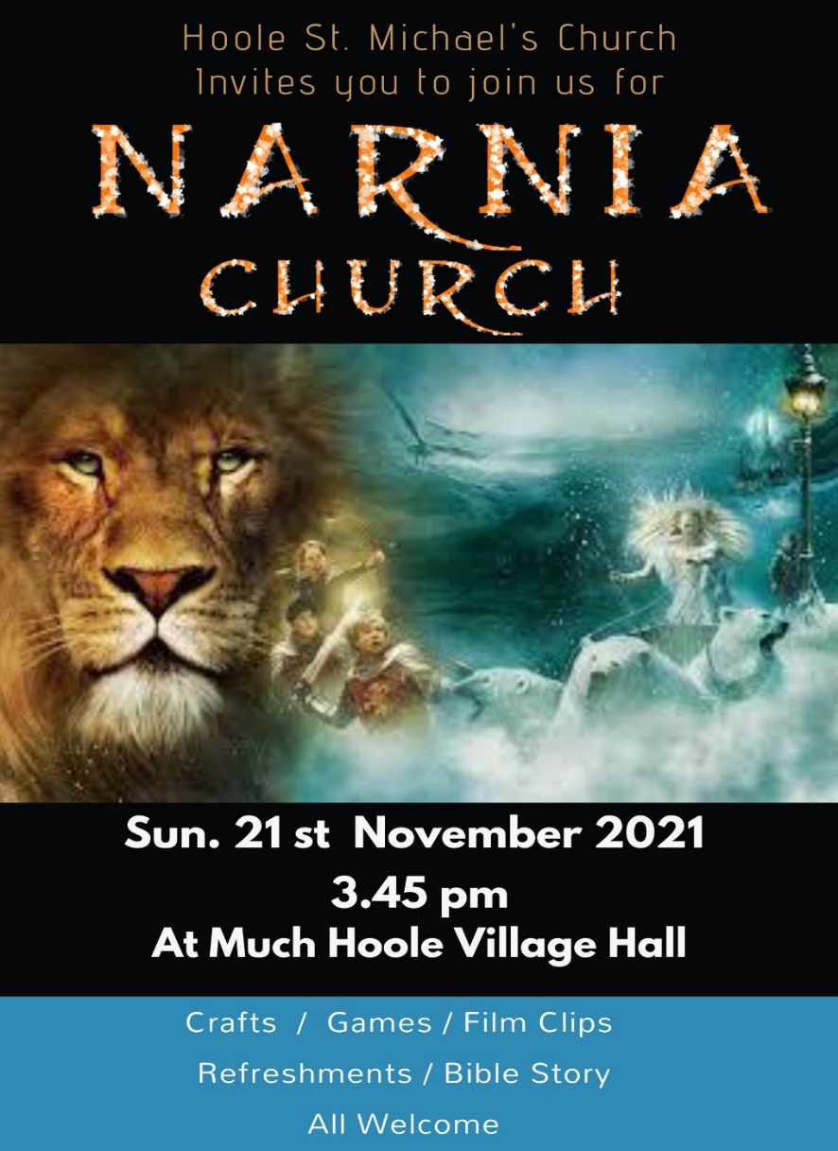
Suggested Bible readings this week.
Monday 22nd Nov. Luke 21: v 1-4. Tuesday 23rd Nov. Luke 21: v 5-11.
Wednesday 24th Nov. Luke 21: v 12-19. Thursday 25th Nov. Luke 21: v 20-28.
Friday 26th Nov. Luke 21: v 29-33. Saturday 27th Nov. Luke 21: v 34-36.

