PARISH DATES
Monday 27th Nov. 7.30pm Bible for Beginners in the Lodge
Tuesday 28th Nov. 10.15am Holy Communion in the Lodge.
Wednesday 29th Nov 9.30am-11.30am St Michael’s Little Angels.
Friday 1st Dec. 7.00pm University Challenge in the Lodge.
Sunday 3rd Dec. 9.00am Holy Communion
10.30am Parish Communion.
3.45pm TOY & CHRISTINGLE SERVICE in Church.
4.00pm Holy Communion (Old Mill Court)
Monday 4th Dec 2.30pm Ribble Court Holy communion
Tuesday 5th Dec. 10.15am Holy Communion in the Lodge.
7.30pm Ladies Group Christmas Coffee Evening.
Wednesday 6th Dec. 9.30am-11.30am St Michael’s Little Angels.
Sunday 10th Dec. 9.00am Holy Communion
10.30am Morning Worship with Sunday School.
Monday 11th Dec. 7.30pm The Chosen Christmas Special
with Social in the Lodge.
Tuesday 12th Dec. 10.15am Holy Communion in the Lodge.
7.30pm Men’s Group Christmas Meal in Village Hall.
Wednesday 13th Dec. 9.30am-11.30am St Michael’s Little Angels.
Saturday 26th Dec 12 – 2.00pm Sunday School Christmas party
Sunday 17th Dec. 9.00am Holy Communion
10.30am Parish Communion with Sunday School.
6.00pm CAROLS BY CANDLELIGHT in Church.
Monday 18th Dec 2.30pm Ribble Court Carol Service
Tuesday 19th Dec. 10.15am Holy Communion in the Lodge.
Wednesday 20th Dec. 9.30am-11.30am St Michael’s Little Angels.
Thursday 21st Feb 9.00am St Michael’s School Christmas Service
Sunday 24th Dec. 9.00am Holy Communion
Christmas Eve 10.30am Morning Worship
4.00pm CRIB SERVICE in Church.
11.15pm MIDNIGHT COMMUNION
Monday 25th Dec. 10.30am FAMILY SERVICE WITH
Christmas Day CAROLS AND COMMUNION
Thursday 28th Dec 4.00pm Wedding of Alex Redshaw and Jessica Bodell
Sunday 31st Dec 5.00pm Wedding of Danielle Bamford and Richard Taylor

www.hooleparishchurch.com Facebook : St Michael and All Angels Church, Hoole,
Rector Ann Templeman anntempleman@live.co.uk 01772 448515 or 07877659156
PLEASE TAKE THIS SHEET HOME WITH YOU.
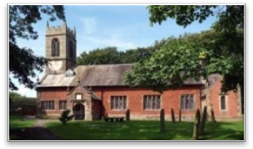
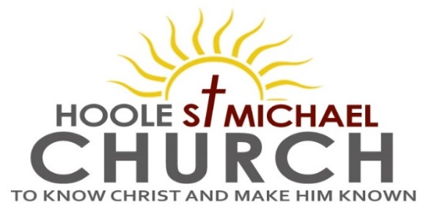

Welcome to our Church today.
Please stay for refreshments in the Lodge which follow the 10.30am service.

Sunday 26th November 2023

CHRIST THE KING

“At the name of Jesus every knee shall bow.” (Philippians 2: v 11)

PRAYER OF THE DAY God the Father, help us to hear the call of
Christ the King and to follow in his service, whose kingdom has no
end; for he reigns with you and the Holy Spirit, one God, one glory.
Amen.


Sunday School today during the service.
There are toys and colouring sheets for younger children
at the back of church.

9.00am. Holy Communion (Book of Common Prayer) begins p237

10.30am. Morning Worship with the Baptism of Samuel Bamber.

Readings: Revelation 1: v 4b-8. John 18: v33-37.
Hymns: 54 – At the name of Jesus (omit v 4).
Screen – Our God is a great big God.
461 – My Jesus, my Saviour.
Suppl. 8 – King of Kings, Majesty.
419 – Lord the light of your love. (Shine Jesus shine)

5.00pm. PIZZA ‘N’ PRAISE IN CHURCH

Suggested Bible Readings for this week: Thursday: Andrew - Apostle
Monday 27th Nov. Luke 21: v 1-4. Tuesday 28th Nov. Luke 21: v 5-11.
Wednesday 29th Nov. Luke 21: v 12-19. Thursday 30th Nov. Matt. 4: v 18-22. Friday 1st Dec. Luke 21: v 29-33. Saturday 2nd Nov. Luke 21: v 34-36.
Reading1: Jesus is King of Kings Revelation 1: v 4b-8.
Grace and peace to you from him who is, and who was, and who is to come, and from the seven spirits before his throne, and from Jesus Christ, who is the faithful witness, the firstborn from the dead, and the ruler of the kings of the earth. To him who loves us and has freed us from our sins by his blood, and has made us to be a kingdom and priests to serve his God and Father – to him be glory and power for ever and ever! Amen.
‘Look, he is coming with the clouds,’ and ‘every eye will see him, even those who pierced him’; and all peoples on earth ‘will mourn because of him.’ So shall it be! Amen.
‘I am the Alpha and the Omega,’ says the Lord God, ‘who is, and who was, and who is to come, the Almighty.’

Reading 2: Jesus is a King but not of this world John 18: v33-37.
Pilate then went back inside the palace, summoned Jesus and asked him, “Are you the king of the Jews?” “Is that your own idea,” Jesus asked, “or did others talk to you about me?” “Am I a Jew?” Pilate replied. “Your own people and chief priests handed you over to me. What is it you have done?”
Jesus said, “My kingdom is not of this world. If it were, my servants would fight to prevent my arrest by the Jewish leaders. But now my kingdom is from another place.” “You are a king, then!” said Pilate.
Jesus answered, “You say that I am a king. In fact, the reason I was born and came into the world is to testify to the truth. Everyone on the side of truth listens to me.”

Prayer: We pray for Samuel Bamber and his family on the occasion of his baptism today. We continue to pray for all those affected by the conflict in the Middle East, for peace, understanding and compassion. We pray for all who are sick especially, Erika Ivy, Jon Slinger, Jean Smallwood, Monica Keane, Edward Kenyon, Josephine Hodge, Marilyn Winter, Bill & Beryl Carr. We give thanks for the lives of Douglas Moon, Paul Metcalfe, Leslie Kennard and Joan Helm and pray for their families & friends.

UNIVERSITY CHALLENGE Friday 1st December in the Lodge at 7.00pm
UNIVERSITY – V – POLYTECHNIC. £5.00each inc light refreshments.
Tickets and information from Colin Wilson 01772 616978.

money, no extra shirt. .
BIBLE FOR BEGINNERS
on MONDAYs 7.30pm in the LODGE
We are looking at the excellent portrayal of Jesus from the Biblical series The Chosen. Next session Mon 27th Nov.

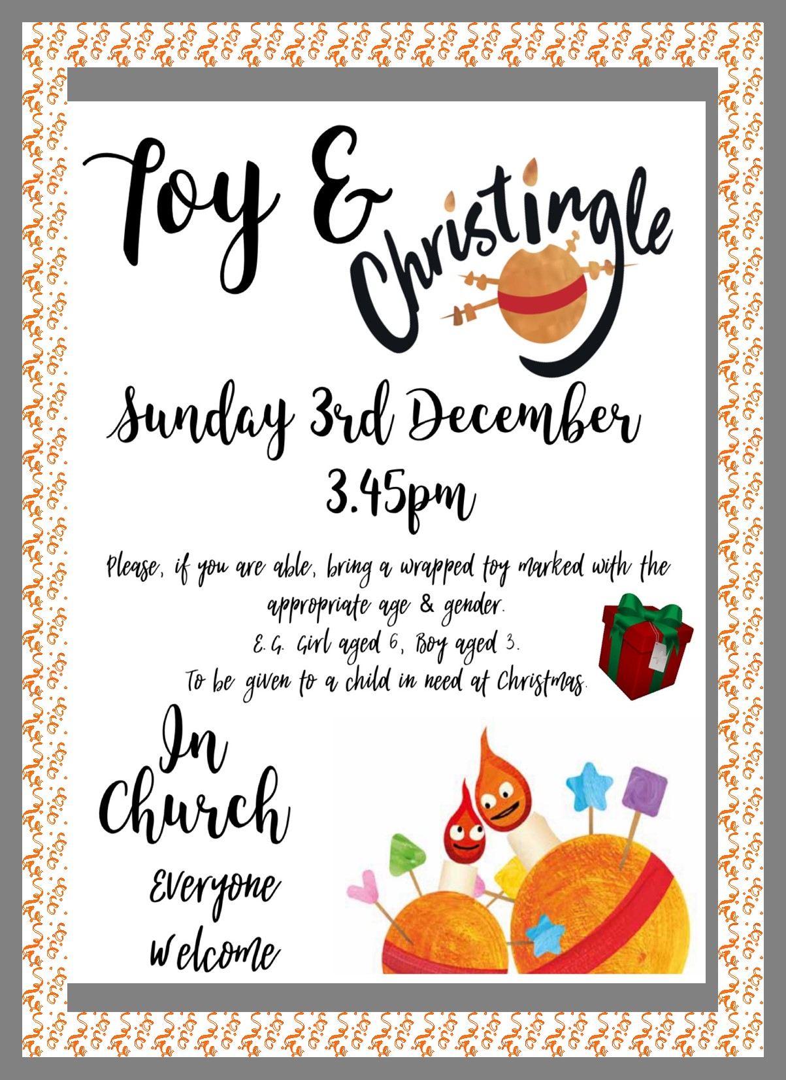
REVEALING JESUS
Please take a copy of the Advent booklet from the Diocese to help you focus on Jesus as we prepare for His coming

