Parish Dates November 2021 onwards
Monday 29th November 4.00pm Griefshare Video at the Rectory
Tuesday 30th November 10.15 – 10.45am Morning Prayer in Church
7.30pm Bible Study at the Rectory
Thursday 2nd December 4:30pm Chat & Chocolate
Sunday 5th December 09.00am Holy Communion
10.30am Parish Communion
3.45pm TOY AND CHRISTINGLE SERVICE
Monday 6th December 7.30pm Bible Study at the Rectory
Tuesday 7th December 7.30pm Ladies Group in Village hall
Thursday Dec 9th from 11.30am Christmas Locals’ Lunch in Village Hall.
Sunday 12th December 09.00am Holy Communion
10.30am Morning Worship with Sunday School
Tuesday 14th December 2.15pm School Carol Service in Church
7.30pm Housegroup Christmas Social at the Rectory – Carols, Christmas readings, refreshments – all welcome .
7.30pm Men’s Fellowship Christmas meal.
Thursday 16th December 4:30pm Chat & Chocolate
Friday 17th December 9.15am Hubbersty Assembly in Church
Sunday 19th December 09.00am Holy Communion
10.30am Parish Communion & Sunday School
6.00pm CAROLS BY CANDLELIGHT
CHRISTMAS EVE 4.00pm CRIB SERVICE
11.30pm MIDNIGHT COMMUNION
CHRISTMAS DAY 10.30am FAMILY SERVICE WITH CAROLS AND COMMUNION
Sunday 26th December 10.30am Parish Communion

SAVE THE DATE
Friday 21st January 7.00pm -10.30pm New Year Parish Social: Music from60s/ 70s and 90s in the Village Hall.
Website : www.hooleparishchurch.com
Facebook page: St Michael and All Angels Church, Hoole,
Rector – Revd Ann Templeman anntempleman@live.co.uk 01772 448515The Rectory, 69 Liverpool Old Road Much Hoole PR4 4RB
Please take this sheet home with you
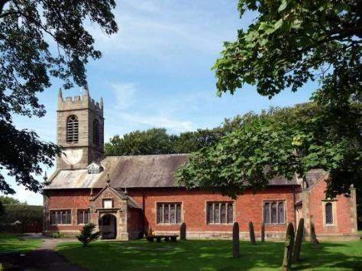
St. Michael and All Angels – Hoole

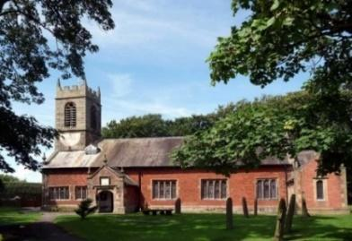

Welcome to our church again this morning. Please stay for a chat and a
cup of tea or coffee after the 10.30 service, a great way to meet people

Sunday 28th November 2021

ADVENT SUNDAY

‘Be always on the watch’ (Luke 21: v 36) ‘May the Lord make your love increase and overflow for each other and for everyone else’ 1 Thess. 3; v 6.

PRAYER OF THE DAY: Almighty God, as your kingdom dawns,
turn us from the darkness of sin to the light of holiness, that we may
be ready to meet you in our Lord and Saviour, Jesus Christ. Amen.

Sunday School today during the service
There are toys and colouring sheets
for younger children at the back of church.

9.00am. Holy Communion (Book of Common Prayer) begins p237

10.30am. Morning Worship with the Baptism of Thomas Lamb.

Readings: 1 Thessalonians 3: v 6-end.
Luke 21: v 25-36.
Hymns: 405– Lo He Comes.
Screen/Video – My Lighthouse.
29 – Amazing Grace.
305 – Lord of the dance.
419 – Shine Jesus shine.

4.00pm. Holy Communion (Old Mill Court)

BIBLE READINGS: 1 Thessalonians 3: v 6-end. But Timothy has just now come to us from you and has brought good news about your faith and love. He has told us that you always have pleasant memories of us and that you long to see us, just as we also long to see you. Therefore, brothers and sisters, in all our distress and persecution we were encouraged about you because of your faith. For now we really live, since you are standing firm in the Lord. How can we thank God enough for you in return for all the joy we have in the presence of our God because of you? Night and day we pray most earnestly that we may see you again and supply what is lacking in your faith.
Now may our God and Father himself and our Lord Jesus clear the way for us to come to you. May the Lord make your love increase and overflow for each other and for everyone else, just as ours does for you. May he strengthen your hearts so that you will be blameless and holy in the presence of our God and Father when our Lord Jesus comes with all his holy ones.

Luke 21: v 25-36. ‘There will be signs in the sun, moon and stars. On the earth, nations will be in anguish and perplexity at the roaring and tossing of the sea. People will faint from terror, apprehensive of what is coming on the world, for the heavenly bodies will be shaken. At that time they will see the Son of Man coming in a cloud with power and great glory. When these things begin to take place, stand up and lift up your heads, because your redemption is drawing near.’
He told them this parable: ‘Look at the fig-tree and all the trees. When they sprout leaves, you can see for yourselves and know that summer is near. Even so, when you see these things happening, you know that the kingdom of God is near.
‘Truly I tell you, this generation will certainly not pass away until all these things have happened. Heaven and earth will pass away, but my words will never pass away. ‘Be careful, or your hearts will be weighed down with carousing, drunkenness and the anxieties of life, and that day will close on you suddenly like a trap. For it will come on all those who live on the face of the whole earth. Be always on the watch, and pray that you may be able to escape all that is about to happen, and that you may be able to stand before the Son of Man.’

Prayer We pray for Thomas Lamb being Baptised this morning and for his parents and family. We pray for those who are sick, especially Baby Erica Ivy, Patricia Mortimer, Rose Wood, Tom Parkinson, Joanna Josephine Hodge and Steve Coughlan. We give thanks for the life of Bryan Marcus and pray for his family and friends

New Longton Methodist Church are performing the Christmas Cantata "The Inn Crowd" at 6.30pm on Dec. 12th. (more details available from Margaret Kirkman)

PLEASE TAKE A FREE ADVENT BOOKLET for BIBLE READING AND PRAYER
AFTER GOD’S OWN HEART
Please take the Diocesan ADVENT BOOKLET AFTER GOD'S OWN HEART. It contains daily readings and prayers for each day of Advent. The daily Advent readings are based around the life of David -Jesus was from the House of David and born in Bethlehem David's birth place.
ADVENT BIBLE STUDIES/HOUSEGROUPS
We are going to take one of the weekly readings in the booklet as the subject of our Bible studies
1.TUESDAY 30th Nov 1 Samuel 16v 1-13
2. MONDAY 6th Dec 1 Samuel 30 v 1-29
TUESDAY 14TH DECEMBER 7.30 HOUSEGROUP CHRISTMAS SOCIAL AT THE RECTORY for everyone

