**Parish Dates From November 2022**

**Tuesday 8th Nov. 10.15am Morning Prayer in the Lodge.**

**7.30pm Men’s Fellowship in the Village Hall.**

**Wednesday 9th Nov. 7.15pm – c8.30pm Alpha Course in the Lodge.**

**Thursday 10th Nov. 4.30pm Chat and Chocolate in the Lodge.**

**Friday 11th Nov. 9.00am St Michael’s School Remembrance Service**

**Sunday 13th November (NB No 9.00am Service today)**

**10.10am REMEMBRANCE SERVICE 4.00pm Holy Communion (Old Mill Court)**

**Monday 14th Nov 7.30pm PCC meeting in the Lodge**

**Tuesday 15th Nov. 10.15am Holy Communion in the Lodge.**

**7.30pm Ladies Group in the Village Hall.**

**Wednesday 16th Nov. 7.00pm – 9.00pm Alpha Course in the Lodge – with Jacob’s Join meal – WHY GO TO CHURCH .**

**Thursday 17th Nov. 4.30pm Bible and Biscuits in the Lodge.**

**Saturday 19th Nov. 9.30am – 1.30 pm QUIET MORNING**

**IN LODGE WITH ARCHDEACON MARK.**

**2.00pm Celebration of the Marriage of**

**Martyn Parker and Janet Moon**

**Sunday 20th Nov. 9.00am Holy Communion**

**10.30am Parish Communion.**

**3.45pm CHOCOLATE CHURCH in Village Hall.**

**Tuesday 21st Nov 10.15am Morning Prayer in the Lodge.**

**Sunday 27th Nov 9.00am Holy Communion**

**ADVENT SUNDAY 10.30am Morning Worship & Sunday School**

**1.2 00 Interment of ashes – Joan Clarkson**

**Tuesday 28th Nov 10.15am Holy Communion in the Lodge.**

**7.30pm Preparing for Christmas- Bible Study in the Lodge**

**Future Key Dates**

**Sunday 4th Dec. 3.45pm TOY AND CHRISTINGLE SERVICE**

**Sunday 11th Deember 6.00pm CAROLS BY CANDLELIGHT**

**Website :** **www.hooleparishchurch.com**

Facebook page: **St Michael and All Angels Church, Hoole**,

Rector – Revd Ann Templeman anntempleman@live.co.uk

01772 448515 or 07877659156

**SO***Please take this sheet home with you*

**St. Michael and All Angels –Hoole**

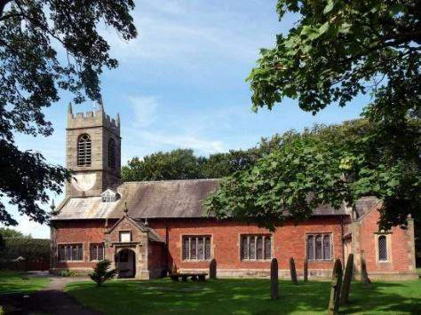

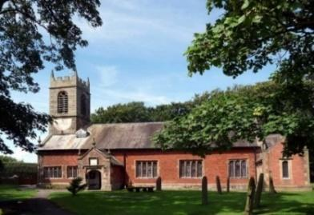

***Welcome to our church this morning. Please stay for a chat and a cup of tea or coffee in the Lodge after the 10.30 service.***

***Sunday 6th November 2022***

**FOLLOWING JESUS.**

**“Go”, Jesus said. “Your faith has healed you”. Immediately he received his sight and followed Jesus along the road.**  *Mark 10: v 52.*

**PRAYER OF THE DAY: Heavenly Lord, you long for the world’s**

**salvation: stir us from apathy, restrain us from excess and revive**

**in us new hope that all creation will one day be healed**

**in Jesus Christ our Lord. Amen.**

**Sunday School today during the service**

There are toys and colouring sheets

for younger children at the back of church

**

**9.00am. Holy Communion (Book of Common Prayer) begins p237**

**10.30am. Parish Communion with Sunday School.**

**Reading: Mark 10: v 46-52.**

**Hymns: 570 – Praise the Lord, ye heavens, adore him.**

**Screen – God can do anything.**

**Suppl. 10 – Here is Love vast as the ocean.**

**29 – Amazing Grace.**

**205 – Glorious things of Thee are spoken (tune 2)**

**H/C Hymns: 285 – Holy, holy, holy is the Lord. Screen – God of glory.**

**Reading: Mark 10: v 46-52.** Then they came to Jericho. As Jesus and his disciples, together with a large crowd, were leaving the city, a blind man, Bartimaeus (which means ‘son of Timaeus’), was sitting by the roadside begging. When he heard that it was Jesus of Nazareth, he began to shout, ‘Jesus, Son of David, have mercy on me!’

Many rebuked him and told him to be quiet, but he shouted all the more, ‘Son of David, have mercy on me!’ Jesus stopped and said, ‘Call him.’

So they called to the blind man, ‘Cheer up! On your feet! He’s calling you.’ Throwing his cloak aside, he jumped to his feet and came to Jesus.

‘What do you want me to do for you?’ Jesus asked him. The blind man said, ‘Rabbi, I want to see.’ ‘Go,’ said Jesus, ‘your faith has healed you.’

Immediately he received his sight and followed Jesus along the road.

**Prayer:** We pray for our Remembrance Services next week – the School service on Friday at 9.00am and our Remembrance Sunday service. We give thanks to all those who have responded to our Gift Day appeal. We pray for those who are sick especially Ann Bradshaw, Sam Burns, Mona Lewis, Scott Eckersley, Christine Barker, Graham Kavanagh, Beryl and Bill Carr.

**Sat 12th Nov 11am Churchyard Clearing etc for Remembrance Sunday Please come and help if you can.**

**Suggested Bible readings this week.**

Monday 7th Nov. Luke. 17 v 1-6. Tuesday 8th Nov. Luke 17: v 7-10.

Wednesday 9th Nov. Luke 17: v 11-19. Thursday 10th Nov. Luke 17: v 20-25.

Friday 11th Nov. Luke 17: v 26-end. Saturday 12th Nov. Luke 18: v 1-8.

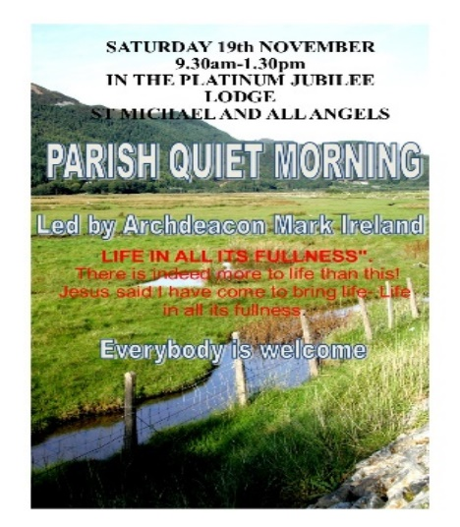

**SAM VERSUS CANCER**

SAM BURNS’ FAMILY and FRIENDS HAVE ORGANISED A CHRISTMAS RAFFLE TO RAISE FUNDS FOR SAM IN HER FIGHT AGAINST CANCER.

If you would like to buy some tickets @£2 or £10 per book contact Barbara Wood 07745208617 bw12252@hotmail.com by Fri 11th Nov

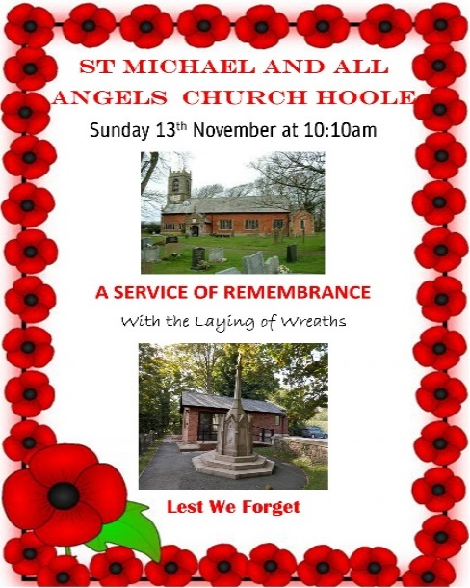



**ALPHA SESSION WED 9th NOVEMBER 7.15PM (note slightly later time): How Can I have Faith?**

**?????????????????????????????????????????????????????????????????????????????????????????????**

**??**

**course this week.**

**SERVICE OPPORTUNITIES IN CHURCH**

**1. Part time church administrator required 6-10 hrs per week. –contact Rev Ann for more information, wages etc**

**2. Voluntary help needed in: A) technology eg data projector, live streaming etc B) publicity: putting up posters, distributing information etc C) catering/refreshments D) help with children’s work. E) church cleaning.**