Parish Dates From November 2022

Tuesday 21st Nov 10.15am Morning Prayer in the Lodge.
Sunday 27th Nov 9.00am Holy Communion
ADVENT SUNDAY 10.30am Morning Worship & Sunday School
12. 00 noon Interment of ashes – Joan Clarkson
Tuesday 29th Nov 10.15am Holy Communion in the Lodge
7.30pm Preparing for Christmas-Bible Study in the Lodge
Thursday 1st Dec. 4.30pm Bible & Biscuits in the Lodge
Friday 2nd Dec. 7.00pm Christmas Mastermind in the Lodge.

Sunday 4th Dec. 9.00am Holy Communion
10.30am Parish Communion
12.00 noon Interment of ashes –Patricia Mortimer
3.45pm TOY AND CHRISTINGLE SERVICE
Monday 5th Dec. 7.30pm Preparing for Christmas 2:-
Bible Study in the Lodge
Tuesday 6th Dec. 10.15am Morning Prayer in the Lodge
7.30pm Ladies Group Christmas Coffee Evening
Thursday 8th Dec. 4.30pm Chat & Chocolate in the Lodge.

Sunday 11th Dec. 9.00am Holy Communion
10.30am Morning Worship with Sunday School.
Tuesday 13th Dec 10.15am Holy Communion in the Lodge
7.30pm Men’s Fellowship Meal in the Village Hall
Wednesday 14th December 7.00pm Christmas Social in the Lodge -carols with Jacob’s Join
www.hooleparishchurch.com
Facebook page: St Michael and All Angels Church, Hoole,
Rector – Revd Ann Templeman anntempleman@live.co.uk
01772 448515 or 07877659156
SOPlease take this sheet home with you
St. Michael and All Angels –Hoole
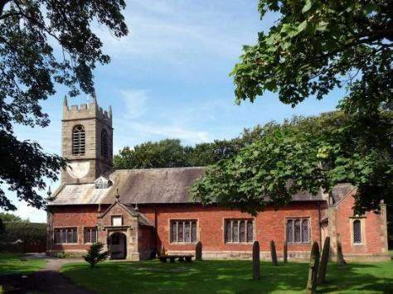

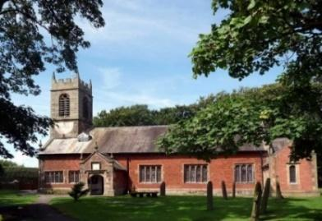

Welcome to our church this morning. Please stay for a chat and a cup of tea or coffee in the Lodge after the 10.30 service.

Sunday 20th November 2022
CHRIST THE KING.

They asked “Where is the One who has been born King of the Jews?”
Matthew 2: v 2.

PRAYER OF THE DAY: God the Father, help us to hear the call of
Christ the King and to follow in his service, whose kingdom has no
end; for he reigns with you and the Holy Spirit, one God, one glory.
Amen.
No Sunday School today during the service
Chocolate Church at 3.45pm
There are toys and colouring sheets
for younger children at the back of church

9.00am. Holy Communion (Book of Common Prayer) begins p237

10.30am. Parish Communion with Sunday School.

Readings: Colossians 2: v 9-15. Matthew 2: v 1-12.
Revelation 3: v 20.
Hymns: 54 – At the Name of Jesus (omit v 4).
Suppl. 8 – King of Kings.
408 – Lord, enthroned in heavenly splendour.
465 – Name of all majesty.
H/C Hymns: 17 – All heaven declares. 436 – Majesty, worship his Majesty.

3.45pm. CHOCOLATE CHURCH in the Village Hall.

Readings: Colossians 2: v 9-15. For in Christ all the fullness of the Deity lives in bodily form, and in Christ you have been brought to fullness. He is the head over every power and authority. In him you were also circumcised with a circumcision not performed by human hands. Your whole self ruled by the flesh was put off when you were circumcised by Christ, having been buried with him in baptism, in which you were also raised with him through your faith in the working of God, who raised him from the dead.
When you were dead in your sins and in the uncircumcision of your flesh, God made you alive with Christ. He forgave us all our sins, having cancelled the charge of our legal indebtedness, which stood against us and condemned us; he has taken it away, nailing it to the cross. And having disarmed the powers and authorities, he made a public spectacle of them, triumphing over them by the cross.

Matthew 2: v 1-12. After Jesus was born in Bethlehem in Judea, during the
time of King Herod, Wisemen from the east came to Jerusalem and asked,
‘Where is the one who has been born king of the Jews? We saw his star when
it rose and have come to worship him.’
When King Herod heard this he was disturbed, and all Jerusalem with him. When he had called together all the people’s chief priests and teachers of the law, he asked them where the Messiah was to be born. ‘In Bethlehem in Judea,’ they replied, ‘for this is what the prophet has written:
‘“But you, Bethlehem, in the land of Judah, are by no means least
among the rulers of Judah; for out of you will come a ruler who
will shepherd my people Israel.”’
Then Herod called the Wisemen secretly and found out from them the exact time the star had appeared. He sent them to Bethlehem and said, ‘Go and search carefully for the child. As soon as you find him, report to me, so that I too may go and worship him.’
After they had heard the king, they went on their way, and the star they had seen when it rose went ahead of them until it stopped over the place where the child was. When they saw the star, they were overjoyed. On coming to the house, they saw the child with his mother Mary, and they bowed down and worshipped him. Then they opened their treasures and presented him with gifts of gold, frankincense and myrrh. And having been warned in a dream not to go back to Herod, they returned to their country by another route.

Revelation 3: v 20. Here I am! I stand at the door and knock. If anyone hears my voice and opens the door, I will come in and eat with that person, and they with me.

Prayer: We give thanks for our Quiet Day held yesterday in the Lodge and for all
other activities taking place there. We pray for Martyn and Janet Parker whose
marriage was blessed yesterday. We pray for those who are sick especially Erika Ivy,
Ann and Tony Bradshaw, Sam Burns, Mona Lewis, Scott Eckersley, Christine Barker, Margaret Thornborrow, Andy Shaw, Beryl and Bill Carr.
Bible Study:- Preparing for Christmas Tuesday 29th November and Monday 5th December at 7.30pm in the Lodge
The Local History Group meets on Tuesday November 22nd at 7.30 in the Village Hall, a talk by Steven Halliwell on Moses Holden (1778-1874) with astronomical connections to Jeremiah Horrocks. There is a small charge of £2.00 per person.
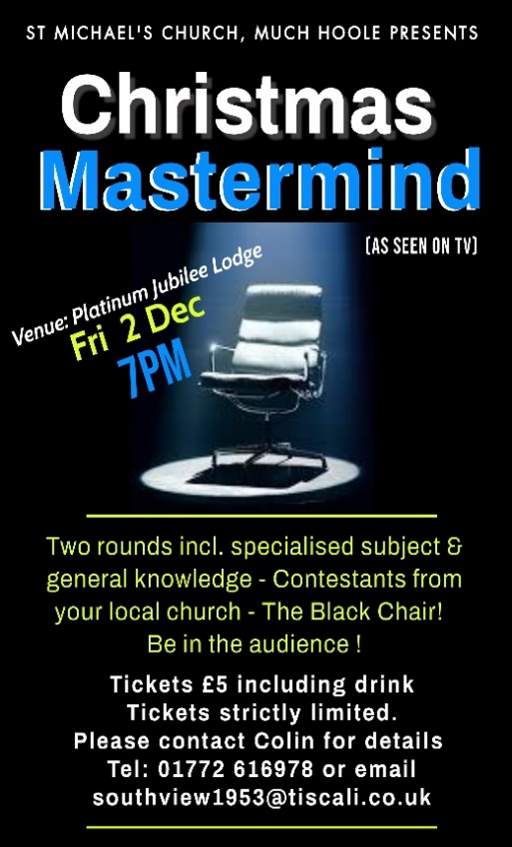

Wednesday 14th Dec. at 7.00pm in the Lodge ;-
Christmas Social, with Carols and Jacob’s Join.

Note – The Food Bank is urgently in need of supplies, Please help if you can.
Suggested Bible readings this week.
Monday 21st Nov. Luke. 21 v 1-4. Tuesday 22nd Nov. Luke 21: v 5-11.
Wednesday 23rd Nov. Luke 21: v 12-19. Thursday 24th Nov. Luke 21: v 20-28.
Friday 25th Nov. Luke 21: v 29-33. Saturday 26th Nov. Luke 21: v 34-36.

