Parish Dates October 2021 onwards

Monday Oct 11th 7.30pm Bible Study at the Rectory.
Tuesday Oct 12th 10.15am – 10.45am Prayer time in Church.
2.45pm School Worship in Church.
Thursday Oct 14th from 11.30am Locals’ Lunch in New Village Hall.
4.30pm Chat and Chocolate group in Church.

Sunday Oct 17th 9.00am Holy Communion
10.30am Parish Communion.
3.45pm Pokemon Church at Hoole Village Hall.
Monday Oct 18th 3.30pm Bereavement group tea.
7.30pm Bible Study at the Rectory.
Tuesday Oct 19th 10.15am – 10.45am Prayer time in Church.

Sunday Oct 24th 9.00am Holy Communion
10.30am Morning Worship with Sunday School.
12.00pm Colin Clark interment of ashes
Tuesday Oct 26th 10.15am – 10.45am Prayer time in Church.
7.30pm Bible Study at the Rectory.
Thursday Oct 28th from 11.30am Locals’ Lunch in New Village Hall.
4.30pm Chat and Chocolate group in Church.

Sunday Oct 31st 9.00am Holy Communion
10.30am Parish Communion with Sunday School.
6.00pm SERVICE OF THANKSGIVING
FOR LOVED ONES.
Monday Nov 1st 7.30pm Bible Study at the Rectory.
Tuesday Nov 2nd 10.15am – 10.45am Prayer time in Church.
Sunday Nov 7th 9.00am Holy Communion
10.30am Parish Communion with Sunday School.
KEY FUTURE DATES

Saturday November 6th 10.00am – 2.00pm
PARISH QUIET DAY AT WHALLEY ABBEY

Sunday Nov 14th 10.10am REMEMBRANCE SUNDAY SERVICE
Sunday Nov 21st 3.45pm Narnia Church at Hoole Village Hall.

Website : www.hooleparishchurch.com
Facebook page: St Michael and All Angels Church, Hoole,
Rector – Revd Ann Templeman anntempleman@live.co.uk 01772 448515The Rectory, 69 Liverpool Old Road Much Hoole PR4 4RB
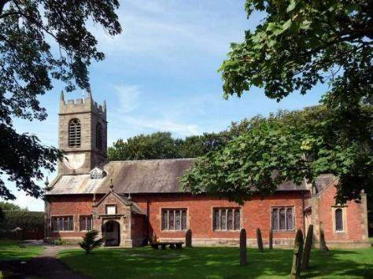
St. Michael and All Angels – Hoole

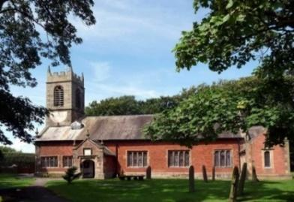

Welcome to our church again this morning. A special welcome to Revd Pat Belshaw who is leading our worship today. We continue to welcome new friends and welcome back others, please stay for a chat and a cup of tea or coffee after the 10.30 service, a great way to meet people.

Sunday 10th October 2021 Trinity 19

I AM THE WAY, THE TRUTH AND THE LIFE

Jesus looking at him, loved him. Mark 10 v 21.

PRAYER OF THE DAY: Faithful Lord, whose steadfast love never
ceases and whose mercies never come to an end: grant us the grace to
trust you and to receive the gifts of your love, new every morning,
in Jesus Christ our Lord. Amen.

Sunday School today during the service
There are toys for younger children
at the back of church.

9.00am. Holy Communion (Book of Common Prayer) begins p237

10.30am. Morning Worship with Sunday School.

Reading: Mark 10: v 17-31.
Hymns: 741 – When we walk with the Lord.
Screen/video – All through History.
45 – As the deer pants for the water.
411 – Lord Jesus Christ.
74 – Blessed assurance.

BIBLE READING: Mark 10: v 17-31. As Jesus started on his way, a man ran up to him and fell on his knees before him. ‘Good teacher,’ he asked, ‘what must I do to inherit eternal life?’
‘Why do you call me good?’ Jesus answered. ‘No one is good – except God alone. You know the commandments: “You shall not murder, you shall not commit adultery, you shall not steal, you shall not give false testimony, you shall not defraud, honour your father and mother.” ‘Teacher,’ he declared, ‘all these I have kept since I was a boy.’
Jesus looked at him and loved him. ‘One thing you lack,’ he said. ‘Go, sell everything you have and give to the poor, and you will have treasure in heaven. Then come, follow me.’ At this the man’s face fell. He went away sad, because he had great wealth. Jesus looked round and said to his disciples, ‘How hard it is for the rich to enter the kingdom of God!’
The disciples were amazed at his words. But Jesus said again, ‘Children, how hard it is to enter the kingdom of God! It is easier for a camel to go through the eye of a needle than for someone who is rich to enter the kingdom of God.’ The disciples were even more amazed, and said to each other, ‘Who then can be saved?’
Jesus looked at them and said, ‘With man this is impossible, but not with God; all things are possible with God.’ Then Peter spoke up, ‘We have left everything to follow you!’
‘Truly I tell you,’ Jesus replied, ‘no one who has left home or brothers or sisters or mother or father or children or fields for me and the gospel will fail to receive a hundred times as much in this present age: homes, brothers, sisters, mothers, children and fields – along with persecutions – and in the age to come eternal life. But many who are first will be last, and the last first.’

Prayer. We give thanks for our wonderful Harvest Festival services last week and the Harvest social we enjoyed together. We pray for those who are sick, especially Baby Erica Ivy, Patricia Mortimer, Bill and Beryl Carr, Harriet Mitcheson, Rose Wood Nicola Middleton Tom Parkinson and Josephine Hodge. We give thanks for the life of Anthony Brogden and pray for his family and friends.

Suggested Bible readings this week.
Monday 11th Oct. Luke 11: v 29-32. Tuesday 12th Oct. Luke 11: v 37-41.
Wednesday 13th Oct. Luke 11: v 42-46. Thursday 14th Oct. Luke 11: v 47-end.
Friday 15th Oct. Luke 12: v 1-7. Saturday 16th Oct. Luke 12: v 8-12.

BIBLE STUDIES AND PRAYER TIMES
Join us for Prayer time 10.15am -10.45am in church each Tuesday morning. Why not try out Bible study this autumn. We will be looking at the Parables of Jesus, and continue tomorrow evening October 11th at the Rectory.
