PARISH DATES
Monday 16th Oct. 7.30pm Bible for Beginners in the Lodge
Tuesday 17th Oct. 10.15am Morning Prayer in the Lodge.
7.30pm Joint meeting of the Ladies and Men’s Groups in
the Village Hall. (topic change - ‘My Life as a Fire Officer)
Wednesday 18th Oct. 9.30am-11.30am ST MICHAEL’S LITTLE ANGELS
Sunday 22nd Oct. 9.00am Holy Communion
10.30am Morning Worship with Sunday School
Tuesday 24th Oct. 10.15am Morning Prayer in the Lodge.
Sunday 29th Oct. 9.00am Holy Communion
10.30am Parish Communion with Sunday School.
Monday 30th Oct. 7.30pm Bible for Beginners in the Lodge
Tuesday 31st Oct. 10.15am Holy Communion in the Lodge.
Sunday 5th Nov. 9.00am Holy Communion
10.30am Parish Communion with Sunday School.
3.00pm Holy Communion (Old Mill Court)
4.30pm SERVICE OF THANKSGIVING FOR LOVED ONES.
Monday 6th Nov. 7.30pm PCC Meeting in the Lodge.
Tuesday 7th Nov. 10.15am Holy Communion in the Lodge.
Wednesday 8th Nov 9.30am-11.30am ST MICHAEL’S LITTLE ANGELS
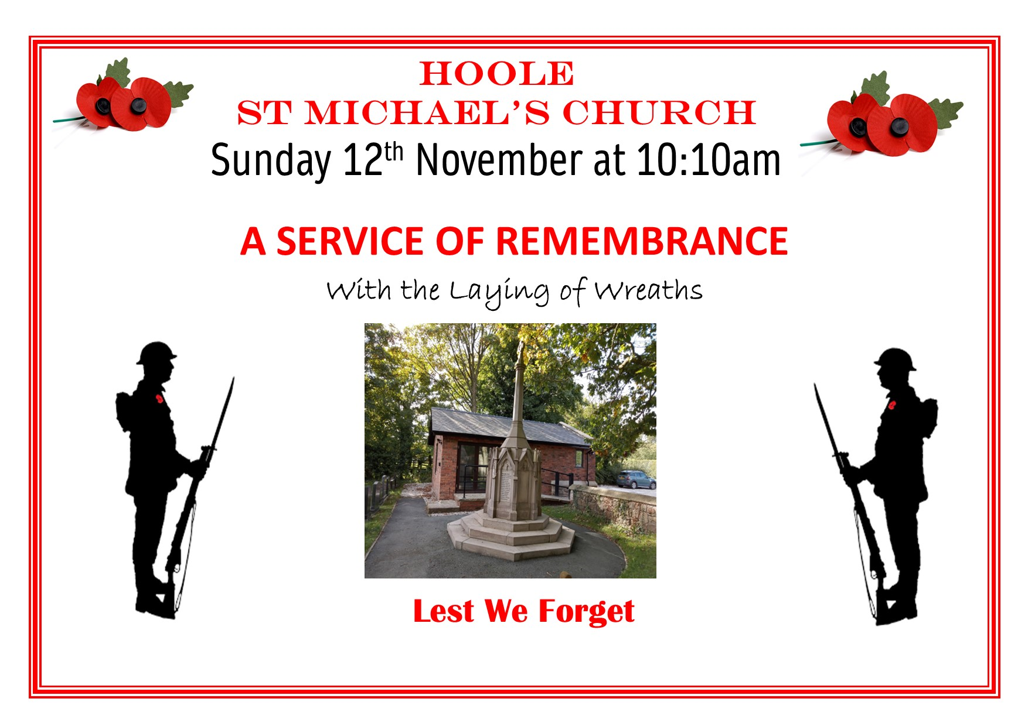

FUTURE DATES FOR YOUR DIARY:
NOVEMBER 11th 10.00 - 2.00 – Parish Quiet Day at Whalley Abbey
NOVEMBER 12th 10.10am – Service of Remembrance
Note – No 9.00 am service of Holy Communion on this day.

www.hooleparishchurch.com Facebook : St Michael and All Angels Church, Hoole,
Rector Ann Templeman anntempleman@live.co.uk 01772 448515 or 07877659156
PLEASE TAKE THIS SHEET HOME WITH YOU.
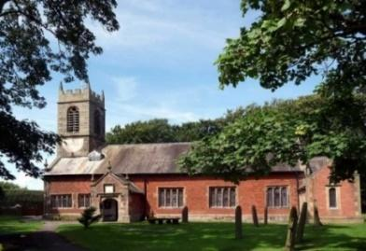

Welcome to our Church today.
Please stay for refreshments in the Lodge which follow the 10.30am service.

Sunday 15th October 2023

REJOICE IN THE LORD ALWAYS

Rejoice in the Lord always . . . Do not be anxious about anything, but in everything, by prayer and petition, with thanksgiving, present your requests to God. (from Philippians 4: v 4 & 6).

PRAYER OF THE DAY Faithful Lord, whose steadfast love never
ceases and whose mercies never come to an end: grant us the grace to
trust you and to receive the gifts of your love, new every morning,
in Jesus Christ our Lord. Amen.

No Sunday School today during the service.
Design and Make Church in the Village Hall at 3.45pm.
There are toys and colouring sheets for younger children
at the back of church.

9.00am. Holy Communion (Book of Common Prayer) begins p237

10.30am. Parish Communion.
Reading: Philippians 4: v 1-9.
Hymns: Screen – Bring to the Lord a glad new song (tune: Jerusalem).
202 – Give thanks with a grateful heart. This is the Day
727 – What a friend we have in Jesus.
465 – Name of all majesty.
H/C Hymns: Suppl. 4 – Oh to see the dawn.
Suppl. 10 – Here is love, vast as the ocean.

3.45pm. Design and Make Family Church in the Village Hall.

Reading: Rejoice in the Lord always: Philippians 4: v 1-9.
Therefore my brothers and sisters, you whom I love and long for, my joy and crown, that is how you should stand firm in the Lord.
I plead with Euodia and I plead with Syntyche to be of the same mind in the Lord. Yes, and I ask you, my true companion, help these women since they have contended at my side in the cause of the gospel, along with Clement and the rest of my co-workers, whose names are in the book of life.
Rejoice in the Lord always. I will say it again: rejoice! Let your gentleness be evident to all. The Lord is near. Do not be anxious about anything, but in every situation, by prayer and petition, with thanksgiving, present your requests to God. And the peace of God, which transcends all understanding, will guard your hearts and your minds in Christ Jesus.
Finally, brothers and sisters, whatever is true, whatever is noble, whatever is right, whatever is pure, whatever is lovely, whatever is admirable – if anything is excellent or praiseworthy – think about such things. Whatever you have learned or received or heard from me, or seen in me – put it into practice. And the God of peace will be with you.

Prayer: We pray for all those affected by the conflict in the Middle East, we pray for peace, understanding and compassion. We pray for all who are sick especially, Erica Ivy, Jon Slinger, Jean Smallwood, Elizabeth Skellorn, Monica Keane, Bill & Beryl Carr. We give thanks for the life of Dorothy Nuttall and pray for her family & friends.
BIBLE FOR BEGINNERS
CONTINUES fortnightly on MONDAYs
7.30pm in the LODGE
We are looking at the excellent portrayal of Jesus’ encounters and teaching in the New Testament from the Biblical film series The Chosen.
Next session on Monday 16th October.

Suggested Bible Readings for this week: (Wed. Luke the Evangelist)
Mon 16th Oct. Luke 11: v 29-32. Tues 17th Oct. Luke 11: v 37-41.
Wed. 18th Oct. Luke 10: v 1-9. Thursday 19th Oct. Luke. 11: v 47-end.
Friday 20th Oct. Luke 12: v 1-7. Saturday 21st Oct. Luke 12: v 8-12.

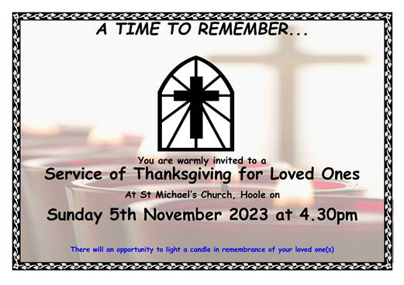
Lost and Found Property. There is a lost property box located in the lower cupboard in the cabinet by the foot of the stairs. See the churchwardens if you left a key in church last Sunday..
n 