**Parish Dates From October 2022**

**Tuesday 18th Oct. 10.15am Morning Prayer in the Lodge**

**11.00am Alpha and coffee –Why did Jesus die**

**7.30pm Joint Ladies Group & Men’s Fellowship**

**Wednesday 19th Oct. 7.00pm – c8.30pm Alpha Course. Cancelled this week**

**due to a bereavement.**

**Thursday 20th Oct. 4.30pm Chat and Chocolate in the Lodge.**

**Sunday 23rd Oct. 9.00am Holy Communion**

**10.30am Parish Communion with Sunday School.**

**Tuesday 25th Oct. 10.15am Holy Communion in the Lodge.**

**Wednesday 26th Oct. 7.00pm – c8.30pm Alpha Course in the Lodge.**

**Why read the Bible**

**Sunday 30th Oct. 9.00am Holy Communion**

**10.30am Parish Communion with Sunday School.**

**6.00pm SERVICE OF THANKSGIVING FOR**

**LOVED ONES.**

**Tuesday 1st Nov. 10.15am Holy Communion in the Lodge.**

**Wednesday 2nd Nov. 7.00pm – c8.30pm Alpha Course in the Lodge.**

**Why and how should I pray?**

**Thursday 3rd Nov. 4.30pm Bible and Biscuits in the Lodge.**

**Sunday 6th Nov. 9.00am Holy Communion**

**10.30am Parish Communion with Sunday School.**

**Tuesday 8th Nov. 10.15am Morning Prayer in the Lodge.**

**7.30pm Men’s Fellowship in the Village Hall.**

**Future Key Dates**

**Sunday 13th November (NB No 9.00am Service today)**

**10.10am REMEMBRANCE SUNDAY SERVICE**

**Saturday 19th Nov. 9.30am – 1.30 pm QUIET MORNING IN LODGE**

**WITH ARCHDEACON MARK**

**Sunday 20th Nov. 3.45 pm CHOCOLATE CHURCH IN THE**

**VILLAGE HALL**

**Sunday 4th Dec. 3.45pm TOY AND CHRISTINGLE SERVICE**

**Website :** **www.hooleparishchurch.com**

Facebook page: **St Michael and All Angels Church, Hoole**,

Rector – Revd Ann Templeman anntempleman@live.co.uk

01772 448515 or 07877659156

**SO***Please take this sheet home with you*

**St. Michael and All Angels –Hoole**

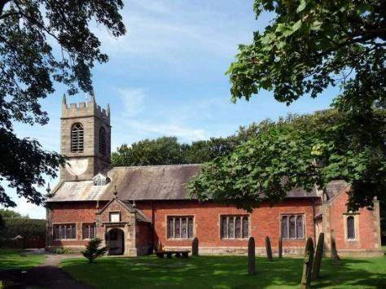

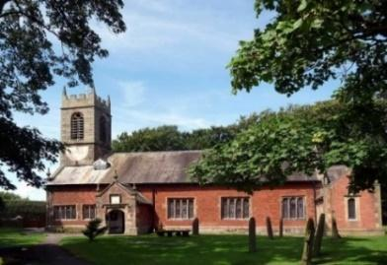

***Welcome to our church this morning. Please stay for a chat and a cup of tea or coffee in the Lodge after the 10.30 service.***

***Sunday 16th October 2022***

**LOVE GOD AND LOVE YOUR NEIGHBOUR**

**“Love the Lord your God with all your heart and with all your soul**

**and with all your strength and with all your mind;**

**and love your neighbour as yourself”.**  *Luke 10: v 27.*

**PRAYER OF THE DAY: God, our judge and saviour, teach us to be**

**open to your truth and to trust in your love, that we may live each day**

**with confidence in the salvation which is given,**

**through Jesus Christ our Lord. Amen.**

**All Age Worship Today**

There are toys and colouring sheets

for younger children at the back of church.

**

**9.00am. Holy Communion (Book of Common Prayer) begins p237**

**Conducted by Rev Richard Plant**

**10.30am. All Age Worship led by our Youth Minister Liz Boland and some of our young people**

**Reading: Luke 10: v 25-37.**

**Hymns: 489 – O God beyond all praising.**

**Screen – I reach up high.**

**Suppl. 1 – In Christ alone.**

**88 – Brother, sister, let me serve you.**

**419 – Lord the light of your love (Shine, Jesus, shine)**

**Reading: Luke Ch. 10: v 25-37.** On one occasion an expert in the law stood up to test Jesus. ‘Teacher,’ he asked, ‘what must I do to inherit eternal life?’ ‘What is written in the Law?’ he replied. ‘How do you read it?’

He answered, ‘“Love the Lord your God with all your heart and with all your soul and with all your strength and with all your mind”; and, “Love your neighbour as yourself.”’

‘You have answered correctly,’ Jesus replied. ‘Do this and you will live.’

But he wanted to justify himself, so he asked Jesus, ‘And who is my neighbour?’

In reply Jesus said: ‘A man was going down from Jerusalem to Jericho, when he was attacked by robbers. They stripped him of his clothes, beat him and went away, leaving him half-dead. A priest happened to be going down the same road, and when he saw the man, he passed by on the other side. So too, a Levite, when he came to the place and saw him, passed by on the other side. But a Samaritan, as he travelled, came where the man was; and when he saw him, he took pity on him. He went to him and bandaged his wounds, pouring on oil and wine. Then he put the man on his own donkey, brought him to an inn and took care of him. The next day he took out two silver coins and gave them to the innkeeper. “Look after him,” he said, “and when I return, I will reimburse you for any extra expense you may have.”

‘Which of these three do you think was a neighbour to the man who fell into the hands of robbers?’

The expert in the law replied, ‘The one who had mercy on him.’

Jesus told him, ‘Go and do likewise.’

**Prayer:** We give thanks for the opening of our Lodge, and for the worship and activities now taking place in there. We give thanks to all those who have responded to our Gift Day appeal. We pray for those who are sick especially Erica Ivy, Sam Burns, Mona Lewis, Jim Ashcroft, Jim Belshaw, Josephine Hodge, Beryl and Bill Carr. We give thanks for the lives of Kate Adams, Isobel Wooldridge & Margaret Kennard, & pray for their families & friends.

**Suggested Bible readings this week.**

Monday 17th Oct. Luke. 12: v 13-21. Tuesday 18th Oct. Luke 10: v 1-9.

Wednesday 19th Oct. Luke 12: v 39-48. Thursday 20th Oct. Luke 12: v 49-53.

Friday 21st Oct. Luke 12: v 54-end. Saturday 22nd Oct. Luke 13: v 1-9.

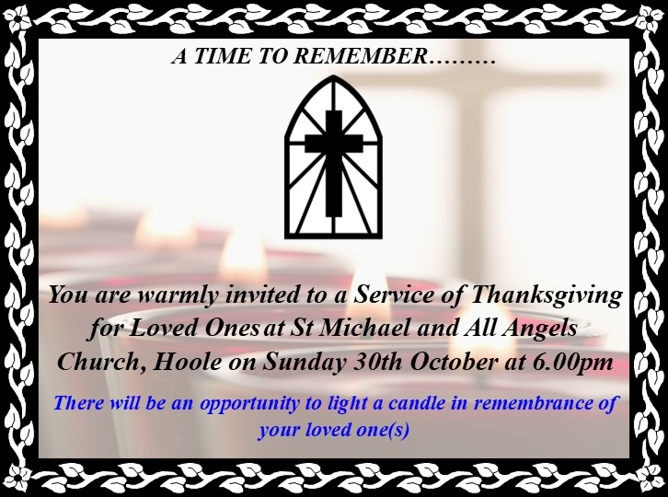



**Please note:- Due to a bereavement, there will be no Alpha session on Wed 19th. Catch up: Why Jesus died Tues 18th in the Lodge 11.am**

**course this week.**

**SERVICE OPPORTUNITIES IN CHURCH**

**1. Part time church administrator required 6-10 hrs per week. –contact Rev Ann for more information, wages etc**

**2. Voluntary help needed in: A) technology eg data projector, live streaming etc B) publicity: putting up posters, distributing information etc C) catering/refreshments D) help with children’s work. E) church cleaning.**