**Parish Dates From October 2022**

**Tuesday 25th Oct. 10.15am Holy Communion in the Lodge.**

**11.00am Alpha in Lodge over coffee**

**Wednesday 26th Oct. 7.15pm – c8.30pm Alpha Course in the Lodge.**

**Why read the Bible?**

**Sunday 30th Oct. 9.00am Holy Communion**

**10.30am Parish Communion with Sunday School.**

**6.00pm SERVICE OF THANKSGIVING FOR**

**LOVED ONES.**

**Tuesday 1st Nov. 10.15am Holy Communion in the Lodge.**

**Wednesday 2nd Nov. 7.15pm – c8.30pm Alpha Course in the Lodge.**

**Why and how should I pray?**

**Thursday 3rd Nov. 4.30pm Bible and Biscuits in the Lodge.**

**Sunday 6th Nov. 9.00am Holy Communion**

**10.30am Parish Communion with Sunday School.**

**Tuesday 8th Nov. 10.15am Morning Prayer in the Lodge.**

**7.30pm Men’s Fellowship in the Village Hall.**

**Wednesday 9th Nov. 7.15pm – c8.30pm Alpha Course in the Lodge.**

**Thursday 10th Nov. 4.30pm Chat and Chocolate in the Lodge.**

**Friday 11th Nov. 9.00am St Michael’s School Remembrance Service**

**Sunday 13th November (NB No 9.00am Service today)**

**10.10am REMEMBRANCE SUNDAY SERVICE**

**Future Key Dates**

**Sunday 13th November (NB No 9.00am Service today)**

**10.10am REMEMBRANCE SUNDAY SERVICE**

**Saturday 19th Nov. 9.30am – 1.30 pm QUIET MORNING IN LODGE**

**WITH ARCHDEACON MARK**

**Sunday 20th Nov. 3.45 pm CHOCOLATE CHURCH IN THE**

**VILLAGE HALL**

**Sunday 4th Dec. 3.45pm TOY AND CHRISTINGLE SERVICE**

**Website :** **www.hooleparishchurch.com**

Facebook page: **St Michael and All Angels Church, Hoole**,

Rector – Revd Ann Templeman anntempleman@live.co.uk

01772 448515 or 07877659156

**SO***Please take this sheet home with you*

**St. Michael and All Angels –Hoole**

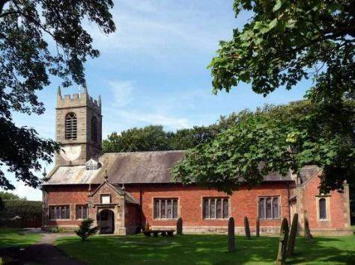

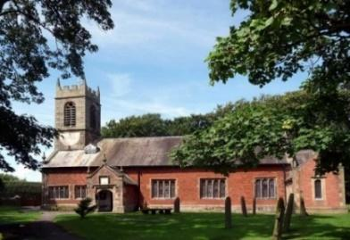

***Welcome to our church this morning. Please stay for a chat and a cup of tea or coffee in the Lodge after the 10.30 service.***

***Sunday 23rd October 2022***

**BIBLE SUNDAY**

**“For everything that was written in the past was written to teach us, so that through endurance and the encouragement of the Scriptures we might have hope.”**  *Romans 15: v 4.*

**PRAYER OF THE DAY: Blessed Lord, who caused all holy Scriptures**

**to be written for our learning: help us so to hear them, to read, mark, learn**

**and inwardly digest them that, through patience, and the comfort of your**

**holy word, we may embrace and for ever hold fast the hope of everlasting**

**life, which you have given us in our Saviour Jesus Christ, who is alive and**

**reigns with you, in the unity of the Holy Spirit, one God, now and for ever.**

**Amen.**

**Sunday School today during the service**

There are toys and colouring sheets

for younger children at the back of church

**

**9.00am. Holy Communion (Book of Common Prayer) begins p237**

**10.30am. Parish Communion with Sunday School.**

**Reading: Romans 15: v 1-6. Luke 4: v 16-21.**

**Hymns: 252 – Guide me, O thou great Redeemer.**

**Screen – All through history. (45 – v 1 & Chorus after sermon)**

**Screen – God has spoken by his people.**

**447 – May the mind of Christ my Saviour.**

**H/C Hymns: Screen – Give thanks. 45 – As the deer pants for the water**

**Readings: Romans 15: v 1-6.**We who are strong ought to bear with the failings of the weak and not to please ourselves. Each of us should please our neighbours for their good, to build them up. For even Christ did not please himself but, as it is written: ‘The insults of those who insult you have fallen on me.’ For everything that was written in the past was written to teach us, so that through the endurance taught in the Scriptures and the encouragement they provide we might have hope.

May the God who gives endurance and encouragement give you the same attitude of mind toward each other that Christ Jesus had, so that with one mind and one voice you may glorify the God and Father of our Lord Jesus Christ

**Luke 4: v 16-21.** Jesus went to Nazareth, where he had been brought up, and on the Sabbath day he went into the synagogue, as was his custom. He stood up to read, and the scroll of the prophet Isaiah was handed to him. Unrolling it, he found the place where it is written:

‘The Spirit of the Lord is on me,     because he has anointed me  
     to proclaim good news to the poor.  
 He has sent me to proclaim freedom for the prisoners and recovery

of sight for the blind, to set the oppressed free,  
     to proclaim the year of the Lord’s favour.’

Then he rolled up the scroll, gave it back to the attendant and sat down. The eyes of everyone in the synagogue were fastened on him. He began by saying to them, ‘Today this scripture is fulfilled in your hearing.’

**Prayer:** We give thanks for the opening of our Lodge, and for the worship and activities now taking place in there. We give thanks to all those who have responded to our Gift Day appeal. We pray for those who are sick especially Erica Ivy, Sam Burns, Mona Lewis, Jim Ashcroft, Jim Belshaw, Josephine Hodge, Beryl and Bill Carr.

**A HUGE THANK YOU TO THOSE WHO HAVE GIVEN GENEROUSLY TO OUR GIFT DAY. IT IS STILL NOT TOO LATE IF YOU MISSED IT!**

**Suggested Bible readings this week.**

Monday 24th Oct. Luke. 13 v 10-17. Tuesday 25th Oct. Luke 13: v 18-21.

Wednesday 26th Oct. Luke 13: v 22-30. Thursday 27th Oct. Luke 13: v 31-end.

Friday 28th Oct. John 15: v 17-end. Saturday 29th Oct. Luke 14: v 1 & 7-11.

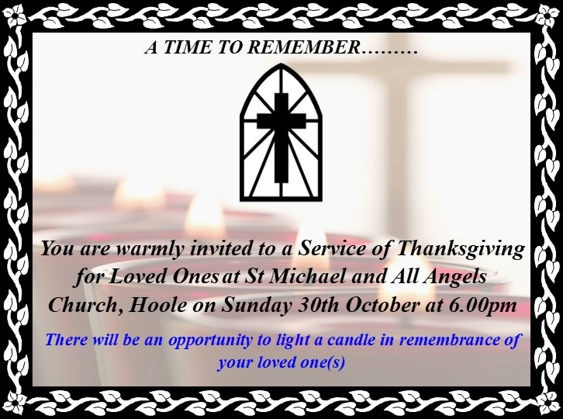



**ALPHA SESSION WED 25TH OCTOBER 7.15PM (note slightly later time): WHY READ THE BIBLE?**

**?????????????????????????????????????????????????????????????????????????????????????????????**

**??**

**course this week.**

**SERVICE OPPORTUNITIES IN CHURCH**

**1. Part time church administrator required 6-10 hrs per week. –contact Rev Ann for more information, wages etc**

**2. Voluntary help needed in: A) technology eg data projector, live streaming etc B) publicity: putting up posters, distributing information etc C) catering/refreshments D) help with children’s work. E) church cleaning.**