**Parish Dates From November 2022**

**Tuesday 1st Nov. 10.15am Holy Communion in the Lodge.**

**Wednesday 2nd Nov. 7.15pm – c8.30pm Alpha Course in the Lodge.**

**Why and how should I pray?**

**Thursday 3rd Nov. 4.30pm Bible and Biscuits in the Lodge.**

**Sunday 6th Nov. 9.00am Holy Communion**

**10.30am Parish Communion with Sunday School.**

**Tuesday 8th Nov. 10.15am Morning Prayer in the Lodge.**

**7.30pm Men’s Fellowship in the Village Hall.**

**Wednesday 9th Nov. 7.15pm – c8.30pm Alpha Course in the Lodge.**

**Thursday 10th Nov. 4.30pm Chat and Chocolate in the Lodge.**

**Friday 11th Nov. 9.00am St Michael’s School Remembrance Service**

**Sunday 13th November (NB No 9.00am Service today)**

**10.10am REMEMBRANCE SERVICE 4.00pm Holy Communion (Old Mill Court)**

**Monday 14th Nov 7.30pm PCC in Lodge**

**Tuesday 15th Nov. 10.15am Morning Prayer in the Lodge.**

**7.30pm Ladies Group in the Village Hall.**

**Wednesday 16th Nov. 7.15pm – c8.30pm Alpha Course in the Lodge.**

**Thursday 17th Nov. 4.30pm Bible and Biscuits in the Lodge.**

**Saturday 19th Nov. 9.30am – 1.30 pm QUIET MORNING**

**IN LODGE WITH ARCHDEACON MARK.**

**2.00pm Celebration of the Marriage of Martyn Parker and Janet Moon**

**Sunday 20th Nov. 9.00am Holy Communion**

**10.30am Parish Communion.**

**3.45pm CHOCOLATE CHURCH in Village Hall.**

**Tuesday 21st Nov 10.15am Morning Prayer in the Lodge.**

**Sunday 27th Nov 9.00am Holy Communion**

**ADVENT SUNDAY 10.30am Morning worship with Sunday School.**

**Future Key Dates**

**Sunday 4th Dec. 3.45pm TOY AND CHRISTINGLE SERVICE**

**Sunday 11th Deember 6.00pm CAROLS BY CANDLELIGHT**

**Website :** **www.hooleparishchurch.com**

Facebook page: **St Michael and All Angels Church, Hoole**,

Rector – Revd Ann Templeman anntempleman@live.co.uk

01772 448515 or 07877659156

**SO***Please take this sheet home with you*

**St. Michael and All Angels –Hoole**

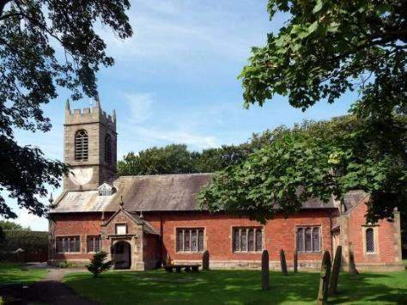

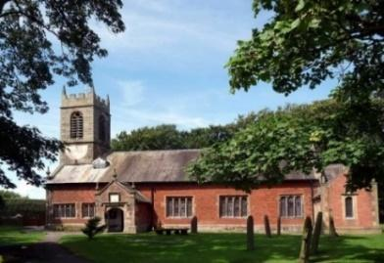

***Welcome to our church this morning. Please stay for a chat and a cup of tea or coffee in the Lodge after the 10.30 service.***

**ALL SAINTS’ SUNDAY *Sunday 30th October 2022***

**THE POWER AND THE LOVE OF CHRIST.**

**“That you may grasp how wide and long and high and deep is the**

**love of Christ”**  *Ephesians 3: v 18.*

**PRAYER OF THE DAY: God of holiness, your glory is proclaimed**

**in every age: as we rejoice in the faith of your saints, inspire us to**

**follow their example with boldness and joy;**

**through Jesus Christ our Lord. Amen.**

**Sunday School today during the service**

There are toys and colouring sheets

for younger children at the back of church

**

**9.00am. Holy Communion (Book of Common Prayer) begins p237**

**10.30am. Parish Communion with Sunday School.**

**Reading: Ephesians 3: v 14-21.**

**Hymns: 450 – Morning has broken.**

**Suppl. 5 – Bless the Lord O my soul.**

**Suppl. 10 – Here is Love vast as the ocean.**

**727 – What a friend we have in Jesus.**

**178 – For all the saints (omit v’s 4 & 5)**

**H/C Hymns: Screen – As water to the thirsty. Screen – God of glory.**

**6.00pm. SERVICE OF THANKSGIVING FOR LOVED ONES.**

**Reading: Ephesians 3: v 14-21.** For this reason I kneel before the Father, from whom every family in heaven and on earth derives its name. I pray that out of his glorious riches he may strengthen you with power through his Spirit in your inner being, so that Christ may dwell in your hearts through faith. And I pray that you, being rooted and established in love, may have power, together with all the Lord’s holy people, to grasp how wide and long and high and deep is the love of Christ, and to know this love that surpasses knowledge – that you may be filled to the measure of all the fullness of God.

Now to him who is able to do immeasurably more than all we ask or imagine, according to his power that is at work within us, to him be glory in the church and in Christ Jesus throughout all generations, for ever and ever!

Amen.

**Prayer:** We give thanks for the opening of our Lodge, and for the worship and activities now taking place in there. We give thanks to all those who have responded to our Gift Day appeal. We pray for those who are sick especially Erica Ivy, Sam Burns, Mona Lewis, Jim Ashcroft, Jim Belshaw, Josephine Hodge, Beryl and Bill Carr and Ann Bradshaw

CONGRATULATIONS TO JEAN AND ELLIS MARTLAND

ON THE OCCASION OF THEIR DIAMOND WEDDING ANNIVERSARY.

**Ladies' Group Coffee Morning** at Banks Farm, Station Road, on Saturday November 5th from 10.00 to 12.30. £5.00 to enter which includes tea/coffee plus refills and cake/scone. There will be a cake stall, bring and buy, quiz and a raffle. Proceeds toward the Lodge and the Ladies' Group. This is an open event – not just for Ladies Group members. – All welcome.

**A HUGE THANK YOU TO THOSE WHO HAVE GIVEN GENEROUSLY TO OUR GIFT DAY. IT IS STILL NOT TOO LATE IF YOU MISSED IT!**

**Suggested Bible readings this week.**

Monday 31st Oct. Luke. 14 v 12-14. Tuesday 1st Nov. Matthew 5: v 1-12.

Wednesday 2nd Nov. Luke 14: v 25-33. Thursday 3rd Nov. Luke 15: v 1-10.

Friday 4th Nov. Luke 16: v 1-8. Saturday 5th Nov. Luke 16: v 9-15.

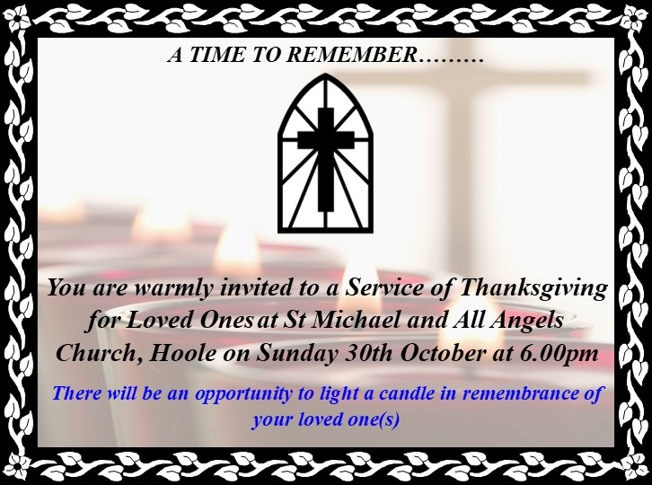



**ALPHA SESSION WED 2nd NOVEMBER 7.15PM (note slightly later time): WHY AND HOW SHOULD I PRAY?**

**?????????????????????????????????????????????????????????????????????????????????????????????**

**??**

**course this week.**

**SERVICE OPPORTUNITIES IN CHURCH**

**1. Part time church administrator required 6-10 hrs per week. –contact Rev Ann for more information, wages etc**

**2. Voluntary help needed in: A) technology eg data projector, live streaming etc B) publicity: putting up posters, distributing information etc C) catering/refreshments D) help with children’s work. E) church cleaning.**