**Parish Dates**

**Monday 10th Oct. 2.00pm Funeral of Margaret Kennard.**

**Tuesday 11th Oct. 10.15am Holy Communion in the Lodge.**

**11.00am Alpha and coffee – Who is Jesus**

**Wednesday 12th Oct. 7.00pm – c8.30pm Alpha Course in the Lodge.**

**Thursday 13th Oct. 4.30pm Bible and Biscuits in the Lodge.**

**Sunday 16th Oct. 9.00am Holy Communion**

**10.30am All Age Worship.**

**Tuesday 18th Oct. 10.15am Morning Prayer in the Lodge**

**11.00am Alpha and coffee –Why did Jesus die**

**7.30pm Joint Ladies Group & Men’s Fellowship**

**Wednesday 19th Oct. 7.00pm – c8.30pm Alpha Course in the Lodge.**

**Thursday 20th Oct. 4.30pm Chat and Chocolate in the Lodge.**

**Sunday 23rd Oct. 9.00am Holy Communion**

**10.30am Parish Communion with Sunday School.**

**Tuesday 25th Oct. 10.15am Holy Communion in the Lodge.**

**Wednesday 26th Oct. 7.00pm – c8.30pm Alpha Course in the Lodge.**

**Sunday 30th Oct. 9.00am Holy Communion**

**10.30am Parish Communion with Sunday School.**

**6.00pm SERVICE OF THANKSGIVING FOR**

**LOVED ONES.**

**Tuesday 1st Nov. 10.15am Holy Communion in the Lodge.**

**Wednesday 2nd Nov. 7.00pm – c8.30pm Alpha Course in the Lodge.**

**Thursday 3rd Nov. 4.30pm Bible and Biscuits in the Lodge.**

**Future Key Dates**

**Sunday 13th November (NB No 9.00am Service today)**

**10.10am REMEMBRANCE SUNDAY SERVICE**

**Saturday 19th Nov. 9.30am – 1.30 pm QUIET MORNING IN LODGE**

**WITH ARCHDEACON MARK**

**Sunday 20th Nov. 3.45 pm CHOCOLATE CHURCH IN THE**

**VILLAGE HALL**

**Sunday 4th Dec. 3.45pm TOY AND CHRISTINGLE SERVICE**

**Website :** **www.hooleparishchurch.com**

Facebook page: **St Michael and All Angels Church, Hoole**,

Rector – Revd Ann Templeman anntempleman@live.co.uk

01772 448515 or 07877659156

**SO***Please take this sheet home with you*

**St. Michael and All Angels –Hoole**

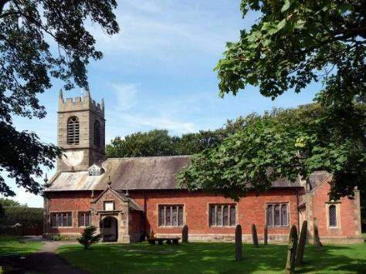

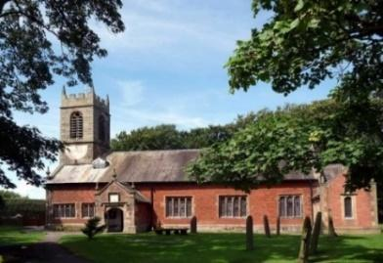

***Welcome to our church this morning. Please stay for a chat and a cup of tea or coffee in the Lodge after the 10.30 service.***

***Sunday 9th October 2022***

**THE PERSON OF JESUS**

**Now this is eternal life that they know you, the one true God,**

**and Jesus Christ whom you have sent.**  *John 17: v 3.*

**PRAYER OF THE DAY: Gracious God, you call us to fullness of life:**

**deliver us from unbelief and banish our anxieties with the liberating**

**love of Jesus Christ our Lord. Amen.**

**No Sunday School today during the service**

**Farm Church at 3.45 pm at the Village Hall**

There are toys and colouring sheets

for younger children at the back of church.

**

**9.00am. Holy Communion (Book of Common Prayer) begins p237**

**10.30am. Parish Communion.**

**Reading: John Ch. 17: v 1-10 & 24a.**

**Hymns: 54 – At the name of Jesus (omit v 4).**

**297 – How sweet the name of Jesus sounds.**

**408 – Lord, enthroned in heavenly splendour.**

**465 – Name of all Majesty.**

**H/C Hymns: Suppl. 8 – King of Kings.**

**436 – Majesty, worship his majesty.**

**3.45pm. FARM CHURCH at the Village Hall.**

### **Reading: John Ch. 17: v 1-10 & 24a.** After Jesus said this, he looked toward heaven and prayed:

“Father, the hour has come. Glorify your Son, that your Son may glorify you. For you granted him authority over all people that he might give eternal life to all those you have given him. Now this is eternal life: that they know you, the only true God, and Jesus Christ, whom you have sent. I have brought you glory on earth by finishing the work you gave me to do. And now, Father, glorify me in your presence with the glory I had with you before the world began.

“I have revealed you to those whom you gave me out of the world. They were yours; you gave them to me and they have obeyed your word. Now they know that everything you have given me comes from you. For I gave them the words you gave me and they accepted them. They knew with certainty that I came from you, and they believed that you sent me. I pray for them. I am not praying for the world, but for those you have given me, for they are yours. All I have is yours, and all you have is mine. And glory has come to me through them.

Father, I want those you have given me to be with me where I am,

and to see my glory.

Great things he has taught us, great things he hath done,

and great our rejoicing through Jesus the Son;

but purer and higher, and greater will be

our wonder, our rapture, when Jesus we see.

**Prayer:** We give thanks for the opening of our Lodge, and for the worship and activities now taking place in there. We give thanks for our Harvest Festival and to all those who responded to our Gift Day appeal. We pray for those who are sick especially Sam Burns, Mona Lewis, Jim Ashcroft, Jim Belshaw, Beryl and Bill Carr. We give thanks for the lives of Kate Adams, Isobel Wooldridge & Margaret Kennard, & pray for their families & friends.

**A HUGE THANK YOU TO THOSE WHO HAVE GIVEN GENEROUSLY TO OUR GIFT DAY. IT IS NOT TOO LATE IF YOU MISSED IT!.**

**Suggested Bible readings this week.**

Monday10th Oct. Luke. 11: v 29-32. Tuesday 11th Oct. Luke 11: v 37-41.

Wednesday. 12th Oct. Luke 11: v 42-46. Thursday 13th Oct. Luke 11: v 47-end.

Friday 14th Oct. Luke 12: v 1-7. Saturday 15th Oct. Luke 12: v 8-12.

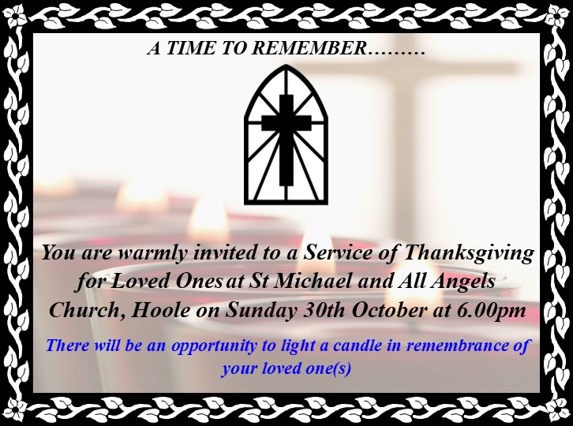



**If you can’t make Wednesday evening for Alpha try Tuesday’s catchup at 11 in the Lodge to watch the 30min film over coffee. Tues 11th Oct: Who is Jesus?**

**SERVICE OPPORTUNITIES IN CHURCH**

**1. Part time church administrator required 6-10 hrs per week. –contact Rev Ann for more information, wages etc**

**2. Voluntary help needed in: A) technology eg data projector, live streaming etc B) publicity: putting up posters, distributing information etc C) catering/refreshments D) help with children’s work E) church cleaning**